  tRAINING MANUAL COMMUNITY PREPAREDNESS TRAINING (CPT)  3/2024 | OUR OATH: I do solemnly swear (or affirm) that I will support and defend the Constitution of the United States of America against all enemies, foreign and domestic, that I will bear true faith and allegiance to the same, and that I take this obligation freely, without any mental reservation or purpose of evasion, pledging my life, my fortune, and my sacred honor. So help me, God.

Contents
COMMUNITY PREPAREDNESS TRAINING (CPT) 2
Preparedness level I 3
Emergency Fires starting and maintenance 4
Preparedness level II 16
Emergency Water Filtration 7
Family Emergency Communication Plan 57
Household Information 65
School, Childcare, Caregiver, and Work Emergency plan 66
In Case Of Emergency (ICE) Contact 67
Out of Town Contact 67
Emergency Meeting Place 67
Important Numbers / Information 68
Preparedness level III 69

COMMUNITY PREPAREDNESS TRAINING (CPT)

Preparedness level I
- Remain Calm and clear-headed in an emergency situation.
- Light a fire without matches or a lighter.
- Walk 2 miles without stopping.
- Locate and purify water for safe drinking.
- Follow, if you are not in a leadership position.
- Maintain a positive Attitude in an emergency situation.
- Build a temporary shelter with indigenous materials.
- Defend yourself, physically, without weapons.
- Carry someone of your weight for 100 yards.
- Navigate from one place to another with a map and compass.
- Forage for edible wild plants.
- Hunt and/or trap for food.
- Defend yourself with a firearm.
- Properly treat Cuts, Burns, and Punctures.
- Tie basic knots.
- Perform CPR.
- Swim.
- Splint a broken bone.
- Maintain situational awareness.
- Lead a small group, if you are in a leadership position.

Remain Calm and clear-headed

- Mindset is everything. The first thing to remember is that panic will only make the situation worse.
- Breathe deeply.
  - Your brain cannot function properly without oxygen, so make sure that you are breathing as slowly and deeply as possible. This is an oldie but goodie for a reason. Breathing seems obvious, but you would be surprised, because when in a survival situation we either will hold our breath or start breathing rapidly. Bringing awareness to the breath and taking a few deep breaths will help slow your heart and clear your mind.
- Assess the situation
  - No matter where you are or what you’re doing, it’s important to always be aware of your surroundings. This doesn’t mean that you should be paranoid or constantly looking over your shoulder, but just noticing what is going on around you. This is especially important when you’re in unfamiliar territory or in a potentially dangerous situation. By being aware of your surroundings, you can more easily identify threats and take steps to avoid them. If you find yourself in the middle of a life-threatening situation, assessing the situation isn’t analyzing, but merely observing what is unfolding which will give you time and space to recognize what the appropriate action should be, if at all. If the house is on fire, the immediate reaction would be to try and save everything of value in your house, but the visceral perception of the collapsing house may allow you to recognize you need to drop everything and get out, fast.
  - If you are in an emergency situation and there are a lot of people standing around in shock or panicking, take control and tell them what they can do to help. Ask them to bring you supplies or call the ambulance.
  - Talk through what you are doing, it will help to calm you down as well as the victim. For example: “I’m just going to elevate your leg now to help stop the bleeding.”
- Embrace Self-care:
  - Maintaining your well-being is essential for mastering your response. Practice self-care to mitigate stress and enhance resilience. Engage in activities that promote physical and mental well-being, such as exercise, mindfulness, hobbies, and spending time with loved ones. Being tired or hypoglycemic intensifies negative symptoms associated with the stress response. By taking care of yourself and prioritizing adequate rest, hydration, and nutrition, you can maintain and sustain your ability to provide compassionate care in demanding situations.
- Reframe the Stress Response:
  - Familiarize yourself with the physiological reactions that occur in your body to prepare it for action. By recognizing these physical changes as advantageous adaptations, you can reframe your perception of stress and perform to your full potential during emergencies. “It’s go time!”

- Education and Preparation:
  - Grow your knowledge and training in emergency protocols and procedures. Continually update your skills and stay updated on the latest advancements and evidence-based practices. The more you understand various emergency scenarios, their signs, symptoms, and appropriate interventions, the better equipped you’ll be to respond confidently.
- Foster Effective Teamwork:
  - In high-pressure environments and emergencies, teamwork is crucial. Cultivate a collaborative and supportive relationship with your team. Effective communication, mutual respect, and clear role delegation contribute to seamless teamwork. During emergencies, rely on the expertise of your team members, and coordinate efforts to provide optimal outcomes.
- Pro Tip:
  - Don’t dwell on the worst-case scenario, (easier said than done) instead focus on the task at hand and whatever that is to survive. This can be very difficult, in certain circumstances, but it is often this type of attitude that allows people to overcome the odds.
  - Take for instance, the (now famous) guy who sawed off his arm to rescue himself trapped in a desert for days on end, or the other guy who was stuck at sea for over a year by himself on a boat with almost no supplies. Without having a serious capacity to overcome the mental doom and gloom chatter of the mind – both men would have been dead. While there is life there is hope. I know, another cliche. But no matter how dire the situation may seem, there is always a chance that you will be able to find a way. Experience is the only way we learn, and sometimes it’s only in those moments that we can rise to the occasion. There are all sorts of stories of regular people who in an emergency scenario transcend the normal limitations of the mind and body. There is even a story of a girl who lifted a car up to free her trapped father.
- Sometimes it takes looking into death’s embrace for us to rise to the occasion.
- Remember to Debrief:
  - Taking time after the situation to reflect on the positive aspects of the team’s response and areas for improvement is crucial for professional and personal growth. Evaluate your own reactions during tense moments and acknowledge your successes and areas where you can improve too. Your ability to respond in stressful circumstances is a skill that can be honed with practice.
- Becoming proficient by embracing physiology and your natural response to stress, prioritizing preparation and education, fostering effective teamwork, embracing self-care and remembering to debrief, you can enhance your ability to excel in emergencies.
- Each training experience offers an opportunity for growth and refinement. With practice, you will develop the confidence and skills to provide exceptional support when every second counts. Embrace the challenge, stay committed to your development, and unlock your potential.

Sources:

- The Survival Doctor: www.thesurvivaldoctor.com
- American Association of Critical-car Nurses: https://www.aacn.org/

Emergency Water Filtration
• Water Filter Basics:
- Have a Portable water filter!
- Can use purification tablets
- Be aware of dead animals or other sources of bacteria in the water.
• Pill Container Filter:
- Stack the following
o Pop bottle cap – must fit snug
o Water purification tablets
o Cotton balls
o Another bottle cap – with multiple holes drilled it it.
o Pill container with a ½” hole in the bottom
- All of the above must be inserted in order.
- Pour water in the top and capture in a clean bottle.
• Bucket Filter:
- Get 2 buckets;
- Top Bucket:
o Stretch a T-shirt or other cotton fabric across bucket. This will be the top debris filter.
o Install a candle ceramic filter in the bottom of the top bucket ($30 – Cheaper than dirt.com). This will be the main filter.
o Drill a ½” hold in the bottom of the bucket.
- Place the top bucket on another bucket with a lid, with numerous holes on it.
- Fill with water and wait.

• Trench Filter
- Build a wooden trench – 3-4 feet long with a gradual slope.
- Place larger rocks at the top, smaller at the bottom, gradually becoming sand at the bottom
- The end should have a T-Shirt or other filter to hold in the sand.
- Place a clean bucket at the end.
- Pour in water at the top, it should be clean into the bucket.
- Will need a drop of bleach or a purification table to kill bacteria.
• Solar Bottle Filter
- Take 2 plastic bottles.
- Drill a hole in each cap and insert a plastic tube.
o The tube should extend deep into one bottle
- Screw bottles together and place in the sun with the tube extending into the top bottle.
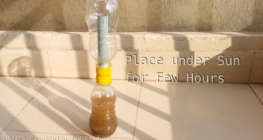
- The sun will heat the water, cause evaporation, which will travel to the top bottle, condense and collect.

• Solar Still
- Dig a pit in the sand or dirt. (can also use any shallow container)
- Place a container in the center, and fill the pit with water.
o May have to line the pit to retain water.
o In some areas this will evaporate water in the soil.
o The water should not flow into the center container
- Cover the pit with a piece of plastic. Clear is preferable.
o Seal the edges of the plastic with rocks/dirt/sand.
o Place a rock in the center of the plastic to create a dip.
- Water from the pit/soil will heat up and evaporate because of the plastic.
- It will then collect on the plastic, condense, and flow to the center, because of the rock. It will then drip into the clean container.
- This method can be adapted to filter water over a fire.
- The method is great on a beach
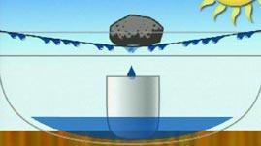
- Other filters:
- Bandana
- T-Shirt

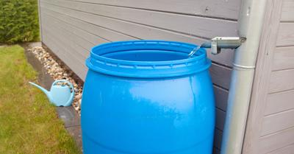
Rainwater Harvesting And Collection: How To Get Started

A rainwater harvesting system can make your home more self-sufficient with an additional water supply. Simple rain collection systems use 40 - 100 gallon barrels, while larger systems use cisterns with filtration systems to capture surface water for human water consumption. While rainwater collection may be an excellent way to save on your water bill, it actually is a much better way to consume water. Since things such as fluoride, chlorine and other chemicals are simply NOT found in rainwater. Keep in mind, a water filtration system is a highly recommended addition to ensure its safe to consume.
Harvesting rainwater is becoming a much more popular resource for self-sustaining homeowners nationwide. With the scarcity of this precious resource occurring all around the planet, many families are collecting and storing rainwater that falls around their homes. While it requires some planning and a little equipment, a home rainwater harvesting system is an excellent way to lower bills and improve the quality of a home. But how do you get started? Is collecting rainwater safe to use as drinking water? Do you need a massive storage tank to collect and filtrate the water running off your roof or just set out a barrel and let the water accumulate? This article will help answer some of the questions about how to get started harvesting and collecting rainwater.
What is Rainwater Harvesting?
Rainwater harvesting is collecting the run-off of a roof or structure and channeling it into a collection device (barrel or cistern) for use later on. Rainwater harvesting can vary from a simple barrel system designed to help or a more elaborate collection in a cistern with a dedicated filtration system. Whether for a homeowner trying to keep his vegetables healthy, or a green building being built with a rainwater storage tank to channel stormwater runoff. These harvesting systems can collect and use rainwater for indoor plumbing applications, like toilet facilities, or industrial applications. With the need to conserve water becoming more prevalent every day, it is easy to see how collecting rain is more important than ever.

What Are the Advantages Of Rainwater Harvesting?
- There are several advantages to installing a rainwater collection system.
- Lower dependence on municipal water systems
- Lower water bills
- Better for the environment
- Steady source of water for gardening, vegetables, or personal plantings
- Use for Livestock Consumption
- Human Consumption (filtration system or rolling boil for at least one minute to remove pathogens harmful to ingest).
Why Should You Not Use Rainwater for Human Consumption?
Rainwater can contain toxins, residual debris, mold, bird feces, and nasty pathogens like E-coli and other pesticides. Acid rain often occurs in areas of the country where the evaporation of residual water contains industrial chemicals that get sent down during storms and end up in groundwater supplies. While municipalities often allow rainwater collection systems to water the lawn or gardens, they may only allow use inside the home with a filtration system. (You will likely have to have an inspector certify that your system is safe should you choose to use rainwater harvesting for anything other than watering your lawn).
How Do You Get Started With Rainwater Harvesting?
Decide What Purpose The Water Will Have For Your Home
Before you begin, it is essential to have a plan for the water you intend to collect. There is a big difference between collecting water for a garden and some vegetables and using the water to cook, clean and bathe. The more extensive plans you have for the rainwater, the more involved the project will become and the greater the expense.

There are three different uses for collected rainwater.
- Simple collection for gardening/plant watering
- Domestic Home Use (non-potable)
- Domestic Home Use (human consumption - cooking, drinking, bathing, hand-washing).
Determine Cost With A Plan
With a detailed plan, you will likely have a much easier time figuring out what equipment you need to complete the task. Domestic uses for human consumption should never be installed without an adequate filtration system. (Many city municipalities have strict codes for what kinds of filters and the water quality must be produced and will require testing and inspection).
There are a couple of ways to catch rainwater for home use. An extensive rooftop rainwater-catching system can cost thousands of dollars. Most collect the run-off from roofs into cisterns that are pumped into the house through a usable filtration system.
Rural homes with well water or not connected to municipal water utilities can bury a cistern near a collection pond to collect surface run-off water. Generally, the rainwater that collects on the ground runs from the surface into a collection area (like a pond) and into a buried nearby cistern.
The groundwater can then be pumped through a filtration system or a series of filters (usually part of the pumping station) before being directed into the home. Because rain and surface groundwater can always contain toxic chemicals or pathogens harmful to humans, there needs to be an adequate ability to make the water usable for human consumption. (Remember that you need to ensure that local building codes are met).
The cost of landscaping a collection pool and burying a cistern can run up to $20,000 for the heavy equipment and labor that will need to be involved.

What Is The Difference Between Grey Water and Rainwater Collection?
There is a distinct difference between the water that is collected from rainwater harvesting systems and the water you have from bathing, washing clothes, or washing fruits and vegetables. The water considered greywater is relatively clean used water from sinks and showers, but it is unsuitable for human internal consumption.
While some complicated systems recycle grey water, it is never good to use it to water gardens or vegetables that will later be consumed unless it is run through a filtration system. Many new home construction sites employ these “grey-water” systems to conserve the demand on municipal systems and aid in the local conservation of water that may already be in scarce supply.
Rainwater collection can be used for grey-water purposes, and many building designers worldwide are exploring systems to do so.
What If I Want To Install A Simple Rain Barrel System?
If you want the easiest way to collect water, use your current roof as the way you’ll funnel the water directly into a barrel. This is by far the most commonly used catchment area. Primarily because it is already equipped with gutters and other fixtures that will guide rainwater run-off in a specific direction. To ensure you get the most water run-off, it’s recommended you designate a downspout directly beneath a steep part where water tends to accumulate. This will ensure you get as much rainwater funneled down towards a designated location as possible. If you plan on using the water for watering your garden, then you can set out a barrel under the downspout of your gutter and have the run-off water from your roof run down into it. Rain barrels are sold at almost any hardware or big-box store, and their installation is easy for the average homeowner. The whole system can be implemented for less than $100.

The following are some steps that you want to employ when creating this kind of system.
Have Screens Installed On Your Guttering
Because rainwater comes off of your roof in torrents at times, it pushes debris, dirt, mud, and leaves into your gutters. If you have ever had to clean out your home’s guttering, you know that you don’t want to have that stuff in the water you are dipping into for your vegetables.

Choose Your Containment Barrel
Most hardware stores sell rainwater collection barrels, but you should look out for a couple of things when purchasing one.
- The barrel must be large enough not to be knocked over by pets or children and large enough to hold the water.
- The color should be opaque to prevent any kind of algae growth.
- Be covered to prevent debris or kids from messing with it.
Remove A Section Of The Downspout
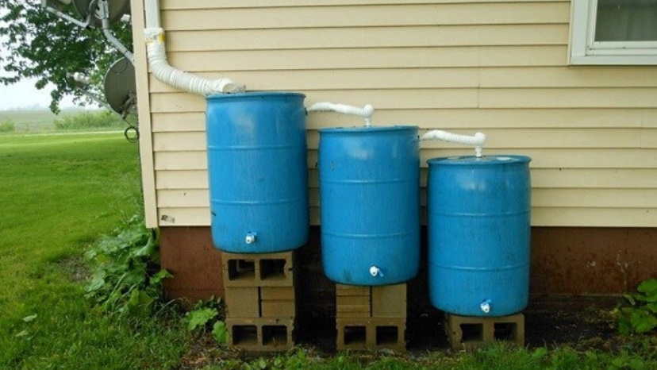
You want the downspout to funnel the run-off water into the barrel. You may have to cut a downspout section to allow the rain collection instrument to fit. You want to have a barrel that is large enough to accommodate the amount of rain your area receives. (The more average rainfall reaches your region, the larger barrel you will likely need).

Put Your Rain Barrel On Blocks
Your rain barrel should be off the ground. Rainwater is affected by gravity just like anything else. Rather than reaching all the way to the bottom to scoop out the few drops of precious water, stack the barrel up, and insert a plug in the base. (Many rain barrels come with stoppers at the bottom of the barrel to allow convenient water retrieval). A barrel that is elevated makes attaching the hose much more manageable.
Consider the Location of the Barrel Carefully
Never place the rain barrel near a structure or stairs where animals or children can climb onto the top. You want the barrel closed at the top with a lid (you can cut a hole in it to fit the downspout).
Install An Overflow Valve Near the Top
If there is no overflow valve on the barrel, you need to install one. An overflow valve should stay open and is designed to keep the water level in the barrel from overflowing and creating a mess. (Most gardeners attach a rubber hose from the open valve to a nearby flower bed to use the overflow that might occur).
How To Collect Rainwater Without Gutters Or A Roof
Catching rainwater without using gutters or from a rooftop is easier than you might imagine. You need a container or (a tarp strung up and angled toward a container also works). For larger applications, you can dig a hole in the ground, line it with polystyrene, and have it collect rainwater.
Many survivalists, outdoors people, and even planters of roof gardens know the value of rainwater harvesting. They learn that water isn’t just crucial for bringing May flowers (April showers). It can be critical for the survival of both humans and vegetables. Whether you are caught in the wilderness needing to collect rainwater to drink or just want to capture some rainwater for your flower beds, a sound rainwater harvesting system is vital. While collecting rainwater may make the difference between life and death, most of the time, it’s just a way to save money by giving gardeners a natural way to help the environment. So, what should you do when you don’t have a rooftop or gutters to help with your rainwater collection system? This article will explore some of the rainwater catchment techniques both survivalists and rain garden purists use to collect rainwater.
‍What Do I Need To Collect Rainwater?
There are three things you need to gather rainwater. First, you will need a rainwater surface area. Second, you need a means of transferring the water you collect into a diverter pipe (system) and toward a container. Finally, you need a place to store rainwater. Think of the three C’s. (Collection, Conveyance, and Container).
How To Collect Rainwater For Survival?
Here are several ways to devise a system to harvest rainwater outdoors when you do not have a roof or gutters to provide runoff or channel it into a storage container.
Use A Tarp System
Depending on where you find yourself (i.e., in a forest), choose a site near your camp where you can tie the tarp to a couple of trees or limbs (assuming you have rope, twine, or shoelaces). If you don’t, find a couple of young saplings that you can plant firmly into the ground and prop up the corners of the tarp).
You want to position the tarp to angle toward the container (pot, barrel, bucket, or whatever you decide to use as a final storage container). A canvas tarp is very porous, and water drips through the fabric. Polyethylene or nylon tarps are designed to be water-resistant, so you will need to angle the water flow toward the container or poke a hole in the center of the tarp for the water to flow from the tarp into the container.
An example of this method might be to follow the procedure that many UN refugee camps use. Refugees stick four posts made from tree branches into the ground in a space equal to the size of the tarp. They hang the tarp’s corners on each stick securely as if they were building a sun shelter. The rainwater funnels to the center of the tarp, dripping through the canvas to waiting containers below. (If you don’t prop up the center, but only the corners, the weight of the tarp should angle toward the center).
Another example of the tarp method is to attach a tarp to two parallel tree trunks at a higher level and then stake or tie the front of the tarp lower towards two other posts or trees. You want to be sure that you angle the tarp downward and leave enough slack for the bottom area to form a collection site or tie the tarp in such a way that it forms a V shape opening. The rainwater will run from the wide end of the tarp to the narrow end and into a container.
If you do not have a tarp, you could use a trash bag, a poncho, or another item, to capture rainwater. (You might have to put a small rock in the center to form a bowl for water collection). Many survivalists keep a sheet of polyethylene when camping outdoors.
Use A Bucket System
Depending on what is available, you can use a bucket or a basin for rainwater collection. Look for a way to form the ground or terrain to funnel more water into the bucket container to capture more water. (One survivalist suggests finding a large palm leaf or piece of wood from a hollowed-out tree that can be propped over the bucket’s edge and angled toward the container for water flow. You can also place a series of rocks on either side of a carved-out place in a hill to act like drainage pipes).
Use A Rock System
Water follows the laws of gravity just like the rest of the world. If you are near a rock cropping or seeking shelter in a cave, chances are that heavy rain will force the groundwater falling from above the cave entrance or outcropping to run off the rocks and down to where you can access it. Place your container where it can collect surface runoff and prop it up so that the rush of water won’t knock it over. Find a natural water channel that can be used as a conveyance system.
Use An Upside-Down Umbrella
If you are camping, you might not have an umbrella, but it can be used to collect water for a drip conveyance system. Open the umbrella and hang it upside down from a low-hanging tree limb or the corner of your tent to act as a rainwater catcher. The inverted bowl will collect water and will likely drip from the center (you can poke a small hole toward the center, but chances are you won’t need to do so). Let the water drip into a bucket, basin, or bowl.

A Word Of Caution
Most surface water contains bacteria, viruses, and other nasty contaminants. Survivalists will be the first to tell you to treat water before consuming it. Chlorine dioxide tablets are some of the most effective treatments for making surface water safe for human consumption.
If you don’t have tablets, a tiny amount of chlorine bleach (four drops for each liter) or boiling the water in a running boil for at least a minute will kill the bacteria. This method is the best way to kill anything harmful inside your stomach. (Hopefully, you have enough water accumulated to boil it).
How To Collect Rainwater When Not In the Wilderness
Assuming that you are not in the middle of the wilderness but just want to collect rainwater for watering a few vegetables in your roof garden, you can use almost anything to catch rainwater. Again, design a system with the three basic things every rainwater collection system needs; a collector, some way to convey the water from one point to a collection site.
Use Rain Barrels
Many hardware stores and big-box home improvement stores carry rain barrels that can be used to collect rainwater. Set them in the middle of your yard where there isn’t much tree cover, and let it go. Most rain barrels hold 40 - 100 gallons and won’t cost you too much.
Use A Child’s Swim Pool
Here is a wonderful use for the kiddie pool your kid swan in at once. Most kiddie pools die an ugly death rotting in the corner of a backyard. Put them to work to gather water. (I had a friend who drilled a small hole in one side of the pool and another on the opposite lip. He hung the pool up, angled it down, put a rain barrel underneath the hole, and collected enough water to use in his garden).
Use A Rainwater Catch Pond
Some homeowners build a rain pond for harvesting rainwater in a collection area. You can dig a hole in the ground, line it with plastic and then install a drainage pipe or storm drains to channel other surface runoff into the catchment area. The collected water sits until needed for watering fields or other needs. Most municipalities have ordinances about the creation of rain ponds. They can also be susceptible to evaporation or stagnate from too much exposure to direct sunlight. In addition, soil erosion is a problem for rain ponds.
A Word Of Caution
Standing rainwater can grow into stagnant water if it sits in a catchment area for any time. Do not allow rainwater to sit in a rain barrel or collection point so long that it becomes filled with algae or debris. In addition, if you live with mosquitos, the West Nile Virus is a real health hazard and can be deadly, so use the rainwater as it is collected.

Frequently Asked Questions
How To Filter Rainwater for Drinking?​
As you read above, the first line of defense from outside contaminants such as leaves, dirt, bird droppings, dust, rocks, bugs, and among other things, is to have a mesh net installed inside the gutter. From there you’ll have a first flush system to further get rid of unwanted materials, and then have the water make its way down towards the water tank.
From the water tank you can run the water through a fine mesh filter, and then through a cartridge-style filter which will further remove contaminants. If you’d like to further filter the water, you can even use an Ultra Violet Light filter which will further kill any pathogens found in the water.
How To Collect Rainwater WITHOUT Gutters?​
This can be done one of three ways, you can either create a giant rain-saucer which funnels water directly into the a rain barrel, you can use a rain catching tarp which is even more effective, OR you can build a separate roof which will be created specifically for funneling water into a rain barrel. The latter being the most time consuming and expensive method.
Is Rainwater Safe To Drink From The Sky?​
Yes absolutely, it is as safe as your tap water or bottled water (which is often filtered tap water). The difference between rainwater and water you’ll find from the tap… is that rain has no added chemicals by nature.
What Are The Main Benefits of Harvesting Rainwater?​
If you filter your rain water, you can drink it and if you don’t, you can use it for essentially anything you can put your mind to which doesn’t involve human consumption. From washing your car, cleaning your house, washing your pets, and to watering your garden. The options are limitless really, after all its water directly from the sky!

Can I Store Rainwater Underground?​
Yes, you absolutely can. This is often done by those who have a big water container (1,000 gallons+), this requires either a small tractor to DIG or a shovel with a few hours of dedication.
How Long Can Rainwater Be Stored?​
Rainwater does not have a set shelf life, as long as it is away from sunlight… it is likely to be fresh to drink or at least use for other purposes. Remember, microorganisms and algae can grow in water that is exposed to sun light. Properly keeping an eye on your stored water will ensure you have nothing harmful growing.
What Is The Formula For How Much Rainwater I Will Collect?​
Alright, here’s the formula for how much rainwater you’ll actually collect from your roof. We are going to measure the roof in square feet (sq.ft).
Lets say the average area size of a roof is around 1,500 square feet and you receive 25″ inches of rainfall every year, that means your roof will collect 23,362.5 gallons of rainwater. That is about 1,946.87 gallons per month to use or about 64.8 gallons of daily water to use.
Formula: inches of rain X square feet of roof area = gallons harvested
Example Given: 25″ inches of rain X 1,500 sq.ft = 23,362.5 gallons harvested

Sources:
www.buildastash.com article by Mark Walker
www.simplyoffgrid.com

Emergency Fires starting and maintenance

1. How to Make Tinder for a Fire
Whether you're stranded in the woods in the middle of the night in desperate need of heat, or simply trying to impress your friends with your top-notch scouting skills, finding and making dry tinder to start your fire can be tricky. The key to making your own tinder is finding small bits of easily combustible, dry material that can be nurtured into a larger flame or can transfer heat to a burning coal.
• Finding Dry Tinder in Nature
Use tree bark. The type of tree will vary depending on your location. The most important characteristic of the bark is that it is dry. Break off the inner bark and shred or break it into small strips or chips, depending on the strength of the wood.
- Do not strip bark unless necessary. Cutting bark can damage or kill trees. Ideally, pick bark that is on dead trees, on the ground, or the like. Peeling bark off trees should only be done in an actual emergency.
• Different barks burn differently. As natural materials, they also will burn differently depending on your environment, the season, and your weather conditions.
• Choose cedar, if possible. You can spot a cedar tree by its reddish-brown fibrous bark that is easy to shred with your hands.
• Cut off a chunk of cottonwood bark with whatever sharp tool you have and whittle away the outer bark until you can see the cord-like strands on the inside. Cottonwood bark has a soft characteristic that can, like cedar bark, be stripped into small pieces.[1]
Search near bodies of slow-moving water for cattails, sometimes called bull rushes. Cattails are common throughout Europe and America and are abundant around swamps and ponds.[2]
• You want to use the bushy, cotton-like material on the top of the stem which flourishes in the fall as the plant goes to seed. Simply snap it off and ignite.
• In mid to late summer, cattails bloom into a brown sausage-shaped substance on the top of the cattail. This part of the plant works for tinder as well. Snap it off and break or cut it open to get to the driest material possible.

Locate trees with patches of tinder fungus, a specific growth that works excellently as tinder. Cut off a large piece and break it into smaller chunks if it is sufficiently dry.
• Tinder fungus predominantly grows on birch trees, which can be identified by their white bark, and has the appearance of a chunk of burnt or blackened crusty bark.
• If the material is wet, you can slowly air-dry the fungus over time for later use.[3]
Whittle bamboo reeds into thin shavings.
• Holding a knife at a right angle with the blade pointing away from your body, run the blade back and forth to create small shavings. Your shavings should look similar to sawdust.
Gather other plant materials in nature. In a pinch, almost any dry plant material can be used as tinder. This includes dry grass, leaves, sticks, dry pine needles, cotton fabric, or natural twine or rope. These may not be the easiest materials to ignite, but they will kindle a fire in desperate situations.
• Using Man Made Material
Make char cloth squares using pieces of cotton fabric. This material is an invaluable resource to take with you when you venture into the outdoors.[4]
• Place several small squares (about one square inch in size) of cotton fabric into an airtight container that can withstand heat, such as a metal water bottle.
• Set the container atop an already flaming fire for about five minutes.
• Remove the container from the fire using tongs and allow to cool.
• Open the container and observe the squares. They should be blackened in color.
Purchase steel wool from a supermarket or hardware store. The steel wool you use to scour your pots can be excellent tinder and all you have to do is light it.
Collect dryer lint from the screen in your clothes dryer. Finally, that annoying lint that you have to clean out of your dryer every time you put in a new load has a use! Simply collect enough lint to form it into a long rod-shaped mold and ignite.[5]
Soak cotton balls in petroleum jelly and store them in an airtight container. The petroleum grease ignites extremely easily.[6]

Tear up whatever paper products are available to you into long shreds. A rolled-up newspaper, the cover of a paperback novel, or whatever paper material is available to you will help get a fire started. While you wouldn't want to turn your map into tinder, any spare paper can work to ignite a fire, though it requires more patience than some of the other methods.
If you are trapped in the wild, that would count as an emergency. In that case, youmay want to signal for help by flashing a mirror, building a smoke signal by burning green wood or leaves, and yelling for help when you hear passersby. If you have to build a fire to keep yourself warm, you should do that. Also, insulate yourself from the ground while sleeping by placing pine needles or other material beneath you while sleeping, because you lose more body heat from the cold ground than from the cold air.
• Tips
• Choose freezer grade ziplock bags--they are thicker than sandwich ziplock bags and are more effective at keeping water out than regular Ziplock baggies.
• Once you ignite your tinder using waterproof matches or a lighter, make sure to kindle the flame by blowing steadily on the material until it glows bright red and becomes a coal. This allows you to sustain heat and transfer the glowing coal into a burning flame when added to larger logs of wood.
• Fluff or shred materials. This will make it easier for the flame to get access to the most areas of combustible material.
• Stock up on other easy to find tinder storage containers such as aluminum water bottles, old cough-drop boxes, small snack-sized food storage containers and travel toothbrush containers.
• Cotton wool covered in petroleum jelly also works well.
• Keep your tinder dry. Good tinder can save your life in the wilderness, especially in wet weather. When you have a good supply of tinder, secure it in a waterproof container, such as a small container found at most outdoor supply stores. Ziplock bags are not waterproof!
• Practice using your homemade tinder, so you don't waste your one shot in the wild.
• Fluff from a tumble dryer works as great tinder.
• Warnings
• Make sure to put out your fire properly when you are finished with it by smothering it with sand or water.
• Whenever dealing with fire, be sure to use caution to prevent accident or injury.
• Always tend fires responsibly, and as prescribed by authorities, on all public lands.
• Make sure you are legally allowed to start a fire in the wilderness. Certain conditions may warrant a fire ban.
2. How to start a fire:
• Recommendations
- Pack some type of fire starter pellets for emergencies.
- Prepare other fire starters.
o Cotton Balls with Vaseline (or Chapstick)
o Charcloth Tinder (Burned fabric in a tin)
o Cell Phone Battery (Li-ion Battery)
o Magnesium Fire Starter
o Road flare
o Steel wool and car battery or other small battery
• Methods
o Bow and drill (difficult, only use as a last resource)
▪ Make a bow, Tie a paracord around a branch to make a bow.
▪ Make a drill/spindle. Make the contact end rough!!!
▪ Get a baseboard, and make a hole with a V-shaped notch from the center out. This will catch the hot embers.
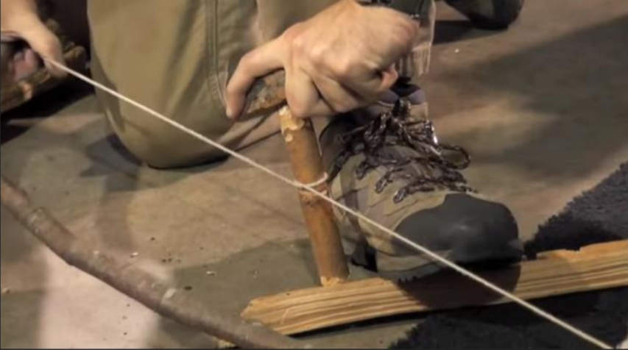
▪ You can add steel wool
under the baseboard
to quicken this up.
▪ Wrap string on the bow
around the drill, spindle.
▪ Recommend using a
rock to apply pressure
on top of the drill.

• Steel wool and battery
- Prepare a tinder ball and fire Teepee
- Remove a small strip of steel wool (fine)
- Connect to both terminals of the battery.
- A fire should be ensured. Immediately place into tinder.
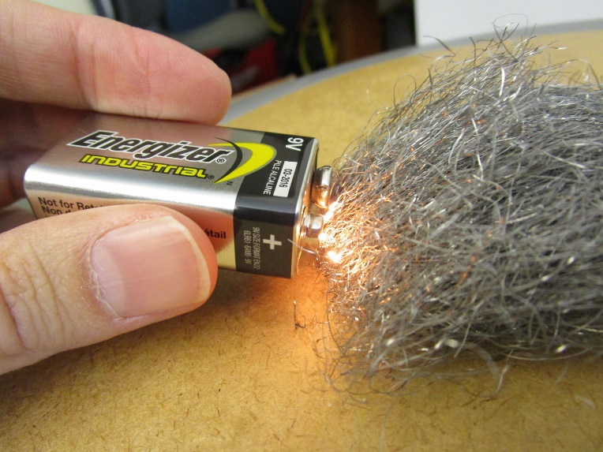
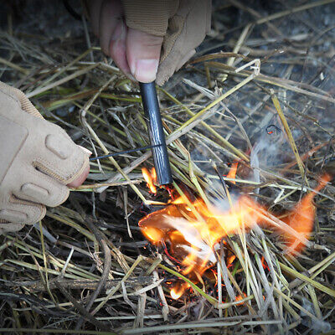
• Using a Flint and magnesium starter
- Make a small ball of fine tinder
- Scrape magnesium shavings into tinder
- Use flint to drive a spark onto shavings.
- The tinder should light. Immediately
place into fire Teepee.

• Cell Phone Battery (Li-ion Battery)
- Dangerous, use only in a dire emergency.
- Cover nose and mouth as fumes are toxic
- Remove battery from phone.
- Use a knife or other metal strip to short the terminals.
- If dead, place in kindling and use a knife to pierce the battery. It will start a fire.
• References
1. http://www.wildwoodsurvival.com/survival/fire/tinder/findingdrytinder.html
2. https://www.outdoorlife.com/blogs/survivalist/survival-skills-5-survival-uses-cattail-fluff/
3. http://wildwoodsurvival.com/survival/fire/tinder/tinderfungus/true.html
4. https://www.outdoorlife.com/blogs/survivalist/survival-skills-5-survival-uses-cattail-fluff/
5. https://glampingorcamping.com/home/9-sure-fire-campfire-tinder-hacks-includes-dryer-lint-hack/#Dryer-Lint-Campfire-Tinder-Hack
6. https://glampingorcamping.com/home/9-sure-fire-campfire-tinder-hacks-includes-dryer-lint-hack/#Dryer-Lint-Campfire-Tinder-Hack

Building a temporary shelter

Shelter is one of the most important things that you need in any survival scenario. Without shelter, you are not safe, your family is not safe, and your stuff is not safe, either. So in any sort of situation, you would have to have some idea on building a temporary survival shelter to last you through the night, or at least a few weeks.
Your survival could depend on what sort of shelter you build. Here are a few essential tips for building a survival shelter.
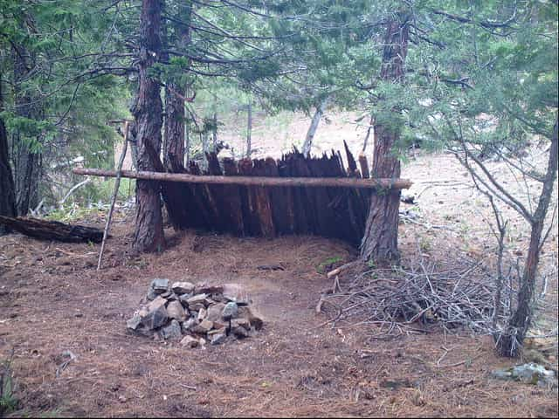
- Use fallen or hollow trees as a place to sleep.
- Find an area of dense tree cover to provide an instant canopy of thick leaves and branches.
- Get inside a shallow cave or under a rock overhang to stay out of the wind and rain.
- Use boulders or large logs to break the wind or as a “wall” to build a shelter.
- Use debris from the ground such as dirt, leaves, and twigs, to create a mound and use larger sticks to frame it.
- Clear a hole just big enough to crawl into and cover the opening to block air flow and limit the open space.

- Choose a material that would be good for the environment that you are in.
- Use a suitable shelter design. Remember it dosen’t need to look good as long as it does the job.
- Take advantage of the surroundings.
- The some obvious options are:
  - Tents
  - Poncho
  - Tarps
  - Living in a vehicle
  - Lean-to shelter
  - Caves
  - Rock formations (if sturdy)
  - Dug-out shelters (similar to tarp idea, but with more shovel work)
  - Shipping containers
  - Trains
  - Cardboard (if abundant)
- Stock your shelter.

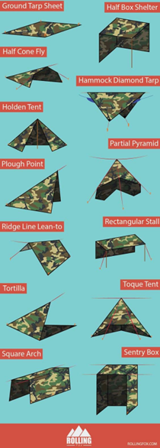
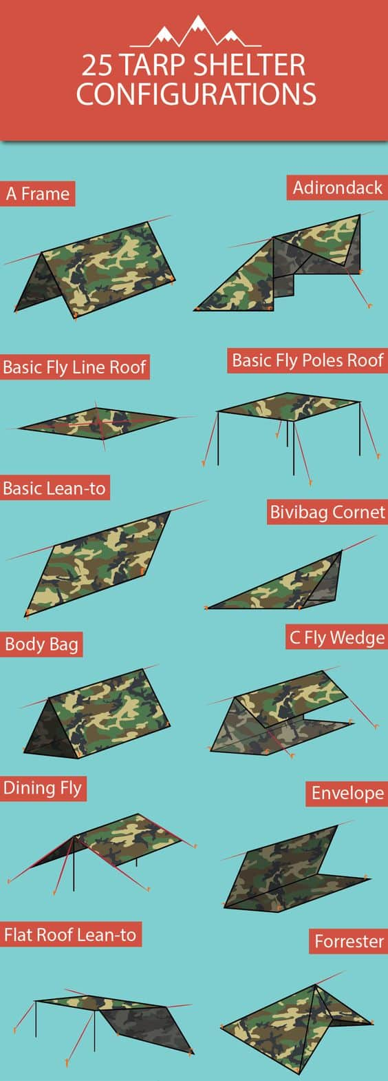
Sources:
- The Hidden Dominion: www.hiddendominion.com

How to Defend Yourself Without a Weapon

The goal of any combative situation is to get away safely. If you don’t need to stay and fight, then don’t stay. Run away. Some might criticize this as the “coward’s way out,” but a strategic retreat is a sensible move. If an attacker has a weapon and you do not, then get away as fast as possible.If you do not have the chance to get away, here are some additional methods to help you fight back.
- GET LOUD
  - When you know that escape isn’t possible, it’s time to sound an alarm. Get as loud as possible. Yell at the attacker to “Back off!” Push them away from you to create some space, if possible. Then get away if you can.
- HIT THE VULNERABLE PARTS
  - If an attacker continues to press forward, then you must target a sensitive part of the body. The eyes, throat, and groin are your best options. The ears, nose, and knees are secondary vulnerabilities that can give you some leverage as well.
  - The best way to defend yourself without a weapon is to strike sensitive areas with repetition, and preferably multiple points. For example, you could kick an attacker in the groin and then grab their head, raise your knee, and strike them in the face.
- MAXIMIZE YOUR DAMAGE
  - Never strike with a closed fist. This can cause your bones to break and put you at a disadvantage.
  - Use the hardest points on your body instead. Strike with your elbows, knees, or even the top of your forehead. This will help you to maximize the damage you can create.
  - Use your weight to your advantage as well. Even if you are small-statured, adding force through your body weight can help to create more damage with each strike.
  - Added weight can also create separation, which can help you to get away.
- KNOW THE WEAK POINT
  - Many attackers will grab you around the arm or the neck, especially if they do not have a weapon either. Even though this can be a scary experience, it gives you a definite advantage. This is because every grip has a weak point.
  - Look for where the attacker’s fingers come together. This is where you can escape.
  - Rotate your arm or leg so that the point of your bones is parallel to the weak point in their grip. Then use force to pull away. Grab your other arm if necessary to give yourself enough force to escape.
  - For a two-handed grip, twist your arms so that the attacker gets pulled closer to you. Then, as you escape, kick the attacker in the groin. Follow with a knee to the face, if possible.
  - If an attacker gets you around the neck from the front, then lift your hands. This naturally breaks the hold. Then twist out of it and get away fast.

  - If the hold is from behind, tuck your chin into the attacker’s elbow. This will give you some room to breathe, even if the attacker is stronger than you. Then pull down on the attacker’s wrist, pull up on their elbow, and drop to the ground quickly to get free.
  - You can defend yourself without a weapon, but having self-defense tools within reach will increase the chance that you can get away. Whether you carry pepper spray with you or you use another option, make sure that you stay safe out there today.
Sources:
- Self Defense Guide: www.selfdefenseguide.org

9 Ways To Defend Yourself Without A Gun


- Knife
  - This is probably the first weapon besides a gun that comes to mind. The knife, whether it be a small pocketknife or a larger, fixed-bladed one, is a very commonplace tool because almost everybody has at least one or two of them. While larger knives can draw attention to you, there are plenty of smaller knives that can be easily concealed on your person. I recommend a folding knife with a serrated blade that can be opened and closed quickly.
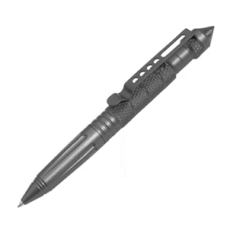
- Tactical pen
  - While it’s true that any pen can technically be used as a stabbing weapon, tactical pens are better for this purpose. Tactical pens differ from regular pens in that they are constructed out of a very durable metal and the end of the pen has a sharp edge that can be used for protection.
- Pepper or wasp spray
  - Both pepper and wasp spray are non-lethal weapons that serve as effective deterrents because they inflict significant irritation to the mouth and eyes.
  - While the active ingredients don’t typically lose their sting and can be stored for a long time, keep in mind they don’t perform well in all conditions, such as rainy weather. Flashlight

- CO2 pressurized projector
  - less-lethal pistols are highly powerful self-defense weapons that are powered by compressed air (CO2)
  - Can project rubber balls or pepper balls.
- A durable flashlight
  - will hit hard and give you lots of reach, allowing you to fend off assailants with something that has the “punch” of a baseball bat.
- Stun gun

  - A stun gun is going to do just as the name suggests and buy you some time to get away to safety. While they are often designed to look like traditional guns, many models are designed to not look like weapons and can be carried discreetly, without drawing attention to yourself. They also work in the rain whereas pepper or wasp spray do not. Of course, they aren’t legal in all states.
- Keychain knuckles
  - Keychain knuckles are easily the most effective self-defense weapon that can be attached to your keychain. They have sharp edges and are constructed out of a virtually unbreakable plastic. In addition, they are very lightweight and deliver a brutal punch.
- Belt
  - The belt is one of the most common items, and it can be used just as well for self-defense as it can for holding up your pants, but only if you have the right kind of belt and know what you’re doing. The metal buckle not only delivers damage to an opponent, but can keep him or her at bay if you’ve wrapped the other end around your fist.
- Umbrella
  - Just as there are certain pens that are built for self-defense, there also are umbrellas that are built for the same reason. The difference between self-defense umbrellas and regular ones is that the former are constructed out of a fiberglass material that is both lightweight and offers the same hardness as steel.
- Rock
  - If you have literally nothing else to use as a self-defense weapon, look for a rock. You can pick up a rock with a sharp edge to use as a knife-like weapon, or a rounded one to use as a club in your hand.
Resource:
- Off The Grid News: www.offthegridnews.com
- Byrna: www.byrna.com
- Self Defense Products: www.selfdefenseproducts.com

How to Use a Compass

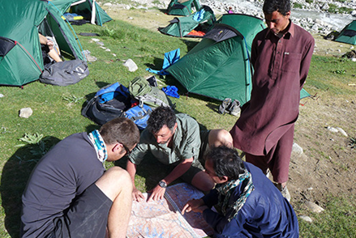
- Get to Know the Parts of a Compass: 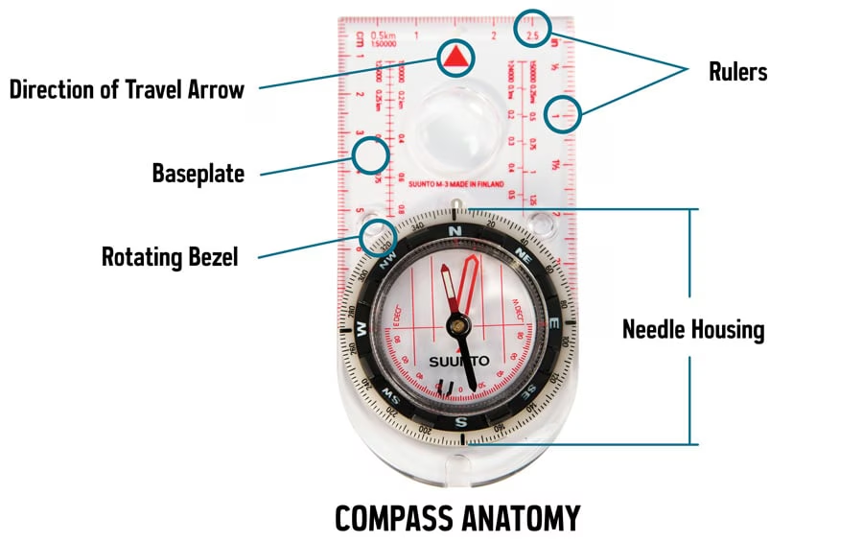
  - Baseplate:
    - Clear, so you can see the map below it, it has at least one straight edge for taking bearings and transferring them to your map.
  - Ruler(s):
    - Used with your map’s scale to determine distances.
  - Direction-of-travel arrow:
    - Tells you which direction to point the compass when you’re taking or following a bearing.
  - Rotating bezel:
    - Also called the “azimuth ring,” this outer circle has 360 degree markings.
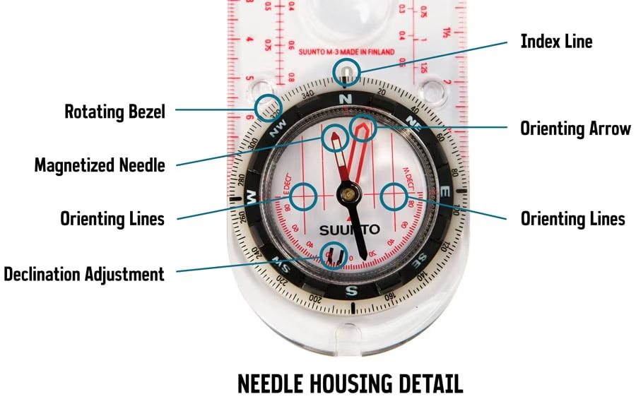
  - Index line:
    - Located directly above the bezel, it’s also called a “read bearing here” mark.
  - Magnetized needle:
    - The end that always points to the magnetic pole is usually colored red or white.
  - Orienting arrow:
    - Used to orient the bezel, it has an outline shaped to exactly fit the magnetized end of the needle.
  - Orienting lines: Parallel lines that rotate with the bezel; correctly aligning these with the north-south lines on a map aligns your orienting arrow with north.

- Adjust Declination
North on a map is easy to find (it’s at the top). In most locations in the real world, though, magnetic north (where your needle points) and true north differ by a few degrees: That difference is known as “declination.”
In the continental U.S., declinations vary from 20 degrees east in parts of Washington state to 20 degrees west in parts of Maine. Because a single degree of error can set you off course by 100 feet over a mile, it’s important to accurately adjust for declination.

Before you can adjust for it, you have to find the declination value in your trip area. Topo maps list it, but the value varies over time. So check the map’s revision date or, better yet, consult the National Oceanic and Atmospheric Administration (NOAA) magnetic declination.
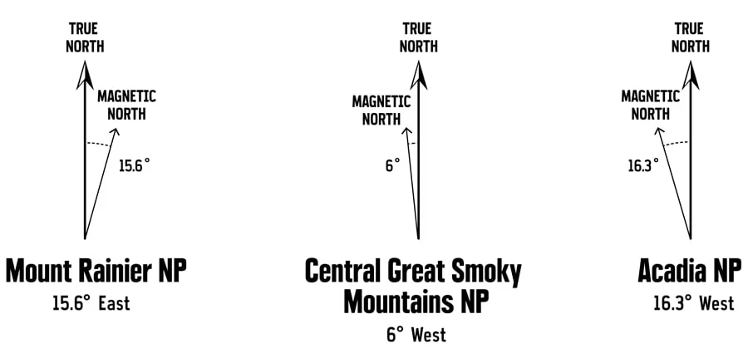
The way you adjust for declination varies with different compass brands (some use a small tool) and you'll need to follow the provided instructions. Once the declination is set for a trip, you don’t have to think about it again until you travel to a faraway place.

- Orient Your Map
Map reading—correlating what you see on paper to what you see around you—is a foundational skill that you should practice early and often. Before you can do that, though, you have to have your map oriented correctly.
Once you’ve set your declination, map orientation is simple:
- Place your compass on the map with the direction of travel arrow pointing toward the top of the map.
- Rotate the bezel so that N (north) is lined up with the direction of travel arrow.
- Slide the baseplate until one of its straight edges aligns with either the left or right edge of your map. (The direction of travel arrow should still be pointing toward the top of the map.)
- Then, while holding both map and compass steady, rotate your body until the end of the magnetic needle is within the outline of the orienting arrow.
Now you have the map oriented correctly and can identify nearby landmarks on it. Take time to become familiar with your map and surroundings before you head off. And keep reading your map along the way: Staying found is far easier than finding yourself after you’re lost.
- Take a bearing
A “bearing” is simply a navigationally precise way to describe a direction. For example, instead of heading “northwest” to get to a campsite, you might follow a bearing of 315 degrees.
Bearings are always relative to a specific location. Following the same bearing from two different places will not get you to the same destination.

You can use a bearing to get to a location any time you know where you are on a map:
- Set your compass on the map so that the straight side of the baseplate lines up between your current position (1a) and the map location for a destination like a campsite (1b).
- Make sure the direction of travel arrow is pointing in the general direction of that campsite (in other words, it's not upside down).
- Now rotate the bezel until the orienting lines on the compass are aligned with the north-south grid lines and/or the left and right edges of your map. (Be sure the north marker on the bezel is pointing north on the map, not south.)
- Look at the index line to read the bearing you’ve just captured.

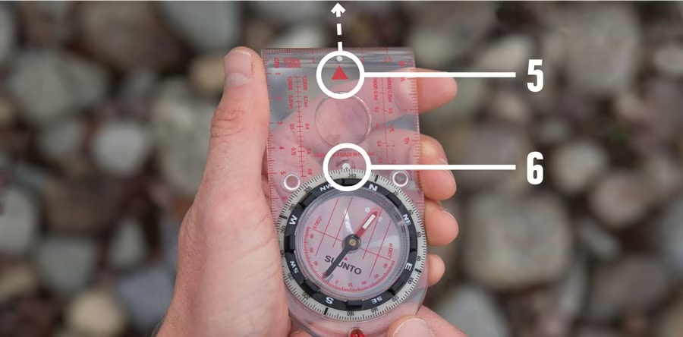
Now you can use the compass to follow that bearing to your destination:
- Hold the compass with the direction of travel arrow pointing away from you.
- Rotate your body until the magnetized needle is inside the orienting arrow. The direction of travel arrow is now facing the bearing you captured and you can follow it to your destination.

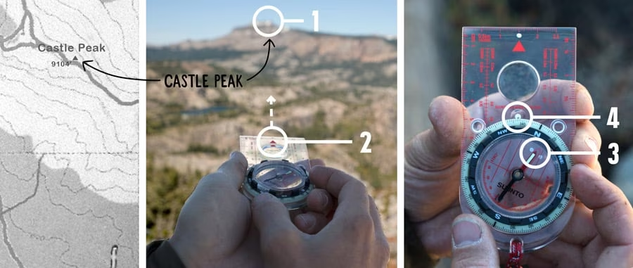
You can also use a bearing to find where you are on a map. You might want to know exactly where you are along a trail.
- Start by finding a landmark that you can also identify on your map.
- Hold your compass flat with the direction of travel arrow pointing away from you and directly at the landmark.
- Now rotate the bezel until the magnetized needle is inside the orienting arrow.
- Look at the index line to read the bearing you’ve just captured.


Now you can transfer that bearing to your map to find your location:
5. Lay your compass on the map and align one corner of the straight edge with the landmark.
6. Making sure that the direction of travel arrow remains pointed in the general direction of the landmark (6a), rotate the entire baseplate until the orienting lines are running north/south (6b) and the north marker on the bezel is pointing to north on the map (6c).
7. Now you can draw a line on the map along the straight edge of your compass (7a). The point where that line from the landmark crosses your trail is your location (7b).


You can also use multiple bearings to find where you are on a map. If you aren’t on a linear feature like a trail, you can still find where you are on a map. Called “triangulation,” this process simply requires you to follow these same steps with a second and a third landmark, preferably ones that are at least 60 degrees away from your first landmark (and each other).
If the lines you draw meet at a single point, that's your location. Most of the time, though, the three lines will form a small triangle—your location will be somewhere in or near that small area. If the lines form a very large triangle, recheck your work because you have at least one significant error.

Resources:
Caltopo: www.caltopo.com (https://caltopo.com/map.html#ll=40.20825,-86.99524&z=7&b=mbt)
REI co-op: www.rei.com

Proper Identification of Wild Edibles

What is foraging?
What do we mean by “foraging?” We define foraging as the harvesting of uncultivated foods that grow spontaneously in the wild. “Wild” might be the edge of your property, a nearby park, or a vast wilderness area.
Foraging for wild food is a great way to experience the natural world and connect with something ancient and primal within ourselves. And in many ways, it can be a healthier alternative to the assembly line foods we find at the grocery store. Not only is wild food much richer in essential vitamins and minerals, but foraging also provides much needed exercise. It's a combination of hiking and gardening. Before diving into the salad bowl that surrounds us, it's a good idea to be aware of some basic guidelines that will ensure that foraging remains safe and sustainable.
Never eat anything you’re not 100% certain you’ve correctly ID’d AND you’re not 100% certain is edible.
There are a lot of great guides out there now, but there are a couple of books that I recommend for getting started:
Identifying and Harvesting Edible and Medicinal Plants in Wild (and Not So Wild) Places by Steve Brill
Sam Thayer's Field Guide to Edible Wild Plants: of Eastern and Central North America
Learn the few dangerous species in your area before venturing into the wild to forage. If you know what poisonous plants you may encounter, you'll feel more comfortable foraging for the edible species.
Don't always rely on common names. Common names can refer to several different plants. Some wild edible plants share the same common names as poisonous plants. Latin names are more reliable. For example, if someone offers you hemlock tea, before drinking, you might ask whether it's infused with Conium maculatum (Poison Hemlock) or with the tender tips of Tsuga canadensis (Eastern Hemlock tree). Latin was chosen to classify plants and animals because it's a dead language, so we can't expect it to evolve or change, whereas common names vary and fluctuate.
Use all of your senses. Don't limit yourself to visual ID alone. Lots of wild edible plants have look-alikes. Learn how to differentiate similar plants by smell, feel, texture, etc. It's not a rule, but in many cases, poisonous plants are unpalatable and rank smelling. That said, taste should only be used if you're absolutely sure the plant is not poisonous. Some plants, such as water hemlock, are deadly in very small doses.
Learn habitat. You won't find cattails on a high slope, and you won't find ramps in a swamp.
Learn companion plants. Many plants are commonly found growing nearby certain other species. If you see yellow dock, there's a good chance pokeweed will be close by.
Learn to follow wild edible plants through all seasons. This is important for two reasons. First is positive identification. When I was learning to forage, I misidentified the poisonous white snakeroot as wood nettle. I put the leaves in soup for a few months. Fortunately I only added it in small quantities and no one got sick. When it bloomed in July, it became clear to me that I had made a mistake. There are admittedly other subtleties of differentiation that I should have noticed, but the flowers were a dead giveaway.
Another reason to follow wild edible plants through the seasons is to locate perennial plants that you want to harvest in early spring. For example, by the time pokeweed becomes identifiable, it's often past the point of use. If you make note of it during the warmer months, you'll know where to find it when it first appears in spring.
Learn which parts of a wild edible plant are safe to use. Just because a wild plant is considered edible doesn't mean all parts are edible. For instance, while ripe cooked elderberries are safe to eat, the bark, stems and roots are considered poisonous. It's also important to note that some plants are only edible at certain times of the year. For example, stinging nettle shouldn't be used after it goes to seed.
Keep a foraging journal. This is really important for developing a sense of what is available in your area when. Through months and years of recording your foraging finds, you'll gradually compile a calendar that tells you what's on the horizon for harvesting. This will also help you plan a menu schedule ahead of time.
Don't over harvest. Every population is limited. Even where wild edible plants occur in large numbers, the colony should be respected. Try to collect no more than 10% (or less depending on how much foraging pressure the area receives). And of course never collect any more than you will actually use.
Only collect the part of the plant that you plan to use. If you're going to make file powder from sassafras leaves, there's no need to uproot the sapling. Just take what you need and leave enough to ensure that the plant will continue to thrive. A good rule of thumb is to harvest no more than 25% of a plant if you don't need the whole plant.
Consider cultivating wild edible plants in your garden. Many wild plants that are edible are easy to transplant and propagate. Ramps, for instance, are getting scarcer due to over harvest, but can be cultivated given the right conditions. Take the time to research growing conditions of rare plants in your area. There is a great resurgence of interest in foraging wild edible and medicinal plants. That coupled with diminishing habitat puts tremendous pressure on wild plant populations. This puts the responsibility of preservation on us.
Avoid toxic areas. Never forage for wild edible plants near busy roads. Most plants absorb lead and other heavy metals from toxic exhaust. And these toxins tend to settle in the soil even if the traffic no longer exists. Also avoid areas that are or have been sprayed with pesticides.
Know what part of the plant is safe in what season. This was listed above, but it merits mentioning again.
When foraging wild water plants, know the water source. This is especially important if you're planning to eat the wild edible raw. Eating plants that have grown in contaminated water is the same as drinking contaminated water. Chemical and heavy metal pollution are also concerns that can't be removed by cooking.
Only forage plants that appear to be healthy. Plants can be afflicted by disease, fungi, pests or pollution. Harvesting healthy plants minimizes the risk of illness and also means you're getting more nutritious food.
Start with edibles that are easy to identify and easy to find. If you're interested in fungi, try looking for chanterelle mushrooms. Given the right season and condition, they're abundant and easy to differentiate from non-edible lookalikes.

For easy-to-find wild edible plants, a great place to look is your yard! Here are a few that are common in areas like lawns, parks and other suburban habitats where weeds thrive: Common dandelions have long been eaten as a nutritious weed and are often cultivated as a commercially available vegetable. Harvest the younger leaves and eat them raw or cooked. All parts of the dandelion are edible: leaves, flowers, and roots.
Leaves – Dandelion is a nutritional powerhouse, but many people object to its bitter-flavored leaves. For best taste, pick the leaves when the plant is still young and before it begins producing flowers. Rather than eating an entire dish of dandelion leaves, use them as an accent. For instance, add them to a soup. Or use the leaves in a mixed green salad with a honey-vinaigrette dressing. Flowers – Dandelion flowers are used to make wines and jellies. Roots – Dandelion roots are typically used to make a tea, due to its medicinal benefits.
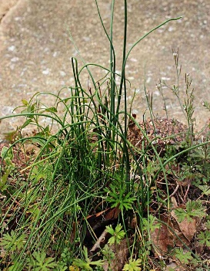

Wild onion and wild garlic look very similar and can be used interchangeably the same way you would use store-bought green onions or scallions. Look for them in clumps throughout lawns, standing taller than the other weeds and grass. Make sure it smells and tastes oniony, as there are toxic lookalikes
Chickweed is a great introduction to wild foods because it's so tasty and nutritious. Look for it in cooler seasons in nitrogen-rich soils like gardens.
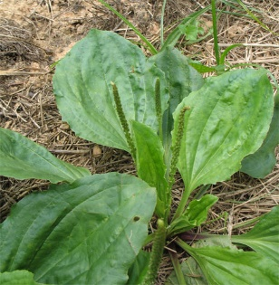

Hairy bittercress is also a delicious cooler weather wild edible that is commonly found in disburbed areas like lawns.
Plantain (or its Latin name Plantago) is not as tasty as some of the other yard weeds, but it's so plentiful, nutritious, and easy to identify, it's worth a forage! Look for the younger, more tender leaves.
It's better as a cooked green than raw and makes a decent spinach substitute, as well as a healthful tea. The seed husks, commonly known as "psyllium husks," are sold commercially as a dietary fiber supplement.

Common violets, both leaves and flowers, make an excellent salad ingredient! The flavor of the leaves is pleasantly mild, while the flowers are slightly sweet. The leaves also make an excellent cooked green.

The fresh flowers of clover make an excellent, mildly sweet tea. I prefer white to red, but both can be used. Avoid picking clover blossoms with wilted brown petals. The flowers can be used fresh or dried, but be aware that clover flowers grown in tropical areas and fermented clover flowers can be toxic so avoid both. Clover is allergenic to some people, so start with a small amount if you're not sure.
Source:
Tyrant Farms: www.tyrantfarms.com
Wild Edible: www.wildedible.com

How to treat cuts, Burns, and Punctures
- Emergency Physicians recommends the following steps to treat minor cuts, scrapes, and punctures:
- Wash your hands. This helps avoid infection.
- Stop the bleeding. Minor cuts and scrapes usually stop bleeding on their own. If needed, gently press the wound with a clean bandage or cloth. Raise the area until the bleeding stops.
- Clean the wound. Rinse the wound with water. Keeping the wound under running water will lower the risk of infection. Wash around the wound with soap. But don't get soap in the wound. And don't use hydrogen peroxide or iodine. Both can irritate wounds. Remove any dirt or debris with tweezers cleaned with alcohol. See a healthcare professional if you can't remove all debris.
- Put on an antibiotic or petroleum jelly. Put on a thin layer of an antibiotic ointment or petroleum jelly to keep the surface moist and help prevent scarring. Ingredients in some antibiotic ointments can cause a mild rash in some people. If you get a rash, stop using the ointment.
- Cover the wound. Put on a bandage, rolled gauze or gauze held in place with paper tape. Covering the wound keeps it clean. If you have just a minor scrape or scratch, don't cover it.
- Change the covering. Do this at least once a day or whenever the covering becomes wet or dirty.
- Get a tetanus shot. Get a tetanus shot if you haven't had one in the past five years and the wound is deep or dirty.
Watch for signs of infection. See a healthcare professional if you see signs of infection on the skin or near the wound. These include expanding changes in color, increasing pain, drainage, warmth or swelling. In most instances, the bandage can be removed after a couple of days and the wound will heal gradually. But if the wound doesn’t appear to be healing, shows signs of infection (such as redness, swelling or pus) or is a source of pain, a doctor should be consulted.
There’s one other factor to consider whenever the skin is broken: tetanus, a potentially serious illness carried by bacteria that can enter the skin through cuts and puncture wounds. Tetanus infections can be prevented by vaccination, but the protection doesn’t last forever. Adults should get a tetanus shot or booster every 10 years, so it’s a good idea to check with your family physician to make sure your shots are up to date.
- Emergency Physicians recommend the following steps to treat Burns:
Call 911 or seek immediate care for major burns, which:

  - Are deep, involving all layers of the skin.
  - Cause the skin to be dry and leathery.
  - May appear charred or have patches of white, brown or black.
  - Are larger than 3 inches (about 8 centimeters) in diameter.
  - Cover the hands, feet, face, groin, buttocks or a major joint, or encircles an arm or leg
  - Are accompanied by smoke inhalation.
  - Begin swelling very quickly
Electrical burns, including those caused by lightning, and major chemical burns need emergency medical care. A minor burn might need emergency care if it affects the eyes, mouth, hands or genital areas. Babies and older adults might need emergency care for minor burns as well.

Treating major burns
Until emergency help arrives:

  - Protect the burned person from further harm. If you can do so safely, make sure the person you're helping is not in contact with the source of the burn. For electrical burns, make sure the power source is off before you approach the burned person. Don't try to remove clothing stuck in the burn.
  - Make certain that the person burned is breathing. If needed, begin rescue breathing if you know how.
  - Remove jewelry, belts and other tight items, especially from the burned area and the neck. Burned areas swell quickly.
  - Cover the burn. Loosely cover the area with gauze or a clean cloth.
  - Raise the burned area. Lift the wound above heart level if possible.
  - Watch for signs of shock. Signs and symptoms include cool, clammy skin, weak pulse and shallow breathing.
Treating minor burns
For minor burns:

  - Cool the burn. Hold the area under cool (not cold) running water for about 10 minutes. If the burn is on the face, apply a cool, wet cloth until the pain eases. For a mouth burn from hot food or drink, put a piece of ice in the mouth for a few minutes.
  - Remove rings or other tight items from the burned area. Try to do this quickly and gently, before the area swells.
  - Don't break blisters. Blisters help protect against infection. If a blister does break, gently clean the area with water and apply an antibiotic ointment.
  - Apply lotion. After the burn is cooled, apply a lotion, such as one with aloe vera or cocoa butter. This helps prevent drying and provides relief.
  - Bandage the burn. Cover the burn with a clean bandage. Wrap it loosely to avoid putting pressure on burned skin. Bandaging keeps air off the area, reduces pain and protects blistered skin.
  - If needed, take a nonprescription pain reliever, such as ibuprofen (Advil, Motrin IB, others), naproxen sodium (Aleve) or acetaminophen (Tylenol, others).
Source:
The Mayo Clinic: www.mayoclinic.org

How to Tie basic knots

Three basic types
- Knots: Basic knots tie two ends of rope, cordage, or other flexible material together.
- Hitches: Hitches are used to tie rope around an object, such as a pole, stick, bumper, or other object. Users can tie a hitch to secure a bundle of things together, as well.
- Lashings: Lashings are knots used to tie two objects together, such as primitive shelter poles, as prehistoric ax heads, or as a simple, temporary fence-post repair.
There also are two terms that help someone follow knot-tying directions: working end and standing end. The working end of a knot would be the tail, or free end, of the rope that users can manipulate to tie a knot. The standing end is the section of rope the knot cinches down onto.
How To's & Quick Tips
10 Types of Knots All DIYers Should Know
Is your knot knowledge holding you back? Tie up those loose ends by learning about these 10 knots that are ideal for DIYers.
By Tom Scalisi | Published Mar 31, 2021 9:58 AM

We may earn revenue from the products available on this page and participate in affiliate programs.

Pinterest Facebook Twitter Email
types of knots
Photo: istockphoto.com

Whether you’re tying down a large item to your vehicle in a store parking lot or relying on a rope in a survival situation, knowing which knot to use can make a big difference. But with so many choices, it’s helpful to know exactly which knot to use.

Don’t worry; you’re “knot” alone. Plenty of folks wrestle with their knot-tying shortcomings. This guide will help. There are 10 important knots that are most helpful to DIYers, and the following provides an introduction and solid foundation in the world of knot-tying.

How Many Types of Knots Are There?
Knots have been around for a very long time. They even predate the ax and wheel. In fact, some scientists maintain that the first knot wasn’t even a human invention: apes and gorillas are more likely the first knotters.
With a history that’s a millennia old, it’s hard to put a number on how many types of knots exist. Plus, many knots are just variations or combinations of other knots. With that in mind, the number of knots could be infinite. But, there are three basic types.
Knots: Basic knots tie two ends of rope, cordage, or other flexible material together.
Hitches: Hitches are used to tie rope around an object, such as a pole, stick, bumper, or other object. Users can tie a hitch to secure a bundle of things together, as well.
Lashings: Lashings are knots used to tie two objects together, such as primitive shelter poles, as prehistoric ax heads, or as a simple, temporary fence-post repair.
There also are two terms that help someone follow knot-tying directions: working end and standing end. The working end of a knot would be the tail, or free end, of the rope that users can manipulate to tie a knot. The standing end is the section of rope the knot cinches down onto.
1. Square Knot
The square knot is one of the most basic and intuitive knots a DIYer can tie. It’s just a combination of two twists, each locking the other in place. It’s ideal for tying two pieces of rope together to create one long rope, as the two twists create quite a bit of friction between each length when weight is applied.
Square knots also are useful for tying two or more objects together. The first twist in the rope squeezes the objects, while the second twist creates a tight anchor over the first twist, locking everything in place. It can be used to tie bundles of firewood, lumber, or branches together for easier carrying.
2. Clove Hitch
The clove hitch is a very useful knot to know in a pinch, as it can be used to anchor things in place in a truck bed, to a fence post, or to a tree. Essentially, it’s three wraps of rope around an object, with one of the wraps creating a lot of friction for holding the rope in place. While it can slip, the addition of an extra overhand knot will usually keep it in place as long as there is tension on the line.
At its most practical, the clove hitch can serve as a quick way to anchor camping tents, patio furniture, and other objects that could fly away in a windstorm.
3. Bowline
Occasionally, DIYers need a way to tie a fixed loop in the end of a rope that cannot loosen, shrink, or expand. A bowline knot creates that loop, and it can function as a hand or foothold. It also might work as loose lashing around a pole or stake in the ground, such as for a tie-out for a furry friend.
This knot is most famously taught by describing a rabbit coming out of a hole, running around a tree, and then back down into its hole. The result is a loop that will not slip, but it’s not at all helpful for securing two lengths of rope together.
4. Sheet Bend
When tying two ropes of varying diameters together, traditional knots don’t work well. The thicker rope can rarely create enough friction on the smaller rope to hold it in place. For those cases, there’s simply no replacement for the classic sheet bend knot. The thinner rope cinches down on itself, over top of the thicker rope, creating a strong connection.
It’s also possible to use the sheet bend on other materials, such as a tarp without grommets and sails on boats (from which this knot’s name originated). Simply grab a handful of the material and tie a sheet bend around it. Finishing it off with an overhand knot will ensure it doesn’t slip.
5. Two Half Hitches
Tying two half-hitches is a great way to hitch a rope to a pole or tree. It’s easy and quick to tie, but also adjustable for increasing or loosening the tension on the line. It also can be used to hold down a tarp or large object in the bed of a truck if the tail-end of the knot is used to create an anchor on the line.
Two half hitches are possibly the best knots for carrying items, as the weight of the object tightens the knot. Tugging on the knot loosens it.
6. Taut Line Hitch
The taut line hitch serves many of the same purposes as two half hitches, but with more friction on the line, it does an even better job of creating tension and is much less likely to slip. It’s the knot of choice for tent guy lines, or any situation where a rope needs to anchor to something that’s under tension, like in the bed of a truck or roof of an SUV.
It’s also possible to use the taut line hitch to cinch objects together. With too much weight and tightening, it can actually be difficult to remove the rope afterward.

7. Fisherman’s Knot
If fishing isn’t a trade or a hobby, there aren’t many uses for the fisherman’s knot. But, if a lot of time is spent chasing the big one, there’s no replacement for it. The fisherman’s knot relies on creating lots and lots of friction by looping the working end of the line around the standing end several times.
Due to the slippery nature of a fishing line, this knot tightens well without slipping. With a traditional rope, it could create too much friction to tighten. This is one of the only knots that work with fishing line. A modified sheet bend is used for fly fishing.
8. Water’s Knot
Tying two pieces of webbing, strapping, or other flat materials can be challenging as traditional knots rarely cinch down enough to create a secure hold. The webbing also tends to bunch, creating uneven friction. Luckily, there’s an answer in the form of a water’s knot. It’s an excellent choice for extending the reach of a ratchet strap or other webbing materials.
A water’s knot is an effective way of securing two lengths of webbing together, creating one long length. Basically it’s two intertwining overhand knots. When dressed correctly, this knot distributes friction across all of the surfaces, offering a secure hold.
9. Rolling Hitch
There are only so many effective ways of adding a rope to an already existing rope. The most effective method is the rolling hitch. Like the taut line hitch, the rolling hitch involves wrapping the standing end with plenty of friction. Finishing off the working end with an overhand knot will lock it in place. The rolling hitch is used in sailing, hauling, and dog sledders have relied on the rolling hitch to add dogs to a sled line. It can be used to attach thinner rope to thicker rope, too.
10. Prusik Knot
The Prusik knot is a favorite of rock climbers and tree trimmers, as it’s a useful knot while ascending or descending a fixed line during climbing. With pressure on the knot, it cinches down on the line, but it can be manipulated by hand to create a “brake” while descending. Without pressure on the knot, it slides up the main rope relatively easily. It’s important to make sure the knot isn’t too small, as it could make it too tight and difficult to move. If it’s too loose, there won’t be enough friction and grip.


Source:
www.bobvila.com/articles/types-of-knots/ article by: Tom Scalisi
www.knotandrope.com
CPR
IOK recommends attending a local CPR training class to better your skills (Red Cross, American Heart Association, …)
CPR, or cardiopulmonary resuscitation can help save a life during cardiac arrest, when the heart stops beating or beats too ineffectively to circulate blood to the brain and other vital organs. However, even after training, remembering the CPR steps and administering them correctly can be a challenge. To be prepared when moments matter, please read the steps below.
Giving CPR
- CHECK the scene for safety, form an initial impression and use personal protective equipment (PPE)
- If the person appears unresponsive, CHECK for responsiveness, breathing, life-threatening bleeding or other life-threatening conditions using shout-tap-shout
- If the person does not respond and is not breathing or only gasping, CALL 9-1-1 and get equipment, or tell someone to do so
- Kneel beside the person. Place the person on their back on a firm, flat surface
- Give 30 chest compressions
- Hand position: Two hands centered on the chest
- Body position: Shoulders directly over hands; elbows locked
- Depth: At least 2 inches
- Rate: 100 to 120 per minute
- Allow chest to return to normal position after each compression
- Give 2 breaths
- Open the airway to a past-neutral position using the head-tilt/chin-lift technique
- Pinch the nose shut, take a normal breath, and make complete seal over the person’s mouth with your mouth.
- Ensure each breath lasts about 1 second and makes the chest rise; allow air to exit before giving the next breath
Note: If the 1st breath does not cause the chest to rise, retilt the head and ensure a proper seal before giving the 2nd breath If the 2nd breath does not make the chest rise, an object may be blocking the airway
- Continue giving sets of 30 chest compressions and 2 breaths. Use an AED as soon as one is available! Minimize interruptions to chest compressions to less than 10 seconds.
Resource:
www.redcross.org
www.cpr.heart.org
How to Swim
Learning how to swim can be scary when you don't know what you're doing. Don't worry though — there are things you can do to make learning how to swim less daunting. Once you get the hang of it, swimming will be a breeze
Getting Comfortable in the Water
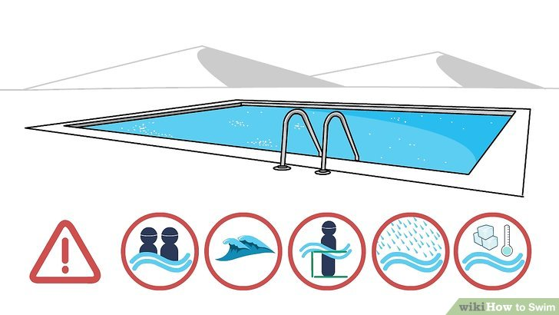
Let go of your fear. A lot of people put off learning how to swim because they're afraid of drowning. While drownings do occur, most of them could have been prevented by simple safety measures. Follow these guidelines whenever you're swimming, and the odds of drowning will decrease dramatically:[1]
- Don't swim alone. Always go swimming with one other person who is a strong swimmer, if not several other people. An area with a lifeguard is usually the best place to swim.
- Don't start out swimming in moving water. If you're learning to swim in an ocean or river, you'll need to be more aware of the motion of the water. If you must learn to swim this way, try to make sure you're with someone who knows what he or she is doing, and be sure to read the step about getting out of a riptide or a rushing river (below).
- Use proper safety gear until you have enough water experience and are reasonably comfortable in the water.
- Stay within a depth you can handle. When you're first learning how to swim, don't venture into water that's too deep for you to stand in. That way, if something goes amiss, you can simply stand up and breathe.
- Avoid swimming during inclement weather conditions. Swimming in a light rain shower should be fine, but if you see or hear a storm approaching, get out of the water immediately. This rule is to be followed regardless of how well you can swim.
- Don't swim in water that's too cold. Moving your limbs to paddle can become suddenly difficult if you're in frigid water.


Get used to floating. When you're in the water, hold on to the side of the pool or a dock, and let your legs float out behind you - they should lift easily if you let them. But, for some people, they like to sink to the bottom, while your upper body floats. Don't worry; just retry the method again. Practice doing this on your stomach and on your back, until you're used to letting half of your body float.[2]
- Try floating on your back or your stomach as soon as you're ready. Stay in a shallow depth so that you can simply stand up if it's not working out. It might feel weird to have water around your ears while your nose and mouth are in the air, but you'll get used to it. For extra stability, put out your arms at a right angle so that your body is in a "T" shape. When floating for the first time, you can try taking a deep breath and then floating. If your lungs are full of air, your body will float for sure. Do this until you're more experienced.

Don't panic. Always remember that you have a fallback if you're in an unmanageable depth or you simply can't move your limbs - floating on your back. Don't flail around or start breathing quickly if you can't swim; simply lie back as flat as you can, and let the water carry you while you regain your composure.
- A good tip for floating on your back is to hold your breath and have lungs full of air. Another good tip is to stick your stomach out.

Practice exhaling underwater. While you're still in a shallow depth, take a deep breath and put your face underwater. Slowly exhale out your nose until you're out of breath, then come back up. Bubbles should come out. You can also exhale out of your mouth, but usually in big bubbles until you finally let out a stream of bubbles.
- If you're uncomfortable exhaling through your nose, you can hold it closed or wear a nose plug and exhale through your mouth.
Wear goggles (optional). Wearing goggles can help you feel more comfortable opening your eyes underwater, and might allow you to see more clearly. Find a pair with spongy circles around the eyes and dip them in the water, so that they'll stick to your skin. Tighten the strap around the back of your head so that the goggles fit snugly.
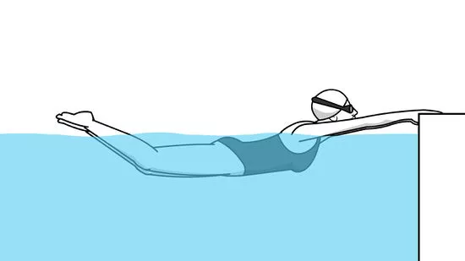
Practice kicking your legs. Whether you're floating on your back or still holding on to the side of the pool, you can practice kicking. (To see how far each kick can propel you, practice it using a kickboard. This allows you to focus on your kicking technique without worrying about keeping your head above water.)[6]
- Try a flutter kick. Point your toes out like a ballerina, keep your legs mostly straight, and alternate legs as you make small kicks. You should feel the most flexion in your ankles.
- Try a whip kick. Keep your legs held tightly together from your hips to your knees, and from your knees to your ankles. Bend your knees so that your shins come up to about a 90-degree angle, then quickly bring your shins apart and move them in a circular motion, keeping your thighs together the whole time. (That is, trace half a circle with each leg, moving your right leg to the right and your left leg to the left.) Bring your shins back together at the bottom of the circle, and lift them up again to restart the kick.
- Try an eggbeater kick. This kick is commonly used to tread water, and stay in a vertical position with your head and shoulders above water. Start with your knees bent and your legs slightly wider than hip-width apart. Then "pedal" each leg as you would on a bike, only they'll go in opposite directions: while one leg pedals "forward," the other leg should pedal "backward." This one takes some practice to get used to, but it's handy for "resting" when your feet can't touch bottom.


Learn how to do a crawl. Crawls are great strokes to learn as a beginner, and they'll move you pretty quickly. Here's how to do them:[7]
- Try a backstroke first. Float flat on your back, and do a flutter kick with your legs. With your arms, do the "crawl" motion, lifting one arm straight into the air and keeping it straight as it re-enters the water next to your head. Once it's underwater, bend it to bring it back to a straight position next to your side, and repeat. Alternate arms as you swim, and try to keep your fingers together and your hands as flat as possible.
- Try a front stroke (also known as a freestyle or American crawl). Floating on your stomach, do a flutter kick with your legs and use your arms to "crawl" forward. Bring one arm out of the water so that it's "reaching" forward, then bring it back down and use your cupped hand to "push" the water behind you. Alternate arms. To breathe, turn your head to one side under the arm that's currently crawling, lifting enough for you to take a breath. Take a breath under the same arm each time, so that you're breathing once every two strokes.


Tread water. Treading water can help you catch your breath and keep your head up without actually swimming. Do the eggbeater kick listed above, and use your hands to keep your balance by "sculling" - keep your forearms flat on the surface of the water, and imagine they're butter knives spreading on a piece of toast. Move one arm in a clockwise circle, and the other arm in a counterclockwise circle.
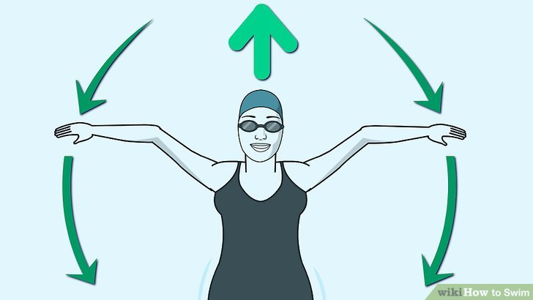

Use your arms to come up from the bottom. If you're below water and would like to come up, use your arms to propel yourself. Put them straight up above your head, and quickly bring them down to your sides. This should push you up a few feet. Repeat until you break the surface.

Try some more advanced strokes. Once you're more comfortable in the water, you can start learning new strokes that will move you more quickly or with less energy. Try these:
- Learn the dolphin stroke.
- The butterfly stroke .
- Swim the breaststroke.
- Do the sidestroke.
- Try swimming laps.
Try diving. Dives can be a fun way to get into the water and start a stroke. Start with a basic dive, and move on to more complicated swan dive, back dive, and rolling dive.[9]
- Always make sure the water is deep enough before you dive. At a bare minimum, the water should be 9 or 10 feet (2.7 or 3.0 m) deep; if you're a tall person, make it at least 11 or 12 feet (3.4 or 3.7 m).
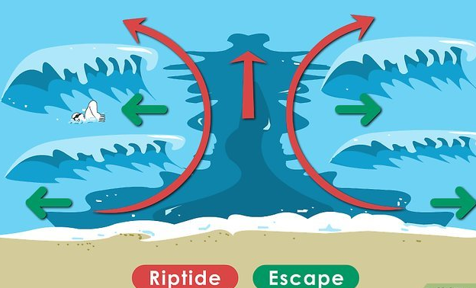
Know how to get out of a rip current. If you're swimming in the ocean, you might get caught in a rip current. Knowing what to do can save your life, so try to memorize these steps before you get into the water.[10]
- Do not panic. This is, by far, the most important step of all. By flailing and panicking, you could actually keep yourself under the water.
- Swim sideways. Do not try to swim directly to shore or directly out further into the ocean. Instead, try to swim in a line that's exactly parallel to the shoreline.
- Swim in a stroke that allows you to breathe. Swim with the strongest stroke you can do that also allows you plenty of room to breathe. This might be a sidestroke, front crawl, or breaststroke.
- Keep swimming until you're out of the rip current. You might have to swim quite far before you're safely out of the rip current, but keep going. You don't want to undo the good work you've done so far by heading for shore at the wrong time.
- If possible call out for help. If you can, motion to the lifeguard or yell "Help!" as soon as possible. However, don't do this if it means sacrificing a breath or if you have to stop swimming - it's better to keep yourself moving.

Know how to get out of a river current. If you're caught in a river that's flowing too quickly or pushing you under, follow these steps to get out:[11]
- Don't flail or panic. As with a rip current, panicking and flailing your limbs can push you deeper into the water. Try to take even breaths and remain calm.
- Aim to swim diagonally toward the shoreline. Swimming toward the shoreline at a 90-degree angle will force you to fight with the current too much, and might cause you to become exhausted quickly. Instead, plan to get to the shoreline at a diagonal angle that goes with the current.
- Don't try to swim upstream. You'll spend too much energy for not enough results. Only try to swim upstream if there's immediate danger downstream, such as sharp rocks or a waterfall.
- If you are being rapidly carried downstream by the current, point your feet in the direction you are being carried. This may prevent you from striking your head on a rock or other obstruction.
Resources:
www.wikihow.com

Splint a broken bone

A fracture is a broken bone. It needs medical care. If the broken bone is the result of major trauma or injury, call 911 or your local emergency number.
Also call for emergency help if:
- The person with the broken bone doesn't respond to you, isn't breathing or isn't moving. Call 911. Then begin CPR if there's no breathing or heartbeat.
- There's heavy bleeding.
- Even gentle pressure or movement causes pain.
- The limb or joint appears deformed.
- The bone has broken the skin and is sticking out.
- The toe of the injured leg or the finger of the injured arm is numb or discolored at the tip.
- You suspect a bone is broken in the neck, head or back.
To keep from making the injury worse, don't move the person unless you must. Take these actions right away while waiting for medical help:
- Stop any bleeding. Apply pressure to the wound with a sterile bandage, a clean cloth or a clean piece of clothing.
- Keep the injured area from moving. Don't try to realign the bone or push a bone that's sticking out back in. If you've been trained in how to splint and medical help isn't available right away, apply a splint to the area above and below the fracture sites. Padding the splints can help reduce pain.
- Apply ice packs to limit swelling and help relieve pain. Don't apply ice directly to the skin. Wrap the ice in a towel, a piece of cloth or some other material.
- Treat for shock. If the person feels faint or is breathing in short, rapid breaths, lay the person down with the head slightly lower than the trunk. If you can, raise the legs.
Sources:
www.mayoclinic.org

7 Ways to Improve Your Situational Awareness

1. Identify Objects Around You
Improving your situational awareness starts with being mindful about your surroundings. Each time you enter a new environment, take a moment to identify every object in your immediate vicinity. Chairs, tables, trash, even walls and doors should all be recognized and recorded in your mind. It should only take a few seconds to identify the objects around you, but looking at your surroundings with a discerning eye and acknowledging each item is a crucial step in developing a mindful attitude. When you’re aware of the things around you, you can effectively determine what can be used as a weapon and what will be a potential obstacle. Should a dangerous situation develop, you’ll have a leg up in using your environment to your advantage.
2. Notice Other People
Identifying objects in your environment is crucial for improving your situational awareness, but it’s equally as important to detect and observe the people around you. Watch out for nervous or agitated behavior in others, and keep an eye on people who seem to be moving outside the norm. You can even monitor the behavior of people you interact with every day, like family members or coworkers. The ability to detect inconsistencies or distress in other people can allow you to anticipate dangerous situations, giving you an opportunity to respond in the most effective way possible.
3. Identify Entry and Exit Points
You’ve identified objects, you’ve monitored the people around you; now it’s time to determine how to remove yourself should a dangerous situation arise. Every time you arrive at a new location, pick out all points of entry and exit. Should you have to defend yourself, you want to know how to withdraw from the situation, thereby limiting your time and need to fight. Knowing how to disengage from a treacherous circumstance is another key connection between situational awareness and safety—you’ll likely be more secure if you can withdraw from a dangerous scenario altogether and avoid engaging with an attacker.
4. Practice Prediction
Perhaps the most challenging element of situational awareness involves predicting the actions of the people around you. It’s a difficult skill to imagine future danger, but it’s one that can be cultivated and enhanced with time. When you enter a new location or observe suspicious behavior, try to imagine what would happen if things went poorly. What if that drunken man suddenly became aggressive and confrontational? What if the group of strangers walking toward you has bad intentions?
In each of these situations, establish one or two potential scenarios that would put you in danger, and outline how you would handle them. We’re not recommending that you allow your imagination to run wild with constant fear and anxiety, but actively working on your ability to identify potential threats can be crucial in improving your situational awareness and automatically choosing an appropriate response to danger.

It’s actually healthy to maintain the realistic mindset that you’re not always safe.

5. Stay Vigilant
While it’s comfortable to walk through life without considering your surroundings, a lack of critical observation of your environment can have dire consequences. Situational awareness requires constant vigilance of your circumstances in order to identify issues and eventually predict problems before they arise. While it can initially feel exhausting to sustain an attentive mindset, it will eventually become a habit that requires no effort to maintain.
On a more practical level, this often means you’re going to have to put down your phone and put the earbuds away (sorry). If you’re walking in an unfamiliar public place and staring at your text message stream, you not only sacrifice your situational awareness but may even be making yourself a target -- attackers love oblivious targets.
6. Trust Yourself
Although it can be easy to second-guess your gut feelings, learning to trust yourself is an important tenet of self-defense. Situational awareness absolutely acknowledges factors outside yourself, but it also requires taking an inventory of your own feelings. Are you feeling anxious or worried? Does the environment just feel “off”? Your internal reactions can be a key element in pointing out danger, so don’t ignore your intuition. If your inner alarms are going off, remove yourself from the situation immediately, as stopping to second-guess yourself could put you in critical danger.
7. Practice Situational Fighting Techniques
While training your mind to be aware of your surroundings at all times is crucial for improving your situational awareness, simply recognizing your circumstances isn’t enough to protect yourself. You also have to train your physical body in order to ensure that you’re able to withstand an attack. At Krav Maga Worldwide, we’ve tailored our training to account for the link between situational awareness and safety. Instead of simply changing environments or tactics, we practice situational drills that will improve your ability to determine appropriate techniques, maneuvers, and reactions in a variety of different scenarios. We genuinely believe we offer the best in self-defense training that will allow you to coach your body and mind simultaneously.
Sources:
www.kravmaga.com

Tips for New Team Leaders

There Can Be A Lot On Your Plate As A New Team Leader
Whether you’re heading up a new team or taking the reins of an existing one, leading a team for the first time can be daunting. There’s no bedrock of personal experience to build on. If you’re a first-time team leader then you’re probably either relishing the challenge or considering a run for the door—or a bit of both.
1. Make Time To Lead
- To be effective, team leaders need to invest time in the role. Too often, this responsibility is simply added onto someone’s already lengthy task list, thus setting the new leader up for failure.

- As a team leader, you need to be visible to the team and available to support them. Part of your new leadership role is to foster a positive working environment and community. If you’re predominantly tied up with your own critical hands-on tasks, you won’t be as visible or able to support your team.
2. Get To Know Your Team
- Leadership is all about how you influence your team to achieve its objectives. This is something you’ll struggle with if you don’t get to know your team members and what makes them tick. While it might be tempting to jump in and start making big moves from day one, remember that you’re not there to flex your ego.

- Take time to listen to your team members; find out what their issues and aspirations are, gather ideas, and identify potential strengths and weaknesses. Only then can you formulate a leadership approach that stands a chance of success. Getting to know who you’re working with is the first step to bonding with the team and establishing their respect and trust. The old saying of listening twice as much as you speak still holds true here.

- Touch base with your team, especially those who may be struggling. New team leaders find success holding brief 10-15 minute check-in conversations. You can even have calendar openings for “office-hours” where people can schedule meetings and connect with you if they need help or need to chat.
3. Communicate, Communicate, Communicate
- Once your team is up and running, it’s imperative to keep the communication going to build relationships, assess progress, and identify risks and issues. When new team leaders communicate often and effectively, they often find more engagement from the team. This is because they see you investing time in them and showing interest in the team.

- Ongoing communication can also strengthen the types of conversations you have with your team. For instance, you have more clout to make expectations and responsibilities clear so that everyone knows who’s doing what, why and by when. This seems obvious but don’t assume everyone has your detailed understanding of the project at hand.

- Encourage and embrace new ideas. The more your team can contribute to the project, the happier they’ll be. Acknowledge and thank your team when they do well and let them know their work is appreciated. You’ll find that your team will be more responsive, happier, more productive and empowered to take the initiative on future projects and tasks.

- There is a fine balance to how you go about communicating with your team. New team managers can easily overcompensate for the distance of remote working or are checking in too frequently, which can create skepticism that negatively affects the team’s productivity. Offer support that is sincere and genuine.

4. Lead By Example
- Think about the behaviors you want and expect from your team members. Be sure to exhibit those traits yourself. As a team leader, you’re the role model, so what you say and do will impact the team’s work habits and attitudes. That said, it’s important to be yourself and to believe in yourself. If you fake it, you’ll soon be unmasked and you’ll lose credibility and trust.

- Be open, honest and passionate. Treat everyone on the team fairly, with respect and without favoritism and you’ll find those behaviors returned. Extend the same courtesy to the rest of the organization as well. Never undermine or criticize other individuals or departments in front of the team. Make it clear you’re all there to work towards the same goals and success for the big picture.
5. Reward The Good And Learn From The Bad (And The Ugly)
- Recognize good performance.

- Be timely in tackling poor performance issues. The longer you leave them, the tougher they’ll be to fix. Look for the best in people and understand that mistakes will happen. When they do, learn from them and see how they can be prevented in the future. And whatever you do, don’t play the blame game.

- If you need to have a challenging conversation, do it in private, no public floggings on a conference call, in a meeting, or in a group email. And don’t try to win a popularity contest. Not all your feedback will be well-received, but if you concentrate more on being everyone’s friend instead of being a strong leader, the work will suffer, as will your integrity.

6. Delegate
- Trust your team to do its job. Being a team leader doesn’t mean you’re there to do other people’s work for them or micromanage at each step. Be clear on what’s expected of everyone and let them get on with it. Helping your team members reach a level of independence enables them to enrich their role within your organization on their terms. When issues or opportunities arise, empower the team to find a resolution themselves with your support—don’t add every new issue to your own to-do list.
- Here are some helpful delegation tips for new team leaders to embrace.
  - Establish the desired outcome of a project. Assign responsibility to achieve results rather than a to-do list of tasks. Ask yourself: “What is the result of what we are trying to accomplish?”
  - Consider who can and should take on the delegated responsibility. Who has the experience to do it? Who can do well with this opportunity? Who needs to learn how to do this task? Who has the time to complete it on time?
  - Define the time details. Determine important milestones, deadlines, and when you expect to have elements of a project completed.
  - Monitor progress and offer feedback. Because you’re still responsible for the success or failure of a project and the team; give positive feedback and coaching as you monitor the project’s progress.
  - Ask for ideas and input from the team. Your role is to understand how things can be improved, who should be involved and how your team can advise on the project’s success.
  - Reflect on the project and gain insights to what was learned in the process. What did you and the team learn? Identify, share and document what can be improved. This tip for new leaders is helpful to figure out better ways to excel in future projects.
7. Be Decisive
- When it comes to producing results, don’t procrastinate. Grab the nettle when you need to. It’s all too easy to defer difficult decisions, but ultimately costly for the job in hand and how you’re viewed as a leader. If you can’t address a larger challenge, it’s ok to make a series of smaller decisions that create momentum and progress toward the bigger picture. If things go wrong, take a breath, gather the information you need to make an educated decision and make it.

- Don’t be afraid of seeking help (it’s a sign of strength, not weakness). Consult with your team. Gaining their outside perspective or having the ability to bounce an idea off of them may help you make a more appropriate and impactful decision. Team management is an ongoing learning process and you will never have all the answers.

- To avoid tough decisions down the road, notice the patterns in advance and be prepared to anticipate a solution. Recognizing patterns enables you to make a faster and clearer decision when faced with a similar challenge.

8. Enjoy It!
- Team leadership is often challenging but frequently rewarding. By bringing the right people and processes together, you’re creating an environment that fosters success and personal growth. Plus, it’s a great feeling to be part of a well-oiled team environment that you’ve positively impacted. So, get out there and go do it!
Resources:
www.liquidplanner.com

Preparedness level II
1. Store food to extend its shelf-life (canning, smoking, salting, fermenting, dehydrating)
2. Cook a meal from scratch with basic stored foods
3. Cook over an ad-hoc stove or open-fire
4. Identify and acquire wild edibles in your area
5. Butcher wild game
6. Fish (trotline, rod/reel, bait, net, trap, spear)
7. Purify water
8. Create a physical preparedness plan for a family
9. Create a get-home plan for a family
10. Create an emergency plan for a family (includes communication plan)
11. Create a bug-out plan for a family
12. Create a bug-out bag
13. Conserve financial resources, and prepare financial reserves
14. Garden
15. Horsemanship
16. Raise animals for food
17. Construct simple renewable power generators
18. Understand and apply the principles of self-sufficiency
19. Make wine/beer/mead
20. Teach others the preparedness skills you know

Long Term Food Storage: A Beginner's Guide

To get started with long-term food storage, you need to build a plan and prepare your storage location. Find a spacious, cool area in your home for storage. All foods can be bought in bulk and packaged with our tips for optimal longevity and shelf-life. Get started right away.
Long-term food storage is an excellent solution that can help you overcome daily challenges. While it is geared towards emergency preparedness, you should be willing to stockpile food for the long run. After you build up a three-month supply, we can get started building your long-term storage.

Disastrous events can occur when we least expect them. This is why we are always testing new food storage strategies to stay prepared. Building food storage requires a commitment over time, so our team is always ready.
How to Store Food Long-Term
Long-term food storage sounds intimidating at first. The costs seem daunting and the repackaging of food is a time-consuming task. However, in the long run, you will save both time and money by starting today.
It will result in fewer trips to the store, less gas used on your vehicle, and more food in the house for easier preparation. Not to mention the peace of mind you can have knowing that you and your family are well protected in an emergency.

Step 1: Build a 3-Month Food Supply
Before even thinking about your long-term supply, we always recommend getting started with something short-term. A 3-month supply serves as an excellent benchmark to aim for in the beginning.
Look for easy-to-store foods in your pantry like canned and pre-packaged goods. The goal is to eliminate your need to shop weekly and give your a safety net to rely on while building something larger and more significant.
Step 2: Create Your Long-Term Plan
While you build your three-month supply, you can start to work on your long-term plan too. Start making a list of all the dietary preferences in your household. These will play an important role when you start shopping.
Make a list of foods that you all enjoy eating. The goal is to eliminate waste when building food storage. You should also track daily meals in your home to try and determine the minimum caloric intake you need per person in a single day.

Step 3: Choose Your Storage Location
The storage location is critical. You need to find a place big enough to hold all of your supplies while hiding them from sunlight, keeping them in a cool area, and eliminating extreme temperature fluctuations.
If you don’t have a reliable shelving system anywhere, you might need to build or buy something too. The ideal location is typically in a corner in the basement that stays dry and cool at all times.
Step 4: Find Your Suppliers and Go Shopping
Finding the right place to buy your food can save you tons of money, especially when buying bulk items. Membership stores are an excellent place to start because they sell industrial-sized amounts for a fraction of the cost. We do not recommend a traditional grocery store for bulk food buying.
Do some research in your area to find the best spots near you. Depending on your location will have an impact on the best stores for you.

Step 5: Stock the Shelves and Maintain Consistency
After you buy some food, it is time to stock the shelves and keep it going. It won’t happen in a single day, so start small. Once you have your storage area ready, we can start using different packaging methods and creating an accessible storage system.
Stick to your plan too. Every week is a new opportunity to add to your supply. Even if it is only one item, it still represents progress.
What Types of Food Can You Store for Long-Term?
The types of foods you are looking for should be dry, long-lasting foods. Long-term storage is defined as ten years or more, with some foods lasting nearly 30 years.
Dry foods that contain less than 10 percent of moisture are the perfect candidates for long-term storage. Anything higher than ten could be difficult. 13% is a crucial number, with any foods higher than that posing too high of risk towards bacteria, mold, and fungus growth. This is an easy way to spoil your food quickly.
An essential supply of food for one person may include:

- Cans of vegetables (potatoes, onion, celery, carrots, tomato powder)
- Grains (wheat, oats, rice, corn, barley, pasta–get a good variety)
Beans
- Sugar or honey
- Quarts of oil (oil, shortening, peanut butter)
- Salt
- Yeast
- Baking soda
- Baking powder
- Cans of dried fruits
- Cans of freeze-dried meats
- Corn and corn starch
- Dry dairy products like milk and eggs
There are plenty of food options to choose from for a long-term supply.
Principles for Building Your Long-Term Food Storage
1. Assume the Worst
Predicting the future is not something you can do confidently. We have no idea when the next crisis will strike. So, it’s best to assume the worst. Imagine a situation where you are unable to leave your house to get stuff from a nearby store.
By assuming the worst, you will never leave anything up to chance and always make sure your foods are packaged correctly, and the storage is fully stocked.
2. Think About the Foods You Will Actually Use
Some people make the mistake of stocking up on different styles of processed foods or similar foods that they don’t like. The goal of food storage is to eliminate waste.
Processed foods don't store well and are packaged poorly, attracting rodents and bugs into your home. Buy only the items that are considered essentials, especially at the beginning.
3. Assume You Won’t Have a Working Refrigerator or Freezer
Refrigeration and freezing are great ways to preserve our foods. But sometimes, these methods may not work out, especially during power outage emergencies. Your freezer will stop working, and if the grid stays down for a long time, all the foods in your freezer will go bad.
To avoid something like this, install a backup power system that can power only your essentials, like a fridge or freezer. The other option is to eliminate the freezer from your storage plan.

Try dehydrated foods, canned foods, dried foods, and naturally fermented foods. These all store well and last a very long time.
4. Label All of Your Foods
Every time you buy new food that will be stored, you should label it with a permeant marker that says what kind of food it is and the date it was purchased.
The type of container you use could change the way you label, but it’s an absolute must for every product on your food storage shelves.
5. Use a Food Calculator
Every human being has a basic caloric requirement that they should meet daily. For example, the average male adult should consume about 2,722 calories per day. This number will vary based on your activity level, age, weight, etc. Consider calories when you are preparing for your food storage.
There are tools like a food calculator that you can use to estimate calories based on specific foods. For example, the calculator will calculate the total number of calories in a bag of rice based on the total weight of the bag.
Using a tool like this can save you time in your preparation process while ensuring your accurate estimates.
How to Package Your Foods for Long-Term Storage
Long-term storage packaging requires tight seals that eliminate oxygen flow around the food and keeps moisture to a low enough level. There are a few different options you can consider for your foods. We will discuss three of the most efficient methods: plastic bottles, glass jars, and Mylar bags.
Each storage method will store specific foods better than others. We will also mention the foods that shouldn’t be stored in each process. Some foods contain too much moisture and can spoil quickly if not stored the right way.

Plastic Bottles
Instead of throwing away your old plastic bottles, put them aside to be cleaned and start building up. You will have a dozen bottles ready to store your grains before you know it.
Recycled plastic bottles are a cheap storage option that stores wheat, rice, beans, and other similar food items best. After cleaning out the bottles, you can start filling them with food.
These bottles provide a solid barrier away from oxygen and added moisture, though it is much weaker than glass jars and Mylar bags.

Remember that any plastic bottle can be used as long as it is recyclable. Look for the PET or PETE recycle symbol on the side of the bottle to confirm it is a suitable option for your food storage.
Avoid using milk jugs as a storage option. They do not provide a strong enough seal for food storage. The most crucial aspect of any bottle you choose is an air-tight seal lid. Check each lid of your bottles to confirm they can seal correctly.

Pros
- Cheap, budget-friendly storage option.
- Available in many different shapes and sizes.
- Bottles can consistently be reused.
- Storage in bottles can last up to five years.
Cons
- Bottles cannot protect against rodents.
- Bottles are susceptible to light.
- Bottles provide the weakest oxygen barrier.
Glass Jars
If you are looking for something more elegant and secure, glass jars could be the perfect choice for your food storage needs. Similar to plastic bottles, they are available in many different sizes to accommodate various food options.
Glass jars are also recyclable. You can purchase new ones or use old ones from around your house after a thorough cleaning. They are a more robust option that creates tougher oxygen and moisture barriers.
Glass jars can keep toxins out of your food too. They are an inexpensive option to create a stronger seal for your food and keep away rodents and insects.
The downside to glass is how fragile it can be if you mishandle it. It requires care when packaging and storing on shelves. It is also essential to place them towards the back of your shelves to eliminate their risk of falling and breaking.
Glass jars are incredibly versatile and can be used for both long-term and short-term food storage. The most reliable glass jars to use are Mason jars because of their durability and reliable air-tight seal.
All foods stored in glass jars must be dry and contain a moisture content of under 10%. Ideal foods are low in both fat and oil content too.

Pros
- Provide an excellent barrier against oxygen and moisture.
- Protects food against rodents and insects.
- Glass jars are easy to clean and reusable.
- Block leach toxins from spoiling your food.
- Inexpensive and easy to buy in bulk.
Cons
- Glass is fragile and breaks easily.
- Glass cannot protect food from light.
Mylar Bags
Mylar bags are a more intense storage container that requires extra preparation and more upfront cost to make it possible. However, they provide several layers of protection for your food with substantial barriers against light, oxygen, moisture, and insects.
You can purchase high-quality Mylar bags meant explicitly for food storage. They are more flexible for storage and seal tightly to guarantee long-term shelf life for your food.
Mylar bags are available in various sizes, but you need some extra equipment to make this storage method possible. You will need a bucket, a heat source for sealing, a permanent marker for labeling, and oxygen absorbers.
Avoid putting foods like nuts, granola, raisins, and other similar foods with high moisture content in your Mylar bags. They do not store well, especially with oxygen absorbers. Mylar bags work by eliminating all oxygen in the bag to create a seal that preserves the food inside.
Pros
- Protect against light, oxygen, and insects.
- Longest lasting food storage method.
- Wide variety of bags available for purchase.
- Bags can be washed and reused in the future.
Cons
- Bags cannot protect against rodents.
- Mylar bags are difficult to stack on shelves.

What are Oxygen Absorbers?
Oxygen absorbers are a small tool that must be used during long-term storage to help seal your food. They are added to the bag or jar with your food and eliminate the oxygen presence around your food. When used correctly, they can remove up to 99.99% of oxygen in your food storage.
Oxygen absorbers work quickly and should be added to any storage method you decide to use. They can fit inside plastic bottles, glass jars, and Mylar bags. After they are opened, you have up to 3 hours to place them in the container before it’s too late.
Oxygen absorbers work by forming a chemical reaction with oxygen. They are made from iron powder that rusts when exposed to oxygen. That means when exposed to oxygen; the absorbers suck up all of the oxygen they can.
Oxygen absorbers are only effective when used with foods containing low amounts of moisture, fat, and oil. With too much moisture, the oxygen absorbers can cause botulism.

What are the Benefits of Long-Term Food Storage?
Building a long-term food storage supply requires commitment. It is best to consider the benefits to stay motivated and help understand why it is vital for your household. Predicting the next disaster or emergency is impossible, and the only precaution you can take is creating security and protection for yourself and your family.
Peace of Mind
It is difficult to put a price on peace of mind. Knowing that you and your family have a backup plan that can keep you safe and healthy in the event of food shortages, power outages, and other related events will help you sleep better at night.
Many people would never have expected lockdowns due to a pandemic. This has helped people realize how important long-term food storage really is. Don’t wait until the next emergency happens to get started.

Convenience
Not only do you create excellent safety for yourself, but the convenience factor is unmatched too. In your storage, you have a long list of foods that can be used at any time. This helps you avoid running to the store when you don’t need to and saves you time in the long run.You can buy groceries less frequently and create more time in your life by starting a long-term food storage supply.

Save Money
While the initial time and cost commitment can seem overwhelming, you will end up saving more money over time. Buying foods in bulk is incredibly cheap when compared to traditional grocery shopping.
You can also eliminate trips to the grocery store to buy one-off items when they are priced at their highest point. Other savings include gas used to drive to the store and temptation purchases that occur while you are at the store. This is the best way to build your food storage on a budget.
Source:
www.buildastash.com article by Mark Walker

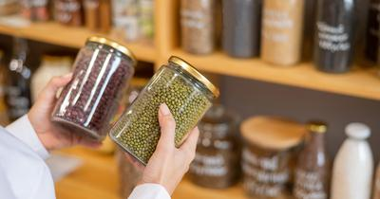
How to Store Dry Beans Long-Term

‍Dry beans are an excellent addition to any food storage stockpile given their prolonged shelf life, but how do you store them long-term?
To store dry beans long-term use either airtight containers, vacuum sealing, food-grade buckets, mason jars, mylar bags, or your freezer. Properly storing dried beans in ideal storage conditions can push their shelf life to 25 to 30+ years.
After extensively researching food storage preparation, I have gathered enough information to determine how to store beans long-term. In this article, we’ll be taking a closer look at the best ways to maximize the shelf life of beans to help you optimize your food storage system.
Which Dry Beans Are Best for Long-Term Storage?
Creating a reliable food storage system is all about finding goods that are guaranteed to last. Dried beans have traditionally been one of the best items that you can incorporate into a stockpile, as they are a great source of nutrients and can last for decades if you store them properly.
With that said, one of the biggest decisions you will have to make when storing dried beans is deciding which beans you want to add to your system. Although most dry beans are great for long-term storage, I’ve found that some are considerably better than others, especially if you are thinking in decades and not years. Consider adding the following dried beans to your stockpile:

- Pinto Beans
- Black Beans
- Split Peas
- Garbanzo Beans
- Kidney Beans
- Soy Beans
- Navy Beans

How Long Can Dry Beans Be Stored?
Preppers and survivalists tend to prioritize dried beans in their stockpiles over most other food items. This dynamic food is loaded with essential nutrients and it can be used in so many different meals to add flavor and substance to your cooking.
However, it’s the shelf life of dried beans that truly makes this such a key item for long-term food storage. Properly stored dried beans can last for decades, with many preppers achieving a shelf life of 25+. If you are looking for a food item that can last, dried beans should be at the top of your list.
Provided there is no contamination in your storage system and the container stays sealed, dried beans can potentially have an indefinite shelf life. What’s more likely to occur is that the quality of the dried beans begins to deteriorate after 25 years, but they should still be safe to eat.
How to Store Dry Beans Long Term
There are more people prepping and storing food than ever before. With a series of major global events occurring in recent years, there has never been a better time to be prepared for the worst.
One of the best ways to do this is to create a long-term food storage system that you can count on in case of an emergency. Any prepper or survivalist will tell you that beans are a mandatory item for any food storage system since they can potentially last decades. While canned beans may be tempting, you want to stick with dried beans to make them last as long as possible.
However, when checking the label on the original packaging, you will likely see a shelf life that is only around 6 months to 2 years. The reason for this is that most sellers assume consumers will store their dried beans in the pantry without additional food storage preparation.
The truth is that you can greatly improve the shelf-life of dry beans by storing them in ideal conditions that will eliminate or, at the very least, prevent chances of contamination.
There are a number of food storage approaches that you can implement to maximize the shelf life of dried beans. You need to consider the quantity of dried beans you want to store, as well as how long you want them to last to determine which shelf life suits your system best.
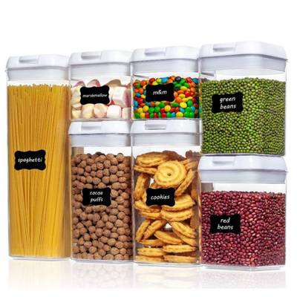
Air Tight Containers (3+ years)
Airtight containers are a practical and logical approach for many households. Airtight containers are cheap and easy to use, and you likely already have some laying around at home.
When you buy your dried beans at grocery stores, you should always empty them out of their original plastic bags and pour them into a more reliable container. Most airtight containers are made out of quality BPA-free plastic and are a great option for storing dried beans for around 3+ years.
While this may not give your dried beans the most prolonged shelf life possible, it is the most straightforward approach. In addition, 3 years is the minimum that you should expect your beans to last in airtight containers, provided you handled the beans properly beforehand.
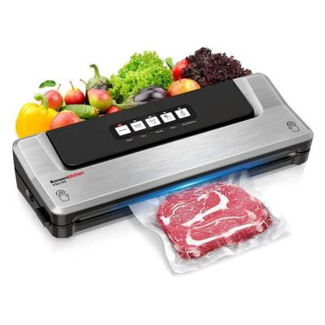
If you want to improve the shelf life of your dried beans with this storage method, add an oxygen absorber to the airtight container before sealing it. An oxygen absorber combined with an airtight container should give your dried beans a shelf life of roughly 5+ years.
Vacuum Sealed (5+ years)
Vacuum sealing technology has been widely used among preppers. This is a safe and reliable way to store food for anyone looking to improve the shelf life of their dried beans, especially if you already have a vacuum sealer at home.
This method involves placing your dried beans inside a pouch to have the oxygen removed with a vacuum sealer. The vacuum sealer will remove oxygen, significantly lowering the chances of contamination down the line.
If you correctly vacuum seal your dried beans, you should be able to make them last at least 5 years in the right storage conditions. The one thing you want to make sure of is that you buy good quality vacuum sealer bags. Cheap bags have notoriously allowed in air and moisture over time, which can easily contaminate all of your dried beans.

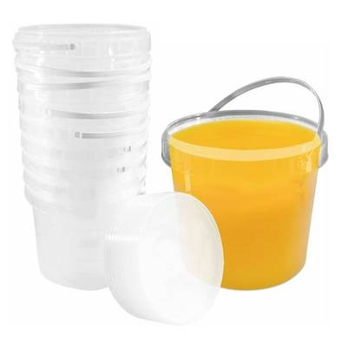
Food Grade Buckets (10+ years)
Food-grade buckets are great for storing beans if you want to maximize quantity. If your bean storage requires a lot of space and you have a lot of dried beans to pack away, a food-grade bucket may be the most practical solution for your system.
Unlike most other storage methods, which are often limited to 1-gallon container sizes or less, food-grade buckets can be purchased in 5-gallon sizes. This greatly improves how many dried beans you can store in a single container, making the process of packing up your goods much more efficient.
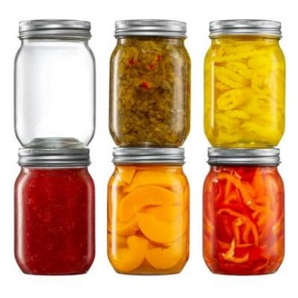
It’s important to use buckets that are ‘Food-Grade’ and not just any regular bucket. In addition, the bucket needs to have an airtight lid that seals for the shelf life to be guaranteed. Dried beans kept in a food-grade bucket should last for at least 10+ years.
Much like with the other storage methods that I covered, adding an oxygen absorber to the food-grade bucket before sealing it, will secure the 10-year shelf life of your dried beans and potentially even increase it.
Mason Jars (5 to 30+ years)
Mason jars are a classic food storage solution that’s been utilized for over a century. These glass containers are as reliable now as ever, making them a popular choice among preppers.
With that said, the shelf life of your dried beans in a mason jar or glass jar can greatly vary depending on how they are stored. Naturally, you should be keeping them in an ideal storage location, but what is equally as important is that you vacuum seal the mason jars after adding your dried beans.
Vacuum-sealing a glass jar can make your dried beans last 25 to 30+ years. Whereas storing dry beans in mason jars without vacuum sealing will likely result in them lasting around 5 to 10+ years. Alternatively, if you don’t have a vacuum sealer, oxygen absorbers are great for adding to mason jars.
Just make sure to keep your glass jar in a safe and dark place, as they are very fragile and let in a lot of sunlight. The plus side is that they can prevent insect infestation, as glass jars cannot be penetrated by pests.

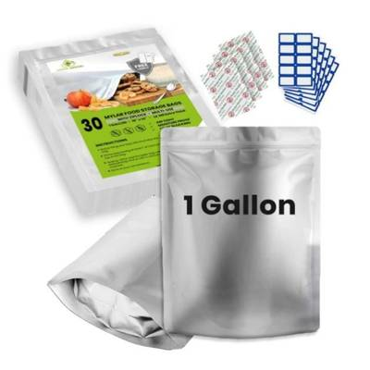
Mylar Bag + Oxygen Absorber (10 to 30+ years)
The ultimate solution for virtually all of your food storage needs is mylar bags. This convenient, versatile, and user-friendly plastic bag has been a game-changer for food storage systems, given how effective they are at maximizing the shelf life of items.
By using mylar bags, you can easily make your dried beans last at least 10+ years. However, if you add oxygen absorbers to the mylar bags, you can increase the shelf life of your dried beans to 25 to 30+ years.
A mylar bag will prevent any oxygen from entering and they are usually designed with a reflective material that doesn’t allow sunlight inside. By properly storing dried beans in mylar bags with oxygen absorbers, they can potentially have an indefinite shelf life.
What is much more likely to happen is after 20 to 25 years the dried beans will lose their flavor. At this point, they should still be safe to eat but may not offer the same vitamins and nutrients as before.
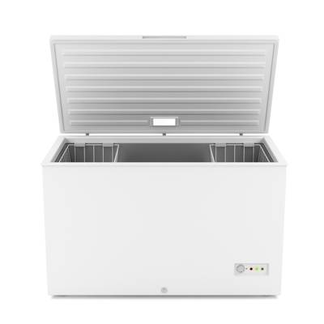
Freezer (30+ years or Indefinite)
If you want your dried beans to last as long as possible, there is no better way to do it than in your freezer. Getting the dried beans down to a temperature below freezing will secure their shelf life for at least 30 years or indefinitely.
Freezing is a very reliable storage solution for a lot of preppers, but certainly not all. You need to keep in mind that your freezer needs to be running the entire time and the beans still need to be packaged in air-tight containers.
If you have the freezer space and can guarantee that you will have power in case of an emergency, the freezer is the best place to store dry beans long-term.
How to Tell if Dry Beans Have Gone Bad
Dry beans have a prolonged shelf life, but you should expect them to go bad eventually. This can be quite common if dried beans were not stored correctly and were exposed to some form of contamination.

With that said, the last position you want to find yourself in is opening up your food stockpile only to find that all of your beans have gone bad. That is why you should always check to see if your dry beans are safe to eat before you consume them.
This may not be as obvious as dealing with fresh food items which become noticeably rancid quite quickly. Make sure to check for the following signs to tell if your dry beans have gone bad.
Mold
Once dried beans are contaminated, they will start to get moldy. However, given how slowly dry beans go bad, you need to keep an eye out for early signs of mold.
Dry beans usually develop spots and smears of discoloration when the first signs of mold become apparent. As the mold gets worse, it will become more obvious, with blatant discoloration and visibly broken beans.
Foul Smell
A foul smell is not the first thing that you should detect when you open up your dried beans. In general, dried beans should have a very neutral and indistinct smell.
If you notice a rancid odor coming from your dried beans, you may also see other signs such as mold developing. As soon as you notice a foul smell, it’s safe to say that the dried beans are no longer good and should be thrown out.
Discoloration
It can be easy to confuse old, discolored beans with mold. While beans certainly have a long shelf life, they will start to lose their quality over time. If they were stored properly, you should not notice any signs for years or even decades.
However, after a while, the older beans will lose their color and appear more faded. This does not necessarily mean that the beans are bad or that mold is present. It simply implies that the older beans are past their prime and will likely not be as nutrient-dense as they once were.
With that said, it’s important to be able to tell the difference between aging and mold to ensure that you do not get food poisoning. As a general rule of thumb, if you have any doubts, it’s probably best to toss out the beans.
Source:
www.buildastash.com article by Mark Walker

How to Store Honey Long-Term

Honey is a great source of simple sugars that can be used as a flavor additive, and it even has medicinal properties. You should always have some on hand.
You can keep honey in long-term storage by using a sealed container in a dark, dry, warm space. You can also freeze honey, but be sure to thaw it properly. When kept in this way, the shelf life of honey is nearly infinite.
We’ll look at the best ways to get you the longest shelf life for your honey, and how to avoid common honey storage pitfalls.
‍How to Store Honey Long-Term
While liquid honey can technically last forever due to its unique chemical composition, it can lose its quality over time. Subtle changes to its color, aroma, and flavor may make it less edible.
Following these simple guidelines for honey storage can help you store honey for the longest possible amount of time.
Use a Sealed Container
A properly sealed container is always the best bet when you want to store honey in a liquid state. The reason for using a container with a good seal is to keep out excess moisture. Honey naturally has very little moisture, and any that leaks in can bring in harmful bacteria or cause crystallization.
The Right Containers for Storing Honey
The best type of container in which to store raw honey is glass mason jars with tight-fitting lids. Glass will not react to the foods stored inside of it, and it will not degrade over time. Glass containers like mason jars are commonly available, and are useful for storing all kinds of foods besides honey.
Plastic containers that are not rated as food-safe are not a good idea. They can release chemicals over time that will affect the quality of your honey. Even food-safe plastic containers can break down over time, and are not as stable as glass containers.
Metal containers also have a tendency to oxidize, which will compromise whatever foods they store. Furthermore, honey is slightly acidic, which means it will progressively eat through metal over time.
Keep Honey in a Dark Place And at an Average Room Temperature
Honey is best stored at room temperature, which is usually between 65 to 75 degrees Fahrenheit, or about 18 to 24 degrees Celsius.

High temperatures may cause your honey to become darker and lose some of its flavor, and cold temperatures will freeze your honey, which can lead to the crystallization process. Crystallized honey is not harmful, but is not always the most usable form.
Additionally, dark spaces are better for storing honey long-term. Direct sunlight or other harsh lighting conditions can also affect its color and flavor.
A closed kitchen cabinet, basement storage unit, or other dark area that does not experience strong swings in temperature are all ideal places for keeping honey over long periods of time.
Avoid Moisture at All Costs
One of the biggest reasons to follow proper food storage protocols is to avoid letting moisture into your honey.
This can lead to fermentation, which is the process by which bacteria break down food slowly over time. This is a key element to making alcoholic beverages, but can be harmful when you do not store honey properly.
Using the right container with a proper moisture seal is essential to keeping your honey fresh over time.
Do Not Refrigerate Honey
While refrigeration is a great option for keeping other foods fresh, it is not helpful to keep honey in the refrigerator. If it gets too cold, honey begins to turn into a solid mass or form crystals, which can affect its composition and quality once brought back up to a usable temperature.
We’ll look into freezing honey below as an alternative, but the “in between” step of refrigeration is more trouble than it’s worth where honey is concerned.
How to Freeze Honey
You can store honey in the freezer as a viable alternative to room-temperature storage. It preserves the honey well, and doesn’t allow crystals to form.
That being said, you must thaw your honey properly to avoid these imperfections later on.
How to Thaw Frozen Honey
When you thaw your honey, be careful not to expose it to overly hot temperatures too quickly. This can not only damage the quality of the honey itself, but if you used a glass jar it might shatter due to the extreme changes in temperature.
Instead, use warm water when it’s time to thaw your honey. Using warm water will bring it up to a usable temperature more gently.

Can You Dehydrate Honey?
If you have a dehydrator, you can also dehydrate your honey for longer term storage. This method removes all moisture completely and converts the honey into honey sugar.
You can store dried honey in this form under similar conditions (airtight storage containers at room temperature), but you should include a desiccant packet to prevent clumping during storage.
How Long Is Honey Good For?
Stored properly, honey is an amazing food with no actual expiration date. Even when it gets darker or crystallizes, it is always safe to eat.
Honey May Expire If It Has Additives
Some manufactured honey products may include other additives that will cause that honey to expire. It’s always best to purchase raw honey with no other ingredients to ensure that it will have a nearly indefinite shelf life.
Different Types of Honey
Raw Honey
Raw honey is the most basic and commonly available form of honey, and is the version most people are familiar with. It may be filtered or unfiltered, which means that the pollens and waxes from the honeycomb may be taken out or left in. Unfiltered honey is a bit more cloudy as a result, but this does not make it harmful.
Raw honey is widely available at grocery stores and at local farmer’s markets. There are numerous health benefits to eating raw honey from local sources, since exposure to the pollens in your area may help prevent seasonal allergies.
Liquid Honey
Liquid honey is much lighter and thinner than “raw honey.” It is also called a honey simple syrup.
Honey in this form is closer to how it naturally occurs before bees store honey in their honeycombs. It is clear and runny, and has not yet been processed by the pollens and waxes that convert it into its “raw” form.
Creamed Honey
Contrary to popular belief, creamed honey does not contain any additional ingredients besides honey. Rather, you can make creamed honey to restore raw honey that has crystallized.
Simply add some crystallized honey to raw honey and mix or whip it together vigorously. The crystallized “seed honey” will bond with the liquid and the crystals will decrease in size. The resulting mixture will end up creamy instead of syrupy.

Creamed honey has a more spreadable consistency, but generally has a shorter “shelf life” - not because it becomes unsafe for consumption, but because it will not remain in its creamy state for long before it starts to separate again. However, you can return it to its creamy form by mixing it again with more raw honey that has not yet crystallized.
Which Type of Honey Is Best for Storage?
Of these three types of honey, raw honey is the most widely available and will remain shelf stable the longest.
Source:
www.buildastash.com article by Mark Walker

How to Store Flour Long-Term

‍Raw ingredients like flour are useful for cooking and baking, and it’s always a good idea to have some around the house or in your long-term food storage.
The best way to properly store flour for long periods of time is in a cold, dark space with as little access to air or moisture as possible. Mylar bags with oxygen absorbers are best here. When you store flour in airtight containers, flour can last up to 25 years without spoiling.
We’ve reviewed the best ways to store flour properly, and how well you can expect each method of food storage to perform. We’ll also look at what kinds of things you should look to prevent when storing flour properly.
Use the Original Packaging Whenever Possible
Flour will last for up to six months in its original packaging at room temperature. However, these packages are usually just a simple paper bag, and are not able to completely keep air or moisture out for longer periods of food storage.
Unopened containers do have a better chance at keeping flour fresh over a longer shelf life if they are combined with one of the other methods for storing flour described below.
A Better Bet? Airtight Containers
Airtight containers generally help keep most foods better for longer. By simply swapping out the manufacturer's packaging with an air-tight container, you can extend flour’s shelf life for up to a total of 10-12 months.
Mason jars or vacuum-sealed containers are good options for storing flour.
Keep Your Flour in the Refrigerator
Another easy trick to store flour long-term is by keeping it in the freezer. Colder temperatures are better for flour storage anyway; plus, the cooler temperatures will keep insects and other pests from feeding on your flour.
However, in most cases, this may only buy you a few extra months of shelf life.
Store Flour in the Freezer
As with some other foods, freezing flour is the ideal way to keep it usable for a near indefinite amount of time. When kept in freezer storage in an airtight container, frozen flour will not spoil.
However, keep in mind that you’ll need to restore it to room temperature properly before using it from food storage in the freezer to avoid any excess moisture.

Store Flour Using a Vacuum Sealer
If you’re able to get your hands on a vacuum sealer, this will provide the best protection for storing flour. Removing as much air as possible from the container by vacuum sealing flour will keep it fresh in food storage for up to 2 years.
It’s important to remember that no container will remain perfectly airtight forever, but it will do a better job than most other methods.
Store Flour By Using Containers with Oxygen Absorbers
If you can’t access a vacuum sealer, getting oxygen absorbers will work even better to store flour long-term.
These tiny tablets will absorb oxygen over time, and when used with food-grade buckets or other containers you can store flour long term for a shelf life of up to 5 years.
The Best Option: Mylar Bags with Oxygen Absorbers
The best overall option for long-term flour storage is with a Mylar bag. These bags are made from a metallic material which is impervious to air and moisture.
If you seal your flour in a Mylar bag with an oxygen absorber, your flour can last between 10 to 15 years in food storage.
Can I Can My Flour?
Some have opted for the dry canning method to store flour over long periods of time in mason jars, like other foods. The thought behind dry canning is that heating food in an oven will help to sterilize it (killing off any bacteria) and create a heat seal on the container.
An alternative to this flour storage method would be water bath canning, which is done by submerging a similarly sealed container into a hot water bath.
This method is not recommended for flour storage, however. Moisture could easily be trapped in the jar and cause additional problems, or the extreme temperatures could cause the glass to explode.
Furthermore, if there is any moisture in the flour you could run the risk of botulism poisoning.
Buying Flour That Is Already Canned
Bulk flour that comes already canned from the manufacturer has been treated to create an extended shelf life.
If left unopened in its original sealed packaging, and kept in the proper condition, canned flour storage can last up to 25 years.

Ways Flour Can Go Bad
If left unchecked, several conditions could cause your flour to go bad. Let’s look at the most common ones.
Oxidation
Oxidation is the process by which oxygen interacts with the nutrients in foods and breaks them down. This can even affect flour, especially whole wheat flour that contains more natural oils than processed white flour.
Mold
Any excess moisture that gets into your flour (even through humidity or fluctuations in temperature) could lead to mold, which will spoil your flour.
Insects
Insects like weevils or moths can easily make it into unsealed storage containers, and even lay eggs. Even if you have airtight containers or food-grade buckets that keep insects out during food storage, there may already be insects living in your flour in the first place.
Smells
Flour also tends to inherit the smells of other things stored nearby, especially if they naturally emit noxious odors themselves. This can apply to exposed fruits and vegetables, or chemicals and cleaning products.
While this may not affect the nutritional quality or how edible it is, the smell can translate into whatever you use the flour to make.
Will These Methods Work for Any Kind of Flour?
There are many kinds of flour, like whole grain flour, cake flour, bread flour, self-rising flour, coconut flour, rice flour, and gluten-free flour.
With some minor exceptions, you can store flour for the long haul with any of these kinds of flour and more.
What to Consider When Storing Flour Long-Term
Colder Is Better
It’s always best to store bulk flour in colder temperatures to keep your flour fresh. This can prevent moisture from spreading, as well as keep dormant any pests that might get into it.
There are also natural oils in flour that can go bad, even if stored at room temperature. Colder temperatures are generally better for this reason as well.

Can I Use My Flour Straight from the Refrigerator or Freezer?
You can keep flour at colder temperatures by storing it in the refrigerator or freezer, but it’s not recommended to use it straight from cold food storage because it won’t rise the same way.
It’s best to only defrost or thaw the amount of cold flour that you’re going to use, rather than unpacking and repacking your entire bulk stock. Thawing and refreezing any food will spoil it if done too often or improperly.
What If My Flour Gets Damp in the Refrigerator or Freezer?
If your flour does get damp from storage in the refrigerator or freezer (or for any other reason), you can safely dry it out for immediate use.
Simply spread out your moist flour on a baking sheet and heat it in the oven at a low temperature (around 200 degrees Fahrenheit or 93 degrees Celsius). This will bake off any excess moisture and leave you with flour that is ready to use.
Darker Is Better
A dark space is also better for storing flour long-term. Light will encourage oxidation, which we’ve seen is an enemy of long-term flour storage.
Keeping things in a refrigerator or freezer will shut out any light, but you should also think about any shelf storage you have and consider storage containers besides clear glass jars that will keep light out.
Source:
www.buildastash.com article by Mark Walker

How To Freeze Food In Containers

Whether you are trying to be more healthy or spend less time cooking, freezing your food is a great place to start. But how can you use containers the right way?
Taking full advantage of your freezer is a kitchen cheat code for anyone looking to improve their diet or save some money. Start by cooking or gathering freezer-friendly foods like proteins, bread, fruits, and vegetables. The best freezer storage methods include freezer bags, airtight plastic containers, and glass jars.
Prepping your foods for freezer storage can be done for both raw and cooked meals. This allows you to buy more foods in bulk and keep your home stocked with necessary items without worrying about food spoiling. Not only do you save time in preparation, but it helps to reduce your grocery costs every week too.
It is a fact that some foods do not freeze as well as others. It is also proven that specific methods will cause foods to spoil much quicker if not packed in the best ways. We have developed an undeniable system to maximize your freezer food storage and get the most out of the way you prepare foods.
1. Set Your Freezer Settings
Before you begin to stock your freezer, always make sure you have the correct settings on with a temperature set to 0 degrees Fahrenheit. When food is stored at this temperature, the ability for bacteria to grow is slowed down significantly to extend the shelf-life of your food.
2. Separate Foods
Uncooked foods can be separated and placed aside before packaging. If you are looking to freeze pre-made or cooked meals, allow the food to cool down first before placing it into the freezer.
3. Choose The Right Container
There are many different types of containers you can consider for freezer storage. Each option is designed to store specific foods better than others. We recommend relying on freezer bags, glass containers, and airtight BPA-free plastic containers for storage. They all can be sealed well to avoid freezer burn and protect your food for a long time.
- Freezer bags
- Airtight plastic containers
- Glass jars or containers
- Vacuum sealed bags
- Aluminum pans
- Plastic or aluminum foil wrap

4. Package Food
After selecting your containers, you can begin the packaging process. If you are tight on space in your freezer, then consider using freezer bags or stackable containers to optimize your freezer storage as best as possible.
5. Label Containers
Always remember to label your food. Using freezer tape or pre-made labels is the easiest way instead of writing directly on your container and staining them forever. When creating your label, include both the name or type of food and the date you stored it on. Your future self will thank you when it is time to thaw out the meals.
How to Package Food for the Freezer
The packaging method for your food in the freezer depends entirely on the specific type of food you are looking to store. Because each food is so different, using various methods in your freezer is the best way to accommodate the different requirements for proteins, grains, vegetables, and more.
Meat & Fish
When you purchase new items like beef, chicken, and fish, it is recommended to either cook it the same day or freeze it right away.
To properly package them, you should aim to eliminate air as best as possible. Of course, this can be done with a vacuum sealer. But the more straightforward option is to use zip-top bags and press down on the bags as much as possible before officially sealing them.
If you would like to be extra safe, wrap your meat in plastic or foil before placing it into the zip-top bag. This provides an extra layer of protection for better shelf life. And remember to always put meat on the freezer shelves, not the door.
Soup
Soup and stew are both excellent candidates for freezer storage. They are best put into large plastic or glass containers with airtight lids to remain fresh. By storing them in a container, it makes the thawing process much more manageable.
Soup is versatile and can also be stored in zip-top bags. However, we don’t recommend this option because thawing becomes messy.
Grains
Food storage requires precision when packaging. You should always correctly portion your foods so thawing out is cleaner, and you can make the most of the space inside your freezer.

When storing grains, these rules apply. The method you choose is up to you because all types work well with grains. But we like to use reusable plastic containers or zip-top bags. However, containers are best to store more neatly without a mess when thawing your food.
If you are more concerned about space, then stick to the zip-top bag method for your grains.
Pre-Made Meals
One of the best life hacks is preparing your meals in bulk and storing them in the freezer. You can simply package one meal in one container and thaw them out a day in advance. This always keeps you a day ahead, and your meals are ready for when you need them.
If you need short-term storage, using tin foil pans is a great way to store large amounts of food in one place, like casseroles. However, this is not ideal for smaller meals.
We recommend using rectangular glass or plastic containers to keep all of your cooked foods in. This way, you can place a single container in the fridge to defrost and then right into the microwave or oven when it’s time to eat.
Fruits & Vegetables
Any vegetable that can be eaten raw is not the best type for storage. This includes foods like carrots, celery, and cucumbers. We recommend only sticking to things like peas or broccoli.
For vegetables, we recommend cooking them before storing them raw. This is just a more straightforward process for you later on and the best way to keep them fresh. This can be done in any type of container or zip-top bag.
Fruits are a bit different. They should be stored raw, and the method can vary too. We prefer to have our berries stored in larger zip-top bags for easier storage. Other things like bananas can be frozen too, but it is recommended to cut them up first rather than placing the banana with the peel in the freeze.
How Long Does Food Last In The Freezer?
The shelf-life of food in the freezer depends entirely on the type of food, packaging method, and whether it was cooked or purchased.

Below are some popular foods with estimated shelf-lives when packaged in containers in the freezer.
- Food Type Shelf Life
- Fruit (Bananas and Berries) 6-12 months
- Vegetables 1 year
- Cooked meat 1-3 months
- Raw chicken 3 months
- Raw steak 6-12 months
- Salmon 3 months
- Cooked Fish 3-6 months
- Soup and Stew 3 months
The key to extending the shelf-life of your food to meet or exceed these deadlines is using airtight containers, bags, or wrap that can protect your food from freezer burn. When air escapes into your containers, it contaminates your food and causes a faster decay. The result is freezer burn.
It is best to always pay attention to the dates you put on your labels when storing your food. By labeling them correctly, you can track how long food has been stored and determine whether it has been spoiled yet.
If you open a container but cannot tell whether the food has gone bad, look for some of the telling signs that indicate it’s time to throw this container away. First, you will see the formulation of ice crystals are your food to indicate freezer burn has formed. Second, you will notice a brown discoloration of your food especially on critical foods like meat and fish.
The difference between spoiled food in the freezer is you will not get sick from eating it. Instead, you will simply notice it has lost its taste and looks completely bland after defrosting and preparing it. This is the ultimate sign your food was exposed to air and spoiled because of freezer burn during storage.
How To Make Foods Last Longer In The Freezer
The best way to properly freeze foods in containers and make them last longer is by using a vacuum sealer. This method completely eliminates air from the packaging of your food to ensure it will not be exposed to freezer burn.
When buying pre-made frozen meals, they are already vacuum sealed with the packaging they come in and have a shelf-life of over one year. If you buy things like meat in bulk, investing in a vacuum sealer is an excellent way to store all of the meat in the freezer for longer.
It is also recommended to avoid leaving your freezer open for too long to cause fluctuations or extreme drops in temperatures. This can cause freezer burn to happen quicker despite our food’s proper packaging.

Foods to NOT Freeze
Not all foods are perfectly made for freezer storage. When you freeze food, it changes the chemical balance and damages the integrity of some foods. Below is a list of things you should never keep in the freezer.
- Fruits with high citrus levels.
- Eggs
- Pre-made pasta
- Creamy sauce/soup
- Dairy like milk, yogurt, and softer cheeses.
- Fried foods
- Sour cream
- Mayonnaise
- Other Food Freezing Tips to Consider
Hopefully, you have learned a ton of tips so far to improve the way you use containers in your freezer. Here are a few more tips to remember to make your storage process even better.
Always label your foods with the type of food in the container and the storage date.
Allow your cooked foods to cool down before placing them in the freezer.
Only freeze foods that are new and fresh.
Source:
www.buildastash.com article by Mark Walker

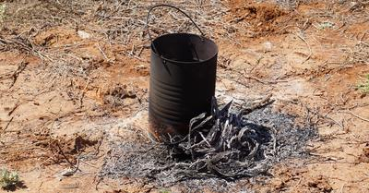
How To Boil Water Without A Pot

‍Whether you're out camping or in a legitimate
survival situation, it's important to know
alternative methods to boil water without a pot.

If you have access to standard cookware and appliances, you can use a kettle or a microwave to boil water. However, during an emergency, you can boil water using a glass bottle (or jar), stainless steel cup, leaf, car engine, or solar still.
Basic Cookware and Appliances
Using a Kettle
If you have access to a kettle, it can be a quick and easy way to boil water without a pot. Simply fill the kettle with water and heat it on a gas stove or fire. Once the water has boiled, carefully pour it into a container of your choice. Be sure to use a heat-resistant container, as the water will be very hot.
Alternatively, you can use an electric kettle to boil water. Keep in mind that you will need to have access to power and electricity for this method to work. Once the water has boiled, it can be safely consumed (once cooled) or used for cooking.
Using a Microwave
If you have a microwave, you can use it to boil water without a pot. Simply fill a microwave-safe container with water and place it in the microwave. Heat the water on high for 2-3 minutes, or until it comes to a rolling boil.
It's important to note that boiling water in a microwave can be dangerous if not done properly. The water can become superheated, which means it surpassed the boiling point without actually boiling.
This can cause the water to explode when disturbed, potentially resulting in serious burns. To avoid this, be sure to use a clean container and stir the water before heating it. This will help prevent superheating and ensure that the water boils safely.

Survival Techniques Using Fire
Using a Glass Bottle or Glass Jar
If you don't have access to a pot, you can use a glass bottle or jar to boil water. Here's how to do it:
- Fill a glass container with water, leaving some space at the top for the water to expand as it boils.
- Place the glass container on a flat surface, such as a rock or a piece of wood.
- Build a fire around the container, making sure that the flames are not touching the glass.
- Wait for the water to come to a boil. This may take some time, so be patient.
- Once the water has boiled, use tongs or a stick to carefully remove the glass container from the fire.
- Let the container cool down before handling it.
It's important to note that not all glass containers are suitable for boiling water. Make sure that the bottle you use is made of tempered glass, which is designed to withstand high temperatures. Also, be careful when handling the glass container, as it will be very hot.
Stainless Steel Cups
Stainless steel cups provide a durable and convenient option for boiling water. To use this method, fill the cup with water and place it near a campfire.
Stainless steel containers heat well and are less likely to crack or warp under high heat. Keeping a stainless steel cup handy in your emergency goods is highly recommended as this is a reliable container that can be reused for boiling water more than once. Be sure to use a heat-resistant glove or tool to handle the hot cup.
Leaf
Another environmentally friendly method involves using large, green leaves as natural, biodegradable containers for boiling water. This practice requires skill and the right type of leaf.
Select a leaf that is sturdy and waterproof. After filling it with water, secure it between hot rocks or sticks above a gentle flame. Monitor the heat to prevent burning the leaf.

Survival Techniques Without Fire
Using a Car Engine
If you are stranded in a car and need to boil water, you can use the car’s engine to generate heat.
One method is to use the radiator. Locate the radiator and remove the cap. Pour water into the radiator until it is full.
Start the car and let it run for several minutes. The heat from the engine will transfer to the water in the radiator, causing it to boil.
It is important to note that using a car engine to generate heat can be dangerous and should only be done in an emergency situation.
Using a Solar Still
When it comes to survival techniques, using a solar still to boil water without a pot is a great option. This method is especially useful in desert climates where water is scarce. Here's how to do it:
- Find a clear plastic bag or sheet, as well as a container to collect water.
- Place a small amount of vegetation or moist soil in the center of a shallow hole in the ground.
- Place the container in the center of the hole on top of the vegetation or soil.
- Place the plastic bag or sheet over the hole, making sure it’s tightly sealed around the edges with rocks or dirt.
- Place a small rock in the center of the plastic bag or sheet, directly over the container.
- Wait for the sun to heat up the hole and evaporate the water from the vegetation or soil. The water vapor will collect on the underside of the plastic bag or sheet and drip into the container.
- After several hours, check the container for water.
This method may take some time, but it's a great way to obtain clean, drinkable water in a survival situation - without relying on a fire to boil water!
Safety Precautions
Boiling water without a pot can be a useful skill in certain situations, but it's important to remember that there are some safety precautions you should take to avoid injury or illness. Here are some tips to keep in mind:
- Always use heat-resistant gloves or a towel to handle hot containers.
- Make sure the container you're using is made of a material that can withstand high temperatures, such as metal or glass.
- Avoid using plastic containers, when possible, as they can melt or release harmful chemicals when exposed to high heat.
- Be careful when pouring boiling water, as it can easily splash and cause burns.
- Keep children and pets away from the area where you're boiling water.
- Consider the environment and abide by local regulations when starting a fire for boiling water.
- If you're boiling water to purify it, it's recommended that you bring the water to a rolling boil for at least one minute (or three minutes at higher altitudes) to kill any bacteria, viruses, or parasites that may be present.
- If you're unsure about the quality of the water, you may want to consider using a water filter or purification tablets in addition to boiling.
Source:
www.buildastash.com article by Mark Walker


How To Rodent Proof Your Food Storage

‍Rodents are pesky pests that can potentially put
your entire emergency goods at risk, but how do you
rodent-proof a food storage stockpile?

To rodent-proof your food storage use durable airtight food containers, block all entry points to your house such as cracks & holes, keep your home clean, keep food in the fridge or freezer, and use traps and repellents. Remember to inspect your stockpile regularly for droppings and chew marks.

After extensively researching food storage preparation and survival techniques, I have gathered enough information to determine how to rodent-proof an emergency goods stockpile. In this article, we’ll be taking a closer look at the most effective strategies you can implement to protect your food storage from rodents and pests.
How to Tell if Rodents Are Active in Your Food Storage
Rodents are a common threat to food storage stockpiles that all preppers should be ready to deal with. These critters can easily make their way into your home and get into your goods if you do not take precautions.
Most people keep their food storage supplies in locations that are quiet and generally, have less foot traffic such as the basement or pantry. This is the ideal place for rodents to strike as they feel less threatened to be active and make their way into your food.
One of the most important things you can do to secure your food storage stockpile is to watch out for telltale signs that rodents are active in your home. Keep an eye out for the following signs when evaluating your home and food storage for rodents.
1. Rodent Droppings
The first thing that you will likely see is rodent droppings or pellets scattered around. After enjoying a free meal from your food storage, rodents usually leave droppings in the area.
Depending on the number of rodents that are actively accessing your goods, you may see small or large amounts of droppings on the floor and within the vicinity of your food.

2. Chew Marks
Rodents will chew on pretty much anything and everything, as these critters like to bite various objects in your home to see if they are edible.
You will likely see chew marks in parts of your stockpile, especially on food packaging. Unlike many other pests and animals, rodents will actually pursue food packaging that is airtight and unopened.
Take a close look at your food supplies and see if you can spot any visible bite marks on the packaging. If pests have found a way into your emergency goods, it will likely be quite obvious. The rats may have gained access to certain food items, which would result in food being scattered on the floor, as well as bite marks on boxes and packages.
3. Visible Destruction
Even if rats or mice did not penetrate your food storage, they may have left other types of visible destruction in the area to indicate a rodent infestation.
Mice chew and destroy various parts of your home, even if it's not food. These rodents will go for paper, wires, clothes - anything that you have laying around.
4. Holes in Walls
If you notice a small hole in your wall that you are certain was not there before, you may have a rodent problem on your hands. These cunning critters will create tunnels to better navigate and access your home.
Holes in walls offer rodents a strategic advantage to get around being spotted while crawling around your house. While they will generally use holes and openings that already exist, they have been known to make their own.
How to Rodent Proof Your Food Storage
Rodent-proofing is an essential part of maintaining a food storage system. The bulk storage of goods in your home can be an open invitation for pests to come inside and try to find food.
To prevent rodents from accessing your food supplies, you need to completely pest-proof your home and stockpile thoroughly.
Rodents can be tricky to contain and you need to tick every box if you want to keep them out for good. Consider the following strategies when rodent-proofing your food storage.
1. Use Food Storage Containers
One of the biggest mistakes you can make is keeping food items in their original packaging. Most of the foods you buy in the store were not designed to be 100% mouse-proof.

Rats and mice have sharp teeth and jaws powerful enough to bite through the packaging of most food items in your stockpile. To prevent rodents from getting into your food, you must transfer your goods into practical and reliable food storage containers.
There are plenty of food storage containers that will prevent rodents from chewing through, such as metal containers, hard plastic containers, and glass containers. Some of the best rodent-proof food storage containers you should consider using are:
- Food-Grade Buckets
- Hard Plastic Airtight Containers
- Mason Jars
If the rats and mice can’t bite through it, then it should be safe from all pests. However, what’s equally important is that you buy airtight containers. Although the container may be durable enough to prevent chewing, an air leak can attract pests to your food storage, not to mention contaminate your food.
Always use airtight containers that completely seal, with tight-fitting metal lids or durable plastic ones. As a general rule of thumb, food-grade buckets, hard plastic containers, and mason jars tend to be the most reliable.
Once you’ve found mouse-proof containers, I would suggest placing all of your goods inside of storage boxes to secure them thoroughly.
2. Block Entry Points
The bottom line is if there is a way in, rodents will find it. Rats and mice are notorious for utilizing even the smallest and most obscure openings to access your home.
These critters will look for any excuse to get inside your food storage, which is why you want to block all entry points that leave your home vulnerable. Naturally, if you see any visible openings, you can take immediate action to seal them before rodents get in.
However, some openings can be trickier to find and may require a thorough inspection. Unfortunately, the incentive to find every potential opening in your home only becomes a priority once rodents become active. Nonetheless, you can use the following methods to block entry points to your home and food storage:
- Steel Wool
- Caulk
- Heavy duty plastic
- Cement
- Metal
- Glass
The type of material you use to block entry points is really up to you, but you may find that some are preferable depending on the location of the opening. Remember to keep an eye out for any openings big or small. Rodents will use holes, cracks, tears, and any opening they can find to get into your food storage.
Once you find an opening such as a hole, use steel wool to stuff the entry point. Alternatively, cracks and tears are much easier to seal with caulk and cement. If the opening requires plastic, glass, or metal, use a material that is suitable for the area of your home.
3. Keep Your Home Clean
There are plenty of scents, food scraps, and other things laying around the house that will attract pests. Maintaining a regular cleaning schedule in your home and food storage will be essential to deter rodents from coming inside.
This is particularly the case with food-related scents and scraps. Any signs of food in your home, including pet food that has not been contained and sealed, will attract mice and rats, which is why cleanliness is a must when rodent-proofing.
4. Keep Food in the Fridge and Freezer
One of the best places to keep food items in your home is the fridge or freezer. Unlike many dry goods in your food storage system, the fridge and freezer offer a contained space that cannot be chewed through or accessed by rodents.
This is an ideal place for keeping your food items if your system allows it. Just make sure that you have the fridge and freezer space for your goods before you rely solely on this approach.
5. Use Traps and Repellents
I would generally only recommend resorting to traps and repellents if you are already dealing with a rodent infestation. However, some preppers like to go the extra mile when deterring rodents from getting in.
Traps and repellents are one of the most reliable tools in your tool kit and they work wonders at preventing rodent infestations from running wild. There are a lot of different options to consider, and you should ultimately decide on a method based on the severity of your infestation and the design of your food storage system.
Best Rodent Traps to Protect Food Storage
Rodent traps or mouse traps are a classic solution to dealing with rats and mice. Some traps stop these critters dead in their tracks, whereas others are a bit more forgiving. Consider the following rodent traps to protect your food storage stockpile.
Snap traps are a go-to pick among preppers, and this method is as effective now as it ever was. Simply place a snap trap as instructed within the area of your food storage stockpile or anywhere in your home where rodents are active.

If you want to keep rodents out of your food storage but do not wish to cause the critters harm, you can opt for a humane rodent trap.
Aside from scaring the rodent, a humane trap does not actually physically hurt them. After placing food inside the trap, rodents will enter, causing the cage’s locking mechanism to trap them inside. You can then release the rodent in a safe location away from your home unharmed.
A glue trap is a very effective way to prevent rodents from accessing your food storage. Much like the name suggests a glue trap will glue the critter to the surface of a board, stopping them from moving any further.
The surface of the board is covered in an adhesive that rodents will stick to as soon as they make contact with it. This trap does not immediately kill the rodent, which will require you to finalize the job.
The new-age approach to dealing with pests is to place an electric trap inside your food storage area. This is the most sophisticated and advanced method given that rodents are physically electrocuted when they enter the trap.
Electric traps look like rectangular boxes that lure rodents inside. As soon as the rodent steps inside, an electric shock stops them dead in their tracks.
Best Rodent Repellents to Protect Food Storage
One of the best ways to prevent rodents from accessing your food storage is to use repellents. Unlike traps, repellents aim to deter rodents from ever coming into your home or to make them feel uncomfortable if they do.
There are several repellents such as poisons that you can use. However, I find that modern-age natural solutions work just as well as traditional rat poisons, without negatively affecting your health or the environment. Consider the following repellents when rodent-proofing your home food storage.
The technology behind repelling rodents has become very advanced over the years. These days, you can repel virtually every household pest by using an ultrasonic electromagnetic rodent Repeller.
This device repels various types of insects, as well as rodents such as rats and mice. By activating the ultrasonic pest Repeller, the device will essentially protect the inside and outside of your entire home from pests.
Natural Oils
Certain oils work wonders at repelling pests and are a natural solution that allows you to stop pests without the use of poisons. The best natural oils for repelling rodents are:

- Peppermint Oil
- Castor Oil
- Citronella Oil
- Eucalyptus Oil

- Lemon Oil
For this method to work, you need to soak your preferred natural oil in cotton balls or old rags. Then place the soaked cotton balls and rags into openings such as holes or cracks that rodents use to enter your home. In addition, simply placing the soaked cotton balls or rags in an area where rodents are active will also work as a deterrent.
Tips for Rodent Proofing Food Storage
If you want mouse-proof storage that prevents all rodents from getting into your goods, you must take measures ahead of time to secure your stockpile.
The last position you want to find yourself in when relying on your food storage is to discover that the bulk of your goods has been contaminated by rodents. To ensure your stockpile is safe from rodents and pests, keep the following tips in mind when securing your food storage.
1. Inspect Your Food Storage Regularly
Food storage areas can often get neglected. It’s quite common for preppers to ambitiously set up a stockpile in an area of their home and then assume their goods are safe for the long haul.
This is not always the case. Rodents can make their way into just about any home and the first place they will likely target is your food storage. That said, it’s important to check up on your stockpile routinely. I recommend inspecting your goods for chew marks and droppings at least once a week.
2. Check All Food Packaging Before Storing
One of the main reasons for rodents to get into a stockpile is if some of the packaging of your goods have been damaged. Any opening can attract rodents, which is why you should always check all packages before storing them.
Look for any tears or holes that are leaking air. To prevent incidents like this from occurring, I suggest transferring all food items to durable airtight containers.
3. Check Outside the House
Many preppers are often shocked when rodents unexpectedly appear inside their home. Even if you have a clean house with all food contained properly, rodents can often be active on your property if you have something outside your home that attracts them.
Fruit-bearing trees and gardens can encourage rats and mice to linger around your residence. If that’s the case, consider repelling rodents inside, as well as outside of your home.
Source:
www.buildastash.com article by Mark Walker

Family Preparedness Plan

Your family may not be together if a disaster strikes, so it is important to know which types of disasters could affect your area.
Active Shooter, Avalanche, Cyberattack, Earthquake, Extreme Heat, Financial Emergency, Flood, Hurricane, Landslide, Novel Pandemic, Nuclear Explosion, Power Outage, Thunderstorm, Lightning, and Hail, Tornado, Wildfire, Winter Storm.
Know how you’ll contact one another and reconnect if separated. Establish a family meeting place that’s familiar and easy to find.
Step 1: Put a plan together by discussing the questions below with your family, friends or household to start your emergency plan.
How will I receive emergency alerts and warnings?
Wireless Emergency Alerts (WEAs)
Wireless Emergency Alerts (WEAs) are short emergency alerts authorities can send to any WEA-enabled mobile device in a locally targeted area. Alerting Authorities who are authorized to send WEAs include state, local, tribal, and territorial public safety officials, the National Weather Service, the National Center for Missing and Exploited Children and the President of the United States.
WEAs look like text messages but are designed to get your attention with a unique sound and vibration repeated twice.
WEAs are not affected by network congestion and will not disrupt texts, calls or in-progress data sessions.
Children will also receive alerts on their WEA-enabled mobile devices. Parents and guardians, talk to your children about WEA Alerts and staying safe in an emergency. A fact sheet about WEAs for kids can be found here.
All major phone providers and some smaller providers participate in WEA.
Emergency Alert System (EAS)
The Emergency Alert System (EAS) is a national public warning system that allows the president to address the nation within 10 minutes during a national emergency. Other authorized federal, state, local, tribal and territorial alerting authorities may also use the system to deliver important emergency information such as weather information, imminent threats, AMBER alerts and local incident information targeted to specific areas.
A tv shows the message: Emergency Alert System National Weather Service has issued a tornado warning for the following counties:
The EAS is sent through broadcast TV and radio, satellite digital audio services, direct broadcast satellite providers, cable television systems and wireless cable systems.
The President has sole responsibility for determining when the national-level EAS will be activated. FEMA and the FCC are responsible for national-level tests and exercises.
NOAA Weather Radio (NWR)
NOAA Weather Radio All Hazards (NWR) is a nationwide network of radio stations that broadcast continuous weather information from the nearest National Weather Service office based on your physical location.
NWR broadcasts official warnings, watches, forecasts and other hazard information 24 hours a day, seven days a week.
NWR also broadcasts alerts of non-weather emergencies such as national security or public safety threats through the Emergency Alert System.
Integrated Public Alert and Warning System (IPAWS)
The Integrated Public Alert and Warning System (IPAWS) is FEMA’s national system for local alerting. It gives federal, state, local, tribal, and territorial public safety agencies the ability to send WEAs, EAS alerts, weather and non-weather-related emergency messages simultaneously through NOAA weather radios, and alerts through systems like sirens and digital billboards.
A graphic showing how IPAWS works by sending alerts through the Emergency Alert System, the Wireless Emergency Alerts, and NOAA Weather Radio
IPAWS empowers local Alerting Authorities to send their own emergency alerts. FEMA does not review, edit or approve alerts.
IPAWS alerts can be locally targeted to ensure only devices in the affected area receive the alert.
FEMA Mobile App
The FEMA App allows you to receive real-time weather and emergency alerts, send notifications to loved ones, locate
Receive real-time weather and emergency alerts from the National Weather Service for up to five locations nationwide.
Find a nearby shelter if you need to evacuate to a safe space.
Find out if your location is eligible for FEMA assistance, find Disaster Recovery Center locations, and get answers to your most pressing questions.

What is my shelter plan?
Sheltering is appropriate when conditions require that you seek protection in your home, where you work or other location when other emergencies arise. The length of time you are required to take shelter may be short, such as during a tornado warning, or during a pandemic. In all cases, it is important that you stay informed and follow the instructions of local authorities.
During extended periods of sheltering you will need to manage water and food supplies to make sure you and your family have what you need to get by. Read more about managing water and managing food.
Choosing to take shelter is necessary in many emergencies. This can mean: Stay-At- Home, Going to a Mass Care Shelter, or Sheltering in Place. Here’s the distinction:
Mass Care Shelter
Mass care shelters provide life sustaining services to disaster survivors. Even though mass care shelters often provide water, food, medicine and basic sanitary facilities, you should plan to take your emergency supply kit with you so you will have the supplies you need. Mass care sheltering can involve living with many people in a confined space, which can be difficult and unpleasant.
- Be prepared to take cleaning items with you like, soap, hand sanitizer, disinfecting wipes or general household cleaning supplies to disinfect surfaces.
- All shelters accept service animals, but many public shelters and hotels do not allow pets inside. Know a safe place where you can take your pets before disasters and emergencies happen.
- Search for open shelters by texting SHELTER and your ZIP code to 43362. Example: Shelter 01234 (standard rates apply).
Sheltering in Place
Whether you are at home, work or anywhere else you frequent regularly, there may be situations when it's best to stay where you are and avoid any uncertainty outside.
Here are some indicators and steps to take if the situation arises:
- Use common sense and available information to assess the situation and determine if there is immediate danger.
- If you see large amounts of debris in the air, or if local authorities say the air is badly contaminated you may want to take this kind of action.
Here are some tips for sheltering in place:
- Local authorities may not immediately be able to provide information on what is happening and what you should do.
- Pay attention to local media outlets for official news and instructions as they become available.
- Bring your family and pets inside.
- Lock doors, close windows, air vents and fireplace dampers.
- Turn off fans, air conditioning and forced air heating systems.
- Take your emergency supply kit unless you have reason to believe it has been contaminated.
- Go into an interior room with few windows if possible.
- Seal all windows, doors and air vents with thick plastic sheeting and duct tape. Consider measuring and cutting the sheeting in advance to save time.
- Cut the plastic sheeting several inches wider than the openings and label each sheet.
- Duct tape plastic at corners first and then tape down all edges.
- Be prepared to improvise and use what you have on hand to seal gaps so that you create a barrier between yourself and any contamination.
- “Sealing a room” is considered a temporary protective measure to create a barrier between you and potentially contaminated air outside. This type of sheltering in place requires pre-planning, by purchasing plastic sheeting and duct tape that you would keep in your emergency supply kit.

Stay-at-Home
Remain indoors as much as possible and try to only leave your home when necessary. You can still use outdoor spaces such as patios, porches and yards.
Outdoor activities such as walking, jogging and exercise are fine if you practice social distancing.
Essential services such as grocery shopping, the gas station, pharmacies and going to the Post Office are still fine to do.
Limit visitors if possible. Try to use video chatting. Call the people you would normally text.
What is my evacuation route?
Many kinds of emergencies can cause you to have to evacuate. In some cases, you may have a day or two to prepare while other situations might call for an immediate evacuation. Planning is vital to making sure that you can evacuate quickly and safely no matter what the circumstances.
Before an Evacuation
- Learn the types of disasters that are likely in your community and the local emergency, evacuation, and shelter plans for each specific disaster.
- Plan how you will leave and where you will go if you are advised to evacuate.
- Check with local officials about what shelter spaces are available for this year.
- Identify several places you could go in an emergency such as a friend’s home in another town or a motel. Choose destinations in different directions so that you have options during an emergency.
- If needed, identify a place to stay that will accept pets. Most public shelters allow only service animals.
- Be familiar with alternate routes and other means of transportation out of your area.
- Always follow the instructions of local officials and remember that your evacuation route may be on foot depending on the type of disaster.
- Come up with a family/household plan to stay in touch in case you become separated; have a meeting place and update it depending on the circumstance.
- Assemble supplies that are ready for evacuation. Prepare a “go-bag” you can carry when you evacuate on foot or public transportation and supplies for traveling longer distances if you have a car.
- If you have a car:
  - Keep a full tank of gas if an evacuation seems likely. Keep a half tank of gas in it at all times in case of an unexpected need to evacuate. Gas stations may be closed during emergencies and unable to pump gas during power outages. Plan to take one car per family to reduce congestion and delay.
  - Make sure you have a portable emergency kit in the car.
- If you do not have a car, plan how you will leave if needed. Decide with family, friends or your local emergency management office to see what resources may be available.
During an Evacuation
- Listen to a battery-powered radio or your HAM and review local evacuation instructions.
- Take your emergency supply kit.
- Leave early enough to avoid being trapped by severe weather.
- Take your pets with you but understand that only service animals may be allowed in public shelters. Plan how you will care for your pets in an emergency now.
- If time allows:
  - Communicate with your out-of-state contact in your family communications plan. Tell them where you are going.
  - Secure your home by closing and locking doors and windows.
  - Unplug electrical equipment such as radios, televisions and small appliances. Leave freezers and refrigerators plugged in unless there is a risk of flooding. If there is damage to your home and you are instructed to do so, shut off water, gas and electricity before leaving.
  - Wear sturdy shoes and clothing that provides some protection such as long pants, long-sleeved shirts and a hat.
  - Check with neighbors who may need a ride.
- Be alert for road hazards such as washed-out roads or bridges and downed power lines. Do not drive into flooded areas.

After an Evacuation
If you evacuated for the storm, check with local officials both where you’re staying and back home before you travel.
- If you are returning to disaster-affected areas, after significant events prepare for disruptions to daily activities and remember that returning home before storm debris is cleared is dangerous.
- Let friends and family know before you leave and when you arrive.
- Charge devices and consider getting back-up batteries in case power-outages continue.
- Fill up your gas tank and consider downloading a fuel app to check for outages along your route.
- Bring supplies such as water and non-perishable food for the car ride.
- Avoid downed power or utility lines, they may be live with deadly voltage. Stay away and report them immediately to your power or utility company.
- Only use generators outside and away from your home and NEVER run a generator inside a home or garage or connect it to your home's electrical system.
Emergency preparedness kit
After an emergency, you may need to survive on your own for several days. Being prepared means having your own food, water and other supplies to last for several days. A disaster supplies kit is a collection of basic items your household may need in the event of an emergency.
Once you take a look at the basic items consider what unique needs your family might have, such as supplies for pets or seniors.
Emergency Supply List
To assemble your kit store items in airtight plastic bags and put your entire disaster supplies kit in one or two easy-to-carry containers such as plastic bins or a duffel bag.
- Water (one gallon per person per day for several days, for drinking and sanitation)
- Food (at least a several-day supply of non-perishable food)
- Battery-powered or hand crank radio and a NOAA Weather Radio with tone alert
- Flashlight
- First aid kit
- Extra batteries
- Whistle (to signal for help)
- Dust mask (to help filter contaminated air)
- Plastic sheeting and duct tape (to shelter in place)
- Moist towelettes, garbage bags and plastic ties (for personal sanitation)
- Wrench or pliers (to turn off utilities)
- Manual can opener (for food)
- Local maps
- Cell phone with chargers and a backup battery
Additional Emergency Supplies
Consider adding the following items to your emergency supply kit based on your individual needs:
- Soap, hand sanitizer and disinfecting wipes to disinfect surfaces
- Prescription medications. About half of all Americans take a prescription medicine every day. An emergency can make it difficult for them to refill their prescription or to find an open pharmacy. Organize and protect your prescriptions, over-the-counter drugs, and vitamins to prepare for an emergency.
- Non-prescription medications such as pain relievers, anti-diarrhea medication, antacids or laxatives
- Prescription eyeglasses and contact lens solution
- Infant formula, bottles, diapers, wipes and diaper rash cream
- Pet food and extra water for your pet
- Cash or traveler's checks
- Important family documents such as copies of insurance policies, identification and bank account records saved electronically or in a waterproof, portable container
- Sleeping bag or warm blanket for each person
- Complete change of clothing appropriate for your climate and sturdy shoes
- Fire extinguisher
- Matches in a waterproof container
- Feminine supplies and personal hygiene items
- Mess kits, paper cups, plates, paper towels and plastic utensils
- Paper and pencil
- Books, games, puzzles or other activities for children
Step 2: Consider specific needs in your household.
As you prepare your plan tailor your plans and supplies to your specific daily living needs and responsibilities. Discuss your needs and responsibilities and how people in the network can assist each other with communication, care of children, business, pets or specific needs like operating medical equipment. Create your own personal network for specific areas where you need assistance. Keep in mind some these factors when developing your plan:
- Different ages of members within your household
- Responsibilities for assisting others
- Locations frequented
- Dietary needs
- Medical needs including prescriptions and equipment
- Disabilities or access and functional needs including devices and equipment
- Languages spoken
- Cultural and religious considerations
- Pets or service animals
- Households with school-aged children
12 ways to Prepare
- Sign up for Alerts and warnings
- Make a Plan
- Save for a Rainy Day
- Practice Emergency Drills
- Test Family Communication plan
- Safeguard Documents
- Plan with Friends/ neighbors
- Make your home safer
- Know your evacuation Routes
- Assemble or update Supplies
- Get Involved in your Community
- Document and Insure Property
Source:
www.ready.gov

Get Home Bag List

What is a Get Home Bag?
A get home bag (GHB) is a bug out bag variant that is designed to do the opposite. Instead of evacuating your home for a bug out location, the get home bag is designed to get you back to your home and supplies.
On average, people spend 38% of their time awake away from their homes. Disaster can strike at any moment, so you don’t want to be unprepared 38% of the time!
The get-home bag usually has similar contents to a bug-out bag because you may not be certain how long it would take you to get home in an emergency. If your workplace is easily walkable, your GHB will be smaller and closer to Everyday Carry (EDC). If you work several hours from your home or travel regularly, your GHB may be closer to an INCH kit. The bags are flexible based on your needs, and our gear guide below reflects our suggestions.
When you are developing your emergency plan and find that you often spend time away from home, that is when you may want to determine your need for a GHB.
Get Home Bag vs Bug Out Bag
Get-home bags are designed to meet different goals than bug-out bags and other bug-out bag variants.
For starters, they are designed for a different starting point. Bug out bags are typically designed to go from point A to point B- which can be predetermined with planning. Get home bags need to be able to go from point X to point A, and you may not be certain where point X is and how far it is.
Because of this difference in planning, GHB bags range in size and what you decide to include.
Get Home Bag List
The standard get home bag essentials with our recommended gear for each area. Grabbing the supplies listed will give you the resources to tackle emergencies, disasters, or just everyday life without notice.
The Get Home Bag:
To keep the kit together, you’ll need a bag, tote, or backpack. I like the 18-30 liter backpacks to fit the essentials, but you may opt for a larger bag if you typically have further to go to get home.
- Backpack: 5.11 LV18 2.0 Backpack (See why this is the best and view other backpack options) – Discrete backpacks work well in this application since they can go to many places unnoticed- whether it’s the workplace or heavily populated areas.

Safety Essentials:
- Survival Knife: Fixed Blade Knife
- Bushcraft Knife: Fixed Blade Knife
- Handgun: Your preferred CCW that you are trained on
- Ammunition: For your CCW, of course
Fire & Light Essentials:
- Flashlight
- Headlamp
- Lighter: Windproof Arc Lighter
- Waterproof Matches
Water Essentials:
- Steel Water Bottle
- Purification Tablets
- Water Filter: Mini Water Filtration System
Food Essentials:
- Ration Bars
- Meals, Ready to Eat (MRE): US Military MRE
Communication Essentials:
- Emergency Radio/Light/Charger: NOAA Solar Crank Radio
- Survival Mirror: Signal Mirror
- Spare Cell Phone Charger: Make sure it works with your main cell phone
Shelter & Clothing Essentials:
- Work Gloves: Mechanix Wear Covert Gloves
- Socks: Darn Tough Light Hiker
- Long Sleeve Shirt: Carhartt Midweight Crew
- Underwear
- Pants: TRU-SPEC Tactical Pants
- Survival Blanket
- Waterproof Tarp
- Survival Sleeping Bag
Hygiene & First Aid Essentials:
- Basic First Aid Kit: 299 Pc First Aid Kit
- Prescription Medication: Don’t get caught without your meds! Pack them securely in an airtight, watertight container.
- Toothbrush
- Toothpaste
- Soap
- Feminine Supplies: Feminine hygiene supplies may make sense to store in your BOB, even if you are a male.
- N-95 Masks
- Nitrile Gloves
Documents & Navigation Essentials:
- Rainproof Pen
- Rainproof Notebook
- Copy of ID: Quickly prove your identity
- Emergency Plan
- Compass
- Local Maps: Print copies of local maps
  - National Geographic USGS maps
  - OpenStreetMap
  - Protect Your Maps
  - Protecting what you print is important. There are many options here, from zip-lock bags in the pantry all the way to using special paper. Here are a few ways to protect what you print:
    - Ziploc– The cheapest option is also the most used. While it is not completely waterproof, it can usually keep it safe inside a pack or kit.
    - Waterproof Bag– This option is better than the zip-lock bag, but it also costs a lot more. You won’t have the leak problems or the sweating problems the zip-lock has.
    - Laminating– Laminating your map can make it handle all sorts of bad weather, spills, sweat, or any other thing a disaster may throw at it. You don’t even need to find a professional copy store or have a laminating machine, they make adhesive laminated sheets you can use. Adhesive laminate is not as good as thermal laminate, but it is better than bare printing paper.
    - Waterproof Paper– Printing your free survival map on waterproof paper is probably the best of the options although it can be costly if you print a lot of sheets. You will have to doctor up your maps on the computer before you print since it will be tough to get anything to stay on the paper besides a permanent marker. Rite in the Rain paper is used by the military and law enforcement.
Miscellaneous Essentials:
- Multitool: Leatherman Signal – Designed for survival
- Paracord: TOUGH-GRID Paracord
- Duct Tape: Gorilla Tape 35 Yard Roll
- Cash Stash: Stash some money in your bug out bag.
Suggested Additions for Your GHB Loadout
This gear may not be essential by definition, but adding any of these to your GHB will improve your kit’s versatility for even more situations.
- Bandana: Colter Co. Reflective Bandana
- Poncho: Staying dry is important during an emergency.
- Boonie Hat
- Jacket
- Boots/Shoes: 5.11 A/T 8″ Waterproof Boots – Sturdy hiking shoes or tactical boots work well in survival situations. Have some for wear and stow some in your pack.
- Power Bank: Portable Charger – Portable battery packs have come way down in cost and are very versatile.
- Signal Flares: Orion Safety Flares – Individual flares are relatively light and pack a punch when you need to signal.
- Whistle: Whistles make getting attention easy
- Canteen with Cup
- Water: If you have weight to spare, fill water containers or bring bagged water.
- Pepper Spray: A great non-lethal weapon for personal protection.
- Batteries: Stocking up on standard batteries is smart
- Sewing Kit: Survival Sew Kit – Repairing textiles and other gear can extend their useful life.
- Folding Saw: cut away debris or make a wilderness shelter
- Garbage Bags:– Use them for trash, or plenty of other survival uses
- Super Glue: For when you want something to stay and never move again.
- Zip Ties
- Military Can Opener
- Camp Stove
- Steel Pot
- Ferro Rod
- Tinder/Fatwood: start fires easier
- Copy of Birth Certificate: An important document.
- Copy of Passport: This can be more important with border access.
- GPS Watch: Garmin Instinct 2– pick your favorite GPS watch
- Ranger Beads: Matte Ranger Beads – Teach yourself to pace count with ranger beads.
- Playing Cards
- Sun Screen: Your favorite brand with high SPF.
- Bug Spray
- Hand Sanitizer: During a pandemic, this is an essential EDC item.
- Portable Bidet
- Anti-diarrheal Tabs: Imodium Loperamide Hydrochloride
Extra Supplies for your GHB Kit
Essentials and suggested additions have been covered, so this is the area will you will find everything else that could be useful to have when you book it home. These extra supplies will help you in very specific situations, are less versatile, and may take up a lot of space. Even still, they could be the difference makers in an emergency- so it could pay off to consider adding these.
- Ham Radio: Baofeng UV-5R – backup communication methods that don’t rely as heavily on infrastructure can definitely come in handy.
- CB Radio: Uniden PRO401HH – Ham may get all the attention, but CB can be an alternative choice that doesn’t require a license.
- Pocket Sharpener: Small sharpener
- Ammo Pouch: Accessible ammo can be a priority depending on your situation.
- Machete
- Axe/Hatchet: This will help you get firewood and get through walls, in extreme cases.
- Quick Dry Cloth: Swedish Sponge Cloth
- Long Underwear: Carhartt Thermal Pant
- Sunglasses
- Scarf/Shemaugh: Explore Land Shemagh – Stay covered in any environment
- Rainproof Shell: Waterproof Backpack Cover
- Ball Cap: Condor Tactical Cap
- Compressed Towels: Lightload Towels
- Handwarmers: HotHands
- Electrolyte Mix: DripDrop Hydration Powder – Stress and hard work getting through a disaster can quickly dehydrate anyone. Combat this with an electrolyte mix
- Bleach: Use for hygiene, sanitization, water treatment, and other sterilization uses.
- Coffee
- Prybar: small and light enough for portable kits, but long enough for leverage.
- Binoculars
- Gold: money that you can hold is still worthwhile even when the main currency crashes.
- Silver
- Hacksaw
- Zip Lock Bags: Lightweight storage is never a bad idea.
- Waterproof Bag: Earth Pak Dry Bag
- Pliers: Adjustable wrench pliers
- Dish Soap: A little bit of dish soap in a small water-tight container.
- Rope: There are plenty of other cordage options besides paracord.
- Fishing Supplies
- Snares: USGI Trip / Snare Wire – Trapping and snaring may require a license in your area. Please check locally to learn the rules and risks before you deploy snares.
- Beef Jerky: Pick your favorite brand and flavor.
- Multi-Vitamins: Make sure your diet completes all of your body’s nutrient requirements.
- Stove Fuel: Extra camp stove fuel.
- Keychain Flashlight
- Steel Wool: So versatile and lightweight.
- Glow Sticks: Great for low light, visibility, signaling, and marking.
- Magnifying Glass
- Fire Extinguisher: A portable fire extinguisher can come in handy
- Insurance Documents: With many regional disasters, it can be a race to file insurance. Being prepared with your documents can make sure you’re at the front of the line.
- Get Home Bag Checklist: Fill it out. Keep it up to date.
- Edible Plants Guide: Edible Wild Plants (Paperback)
- First Aid Guide: Survival Medicine Guide
- Iodide Tablets: iOSAT Potassium Iodide Tablets – Usually found in our specialized kit for those with radiation risk, this one makes sense in a general preparedness kit with its low cost and small package. Protect your thyroid from absorbing radiation during the most terrible emergencies.
- Shaving Supplies
- Foot Powder: Gold Bond Medicated Foot Powder – Keep your feet dry when you’re on the move!
- Toilet Paper
- Floss: Floss is versatile and surprisingly strong!
- Sting Kit: Sting-Kill – Take the bite out of a sting quickly
- Extra OTC Medication: Over-the-counter meds should be a part of your first aid kit, but stashing extras is a good idea.
- Trauma Kit: Trauma IFAK – Use only if trained.

Get Home Bag FAQs
What should I consider when choosing a bag for my Get Home Bag?
When selecting a bag to hold your gear, you should consider your physical capabilities and how far you typically would need to travel to return home. Many people we talk to opt to go with a tote or duffel in their vehicle when they have physical mobility issues that prevent them from practically backpacking the distance.
How often should I review and update the contents of my Get Home Bag?
You should check the contents, test equipment, and review expiration dates at least annually. Adding this review to your annual emergency plan review usually makes sense.
Can I personalize my Get Home Bag based on specific risks in my area?
Yes! And we highly encourage you to do so. If you have an elevated risk of winter weather disruption or have self-defense needs, you should adapt your bag accordingly.
What should I do if I need to use items from my Get Home Bag?
Use them! Even if it’s not an emergency, having resources is one of the great things about having a get home bag with you. Be sure to restock whatever you use so you aren’t limited if you need the item in the future.
How should I store my Get Home Bag when not in use?
As a mobile survival kit, it makes sense to store your get home bag in a location that is out of the way but easy to grab as you leave. I keep mine on a coat hook next to the door to the garage, keeping it off the floor and out of the way but easy to grab every time I leave the house.
Is there a recommended weight limit for a Get Home Bag?
The weight limit of a get home bag should be a maximum of 20% of your body weight. This limit assumes that you are physically-abled and in relatively good shape. It also assumes that you packed the bag with the weight distributed comfortably.
Source:
www.trueprepper.com

Bug Out Bag List

Bug out bags go by many different names, including:
- Go bag
- 72-hour bag (or kit)
- Emergency bag (or kit)
- Evacuation bag (evac bag)
- Survival bag (or kit)
- GOOD Bag (Get Out Of Dodge)
- SHTF Bag (Shit Hit The Fan)
Despite the many names, they all have the same purpose: preparedness for survival regardless of your location. You might see other bags related to survival elsewhere, but those are technically bug out bag variations and not quite the same.
Survival tools, food, and water are the cornerstones of these kits that are designed to sustain you as you execute your emergency plan. They are individual kits, meaning that even in a family, you spread food and water storage across each person’s bug out bag rather than storing it all in one or two large kits. There are many varieties of bug out bags – but they all are built with survival on the go in mind.
The Bug Out Bag:
The bag itself needs to hold all of the essential gear and any other survival gear you deem necessary. Weight and volume can become an issue with smaller bags, plus you will want to pack your bag like a professional backpacker.
Backpack
Safety BOB Essentials:
Self-defense is always a high priority, and that priority is easily supported as crime historically increases drastically during widespread disasters. Even during non-emergencies, security, and self-protection consistently show up as the top focus of most risk analysis.
- Survival Knife: Fixed Blade Knife
- Bushcraft Knife: Fixed Blade Knife
- Handgun: The preferred CCW that you are trained on
- CCW Holster: Alien Gear Concealed Carry Holsters – Get a holster in the profile you want from the best brand.
- Ammunition: PSA Ammo Deals – Get ammo for your CCW at huge discounts.

Fire & Light BOB Essentials:
As you don’t want to be rendered useless for half of the day while it is dark, having light sources available and the ability to create fire are both important. Besides seeing, you’ll need fire sources to stay warm, cook food, and purify water.
- Flashlight
- Headlamp
- Lighter: Windproof Arc Lighter
- Waterproof Matches
Water BOB Essentials:
- Steel Water Bottle
- Purification Tablets
- Water Filter: Mini Water Filtration System
Food BOB Essentials:
- Ration Bars:
- Meals, Ready to Eat (MRE): US Military MRE (from our best MRE review) – a highly portable all-in-one hot meal.
Communication BOB Essentials:
- Emergency Radio/Light/Charger: NOAA Solar Crank Radio
- Survival Mirror: Survival Signal Mirror
- Spare Cell Phone Charger: Make sure it works with your main cell phone
Shelter & Clothing BOB Essentials:
Being able to get covered and clothed is important for surviving a wide range of environments or potential weather scenarios.
- Work Gloves: Mechanix Wear Covert Gloves
- Waterproof Tarp
- Sleeping Bag
- Socks
- Long Sleeve Shirt: Carhartt Midweight Crew
- Underwear
- Pants: TRU-SPEC Tactical Pants
- Survival Blanket

Hygiene & First Aid BOB Essentials:
First aid is common sense and hygiene is often underrated when it comes to survival.
- Basic First Aid Kit: 299 Pc First Aid Kit
- Prescription Medication: Don’t get caught without your meds! Pack them securely in an airtight, watertight container.
- Toothbrush
- Toothpaste
- Soap
- Feminine Supplies: Feminine hygiene supplies may make sense to store in your BOB, even if you are a male.
- N-95 Masks
- Nitrile Gloves
Documents & Navigation BOB Essentials:
Don’t get lost and be able to make notes.

- Rainproof Pen: Rite in the Rain EDC Pen – take notes in any conditions (see why this is the best survival pen)
- Rainproof Notebook: Rite in the Rain Notebook – the best writing pad to have in your survival kit (our waterproof notebook review shows why).
- Copy of ID: Quickly prove your identity
- Emergency Plan: Print a copy of your TruePrepper Basic Emergency Plan
- Compass: Brunton TruArc Compass – navigate and plot your maps. (See why this is the best survival compass)
- Local Maps: Print copies of local maps
  - National Geographic USGS maps
  - OpenStreetMap
  - Protect Your Maps
  - Protecting what you print is important. There are many options here, from zip-lock bags in the pantry all the way to using special paper. Here are a few ways to protect what you print:
    - Ziploc– The cheapest option is also the most used. While it is not completely waterproof, it can usually keep it safe inside a pack or kit.
    - Waterproof Bag– This option is better than the zip-lock bag, but it also costs a lot more. You won’t have the leak problems or the sweating problems the zip-lock has.
    - Laminating– Laminating your map can make it handle all sorts of bad weather, spills, sweat, or any other thing a disaster may throw at it. You don’t even need to find a professional copy store or have a laminating machine, they make adhesive laminated sheets you can use. Adhesive laminate is not as good as thermal laminate, but it is better than bare printing paper.
    - Waterproof Paper– Printing your free survival map on waterproof paper is probably the best of the options although it can be costly if you print a lot of sheets. You will have to doctor up your maps on the computer before you print since it will be tough to get anything to stay on the paper besides a permanent marker. Rite in the Rain paper is used by the military and law enforcement.
Miscellaneous BOB Essentials:
- Multitool: Leatherman Signal – Designed for survival
- Paracord
- Duct Tape: Gorilla Tape 35-Yard Roll
- Cash Stash: Stash some money in your bug out bag.
Suggested Additions for Your Bug Out Bag
This gear may not be essential by definition, but adding any of these to your bug out bag will improve your bag’s versatility for even more situations.
- Bandana: Colter Co. Reflective Bandana
- Poncho
- Tent: Pick a size big enough for your family but not too big to carry.
- Boonie Hat
- Jacket
- Boots/Shoes: 5.11 A/T 8″ Waterproof Boots – Sturdy hiking shoes or tactical boots work well in survival situations. Have some for wear and stow some in your pack.
- Power Bank: INUI Portable Charger – Portable battery packs have come way down in cost and are very versatile.
- Signal Flares: Individual flares are relatively light and pack a punch when you need to signal.
- Whistle: Whistles make getting attention easy.
- Canteen with Cup
- Water: If you have weight to spare, fill water containers or bring bagged water.
- Pepper Spray
- Batteries: Stocking up on standard batteries is smart
- Sewing Kit
- Folding Saw: cut away debris or make a wilderness shelter
- Garbage Bags: Use them for trash, or plenty of other survival uses
- Super Glue: For when you want something to stay and never move again.
- Zip Ties
- Military Can Opener
- Camp Stove: A trusty camp stove will give you yet another option to quickly prepare meals.
- Steel Pot
- Ferro Rod
- Tinder/Fatwood: start fires easier
- Tea Candles: At 7 cents each, a few of these in the bug out bag don’t hurt.
- Copy of Birth Certificate: An important document.
- Copy of Passport: This can be more important with border access.
- GPS Watch: Garmin Instinct 2– pick your favorite GPS watch (see why this is our best-reviewed survival watch).
- Ranger Beads: Matte Ranger Beads – Teach yourself to pace count with ranger beads.
- Playing Cards
- Sun Screen: Your favorite brand with high SPF.
- Bug Spray
- Hand Sanitizer: An essential EDC item can work in your bug out bag as well.
- Portable Bidet
- Anti-diarrheal Tabs: Imodium Loperamide Hydrochloride
Extra Supplies for a Bug Out Bag
Essentials and suggested additions have been covered, so this is the area will you will find everything else that could be useful for your bug out bag. These extra supplies will help you in very specific situations, are less versatile, and may take up a lot of space. Even still, they could be the difference makers in an emergency- so it could pay off to consider adding these.
- Ham Radio: Baofeng UV-5R – backup communication methods that don’t rely as heavily on infrastructure can definitely come in handy. See why this is the best ham radio for preppers and other options.
- CB Radio: Uniden PRO401HH – HAM may get all the attention, but CB can be an alternative choice that doesn’t require a license.
- Takedown Rifle: A 10/22 is an excellent choice for a collapsible, versatile rifle.
- Gun Cleaning Kit: Universal Gun Cleaning Kit – take care of your weapons.
- Pocket Sharpener: Fallkniven DC3 – Small but effective diamond sharpener (check out our other option in our sharpener roundup)
- Ammo Pouch: Accessible ammo can be a priority depending on your situation.
- Machete: CRKT Halfachance Parang
- Axe/Hatchet: Estwing Camper’s Axe These will help you get firewood and get through walls, in extreme cases. (see why this is the best survival axe)
- Quick Dry Cloth: Swedish Sponge Cloth
- Long Underwear: Carhartt Thermal Pant
- Sunglasses
- Sleeping Mat/Ground Pad: Foam Mat
- Scarf/Shemaugh: Explore Land Shemagh – Stay covered in any environment
- Rainproof Shell: Waterproof Backpack Cover
- Ball Cap: Condor Tactical Cap
- Compressed Towels: Lightload Towels
- Handwarmers: HotHands
- Tent Stakes: 7″ Aluminum Stakes
- Electrolyte Mix: Stress and hard work getting through a disaster can quickly dehydrate anyone.
- Bleach: Use for hygiene, sanitization, water treatment, and other sterilization uses.
- Coffee
- Prybar: small and light enough for portable kits, but long enough for leverage.
- Binoculars
- Gold: money that you can hold is still worthwhile even when the main currency crashes.
- Silver: smaller denominations for better payment/barter flexibility
- Hacksaw
- Zip Lock Bags
- Waterproof Bag
- Pliers: Adjustable wrench pliers
- Dish Soap: A little bit of dish soap in a small water-tight container.
- Rope: There are plenty of other cordage options besides paracord.
- Fishing Supplies
- Snares: USGI Trip Wire – Trapping and snaring may require a license in your area. Please check locally to learn the rules and risks before you deploy snares.
- Conibear Traps: Bridger Conibear Traps – Again, check locally for rules and risks before deploying a conibear.
- Beef Jerky: Pick your favorite brand and flavor.
- Condiments: Make anything edible (like an MRE!) by dousing it in your favorite condiment.
- Multi-Vitamins: Make sure your diet completes all of your body’s nutrient requirements.
- Stove Fuel: Extra camp stove fuel.
- Keychain Flashlight
- Steel Wool: So versatile and lightweight.
- Glow Sticks: Great for low light, visibility, signaling, and marking.
- Magnifying Glass
- Fire Extinguisher: A portable fire extinguisher can come in handy
- USB Drive: Load a USB drive with your favorite survival manuals and maps of the area.
- Insurance Documents: With many regional disasters, it can be a race to file insurance. Being prepared with your documents can make sure you’re at the front of the line.
- Edible Plants Guide: Edible Wild Plants (Paperback)
- First Aid Guide: Survival Medicine Guide
- Fishing/Hunting License: It’s not a bad idea to keep licenses around.
- Bible
- Iodide Tablets: iOSAT Potassium Iodide Tablets –Protect your thyroid from absorbing radiation during the most terrible emergencies.
- Shaving Supplies
- Foot Powder: Gold Bond Medicated Foot Powder – Keep your feet dry when you’re on the move!
- Toilet Paper
- Floss: Floss is versatile and surprisingly strong!
- Sting Kit: Sting-Kill – Take the bite out of a sting quickly
- Extra OTC Medication: Over-the-counter meds should be a part of your first aid kit, but stashing extras is a good idea.
- Trauma Kit: Trauma IFAK – Use only if trained.
Source:
www.trueprepper.com

BE PREPARED FOR A FINANCIAL EMERGENCY

In case of a disaster or emergency in your community, you might have only a few seconds or minutes to react. During those critical moments, your primary concern should be ensuring your family's safety. Once the danger has passed, it's crucial to have access to your homeowners or renters insurance policy, bank account information, as well as other household records and contacts. These will be vital as you begin the process of recovery. You've worked hard to take care of your home and save for the future, but unexpected events can lead to financial emergencies.
Now:
Start an emergency savings account. Saving even small amounts like $5 or $10 a week is a good place to start. Make a budget to estimate monthly income and expenses. Reduce debt by making regular payments of at least the minimum due and pay your bills on time to maintain a good credit rating.
Review your insurance coverage including flood, health, and homeowners or renters insurance. Remember, flood insurance typically takes 30 days to go into effect. You’ll want to renew your insurance every year.
Create and update your emergency plan. By having a plan in place, you will be better prepared in case of an emergency.
Keep important records safe and save important receipts. Store them digitally and in a waterproof, fireproof container. Protect your property by taking photos and videos of household items in case you need to repair, replace, or rebuild after a disaster.
- Driver’s license (Photocopy the front and back), Photocopy the first two pages of your passport.
- You can get copies of birth, adoption, death, marriage, and divorce certificates from your state health or social services administration office for a small fee.
- Social Security card(s)
- Make sure that you have your children’s identification records, including recent photographs, child identity cards with fingerprints, dental records (typically stored by dental care providers).
- If you are a veteran, keep copies of your DD 214, which is your military discharge form. You can find copies by contacting the U.S. National Archives and Records Administration at (866) 272–6272 or by accessing Veterans’ Records online at: www.archives.gov/veterans.
- Ensure that you have a copy of your pet’s ID tag numbers and microchip account information, if your pet has one. Also, include a current photograph of you with your pet.
- Housing payment information
- Other financial obligations (e.g., utility bills, credit/debit card accounts, receipts from child support payments). If you do not have a copy of your lease, having proof of utility payments is very important for showing proof of residence.
- Financial accounts (e.g., checking, savings, or retirement accounts) Include the account number, routing number, verification codes, and phone numbers to report lost or stolen cards.
- Insurance policies; Call the claims numbers on your insurance policies to verify that the policy numbers are correct. Retain a copy of the claims call number with your records. Many insurance policies are not active until 30 days after you sign the paperwork. Review your policies’ coverage to be sure they are still enough to support you and your family.
- Sources of income
- Tax statements; You may need tax returns from the previous three years to apply for some new loans. Check whether you are eligible for income-based assistance. Tax experts also recommend keeping all tax returns and records for seven years.
- Estate planning; A will is a legal document that specifies who will receive your property after your death. A trust holds the property transferred to it and you can give it to a trusted loved one before your death. These documents can help reduce family conflicts, legal time, and financial costs during the stressful time of losing a loved one. Most financial planners can help you create a will or trust, or you can contact a local legal aid office for help. Remember to file a living will and advance directive with hospitals and primary care doctors.
This financial information is important because it can help you to:
- Identify your financial records and responsibilities (you may need to show proof of income when you apply for disaster assistance) Many people do most of their banking and other financial business online. If you bank electronically, download electronic copies of your account statements on a removable flash or external hard drive every few months. You can also print and store hard copies of account statements on a regular basis (e.g., every three months). The main goal of this is to keep proof that you have an account, your account number, and the institution’s contact information.
- Re-establish your financial accounts if checks are destroyed or your regular online access methods are not working or inaccessible.
- Maintain payments and credit.
- Be able to speak to companies and individuals who can help you to start recovery (e.g., contacting your insurance company to discuss damages and repairs, contacting utilities regarding outages and solutions)
Keep cash in a secure place so that you can access it in case of an emergency and Automatic Teller Machines (ATMs) are not available.
During:
Use emergency savings for purchasing essentials like food, gas, and temporary lodging.

Contact credit card companies and lenders to learn about payment options to avoid late penalties, interest charges, and damages to your credit. List current expenses and negotiate with lenders for extensions. In the event of an emergency or disaster, you are still responsible for paying your mortgage regardless of the condition of your house or whether you can live in it. You are also responsible for paying your credit card bills. If you do not pay your bills, this can negatively affect your credit at a time when you need credit the most.
Contact TRUSTED community organizations, like food banks and faith-based organizations, for assistance to help cover daily essentials and to connect you with additional resources.
After:
Make a list of all property damage and contact your insurance company as soon as you can. File a flood insurance claim and work with your insurance adjuster and insurance agent to receive guidance through the process.
Be cautious of scams after disasters. Don’t give out your personal identification numbers.
Prioritize your spending and take inventory of your credit cards. Create a list to get all of your information in one place, understand your spending needs, and protect your credit. Research tax breaks you might qualify for based on your situation.
Turn off utilities to save on expenses if you are unable to live in your home.
Sources:
www.ready.gov

Family Emergency Communication Plan

Household Information
Home Number:
Address:
Name: Mobile #
Email:
Medical Info:

Name: Mobile #
Email:
Medical Info:

Name: Mobile #
Email:
Medical Info:

School, Childcare, Caregiver, and Work Emergency plan

Name:
Address:
Emergency @: Website:
Emergency pick up plan:

Name:
Address:
Emergency @: Website:
Emergency pick up plan:

Name:
Address:
Emergency @: Website:
Emergency pick up plan:

In Case Of Emergency (ICE) Contact
Name: Mobile #:
Home #: Email:
Address:

Out of Town Contact
Name: Mobile #:
Home #: Email:
Address

Emergency Meeting Place
Indoor:
Instructions:

Neighborhood:
Instructions:

Out -Of-Neighborhood:
Instructions:

Out-of-Town
Instructions:

Important Numbers / Information
Police/ 911:
Fire / 911:
Poison Control:
Doctor:
Doctor:
Pediatrician:
Dentist:
Medical Insurance: Policy #:
Medical Insurance: Policy #:
Hospital/ Clinic:
Pharmacy:
Homeowner/ Rental Insurance: Policy #:
Flood Insurance:
Policy #:
Veterinarian: Kennel:
Electric Company:
Gas Company:
Water Company:
Alternate/ Accessible Transportation
Other:
Other:

Preparedness level III
1. Making Vinegar
2. Beekeeping – make candles
3. Making Cheese
4. Spinning, Weaving, Sewing, Tailoring
5. Making Soap
6. Construct and operate a simple distillation rig
7. Alternative distance weapons (bow, crossbow, sling, slingshot, spear, atl-atl)
8. Basic Midwifery
9. Basic Dentistry
10. Making salves, tinctures, and essential oils
11. Tracking time without watches
12. Make a pitch tap
13. Blacksmithing
14. Knife smithing / Tool making/repair
15. Auto repair
16. Create emergency plans for larger groups
17. Advanced financial planning
18. Weather forecasting without satellites
19. Lead a preparedness team
20. Design and implement preparedness “kits” for different people’s needs, and different
price points

How To Make Vinegar


I must emphasize that a solution needs to go through two different types of fermentation to become vinegar; Alcoholic, which does not require oxygen, and Acetic, which does. While it is possible to do both simultaneously, it is best practice to carry each process out individually.
Here is a list of materials and equipment you’ll need to make vinegar using whole fruits or leftovers. I’ve included the measurements to make a small batch using 1 lb. of fruit. Adjust these measurements based on your equipment and the amount of fruit you intend to use.

Items
- 1 Lb Fruits Or Fruit Scraps (Use Well ripened fruit)
- ½ Lb Brown Sugar (Use less sugar for whole fruit)
- 1 Liter Filtered Water (Boiled water can be used instead)
- 2 Tbsp. Apple Cider Vinegar (Use Mother of Vinegar or Scoby if available)
- Kitchen Scale
- 2 Liters Wide Mouth Mason jar
- 1 ½ Liter Wide-Mouth Bottle (Preferably glass, but a plastic bottle will work)
- Paper Towel
- String Or Rubber Band (To secure paper towel around bottle mouth)
- Narrow Mouth Bottles (To store the finished vinegar)
- Acidity Tester (To confirm acidity)
- Funnel And Strainer (Preferable cheesecloth or plastic mesh)
- Wine Yeast (Optional) (To assist with alcoholic fermentation)
Note: The primary aim of your first batch of vinegar is to gain experience. You're also trying to cultivate a thick Scoby layer, which will be used to accelerate future vinegar production. As a result, it would be better to make several small batches until you get the hang of it.
Step 1: Collect And Sterilize Equipment
The vinegar-making process uses specific microorganisms and can spoil if the solution becomes contaminated. As a result, you must ensure that you sterilize your equipment correctly before using it to avoid introducing any unwanted microbes into the process. Wash equipment thoroughly using mild soap and water. Then submerge metal and glass utensils in boiling water. You can use strong alcohol to sterilize plastic containers and then allow them to air-dry.

Step 2: Clean, Cut, And Prepare Fruits

While your equipment is drying, it is time to prepare your fruit. You should use well-ripened fruit. Choose beginner-friendly fruits such as Pineapple, Apples, Grapes, and Carambola. These fruits are high in sugar and easy to ferment. Thoroughly rinse the skins of the fruit. Remove any visible dirt and soak to remove possible chemical residue. Discard any materials with signs of spoilage. It is best to use the entire fruit for your first batch or until you get the hang of the process. Cut the fruits into small pieces, then move on to the next step.
Note: You can use a juicer to extract the fruit juice from the pulp. However, this is not necessary but can save you some sugar.
Step 3: Start Alcoholic Fermentation

Weight the fruits and add the sugar to the container, mixing until the sugar becomes like a syrup. Pour the mixture into the wider mouth bottle, cover with the lid and place it in a cool dark area.
Stir the solution daily. You will notice bubbles forming in the solution after about 2 to 5 days. This is proof that fermentation has begun.

Add water to the solution, stir, and close the lid. Typically, I add about twice the volume of the solution if additional sugar is used, Return to a dark area, and remove once daily to stir.
Fermentation can take between 14 and 21 days to complete. Monitor the bubble production for evidence of microbial activity. Once you no longer notice new bubbles, stir the solution and wait another day before moving to the next step.
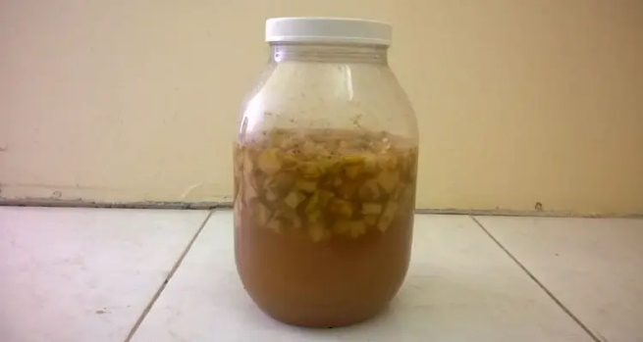
Note: Stirring keeps the solid material submerged and prevents the formation of mold or other fungi. However, do not open the bottle unnecessarily.
Step 4: Start Acetic Fermentation
Now that the primary alcoholic fermentation process is complete, it’s time to prepare for acetic fermentation.
Solution Separation End Of Primary Fermentation
Fruit Solids Float To Top Of Solution
Pour the solution into another wide-mouth bottle, using a strainer or cheesecloth to remove large solid chunks. Leave about 1 to 2 inches free from the top. You should be able to use a smaller bottle without the fruit material.
Add 2 to 4 tbsp of Apple Cider Vinegar, with the mother, to the solution. Alternatively, if you have access to Vinegar Scoby, you can add a large piece instead.
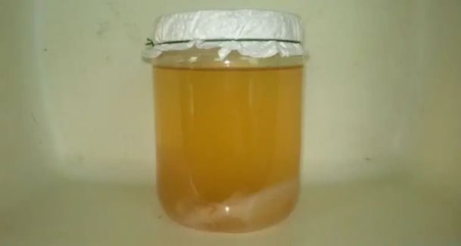
Cover the bottle’s mouth with a sheet of tissue paper and secure it with the string. Then place the bottle in a cool dark area, where it can remain undisturbed for the next few months.
Acetic fermentation can take 1 to 4 months, depending on the solution’s temperature and the amount of Acetobacter present. Also, remember that warm temperatures stimulate microbial activity, shortening the fermentation process’s duration.
Note: You can carry out acetic fermentation with the fruit solids. However, separating the Vinegar SCOBY from the fruit solids can be a pain. Besides, the debris can look unsightly after a few weeks of floating in the solution. Don't ask me how I know…
Step 5: Measure Acidity Using PH Tester
As the weeks go by, you will notice a thin gel-like layer form on the solution’s surface, which will continue to thicken over time. This is the Vinegar Scoby, usually accompanied by a faint Vinegar aroma. This does NOT mean that the vinegar is ready.
The only way to confirm that vinegar is ready for consumption is to do an acidity test. You can use either a litmus paper or a digital PH meter. Vinegar should have a PH reading of 3.5 or lower, which means it is acidic.
Once the PH is confirmed, you can proceed to the long-awaited taste test! Your vinegar is ready. Congratulations! Now it’s time to bottle and store it safely.
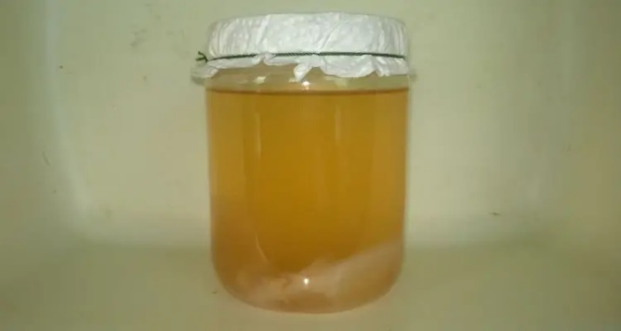
Step 6: Separate And Bottle Vinegar
Now that your vinegar is ready, you should see at least three distinct layers within the solution: Vinegar Scoby at the top, Clear liquid in the middle, which sometimes will have Scoby discs that fell into the solution, and sediments at the bottom, remnants of dead bacteria.

Remove the Floating Vinegar Scoby disc from the mouth of the bottle. Don’t worry if it falls when you touch the bottle. Then slowly pour the clear liquid into a narrow mouth bottle, careful not to allow any solid material to get into the bottle.
Cover the narrow-mouth bottle immediately and place it in a cool dark place for storage. Open the bottle only when necessary, closing it as soon as you’re done. Ensure the completed vinegar gets as little exposure to direct sunlight or oxygen as possible.

Step 7: Store Vinegar Scoby

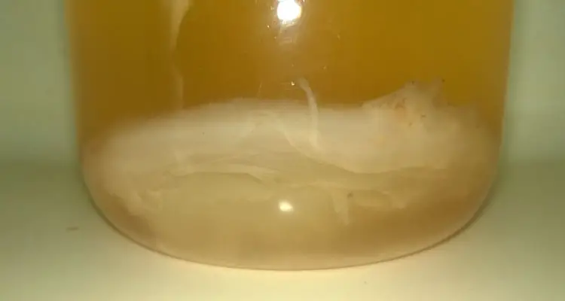
The vinegar SCOBY, Symbiotic Culture Of Bacteria And Yeast, is the gel-like disc that forms on the solution’s surface and often falls into the solution if disturbed. It contains both the yeast for alcoholic fermentation and the acetic acid bacteria, also known as the mother of vinegar.

To safely store the Vinegar Scoby, remove the gelatinous disc from the vinegar solution and place it into a clean bottle. Pour enough vinegar into the bottle to cover the Scoby. Then close tightly to prevent air from entering the bottle. This will cause the microorganisms in the Scoby to go dormant until needed.

You can use just about any vinegar, including distilled White Vinegar, to preserve the Scoby. Ensure that you remember to refresh the solution every 2 to 3 months to keep the Scoby healthy.

What Are The Benefits Of Vinegar?
In recent years, vinegar’s popularity reignited with everyone from celebrity chefs to doctors promoting its numerous culinary and health benefits. Most of these benefits are attributed to raw, unrefined vinegar, which studies confirm to be high in antioxidants and acts as a probiotic.

Vinegar reportedly aids in digestion and the general health of the digestive tract. As a result, it has been shown to assist in weight loss, cholesterol, and several other food-related issues.
Studies suggest that vinegar can assist in regulating blood sugar and pressure, potentially enhancing the body’s ability to fight against diseases.
The active ingredient in vinegar, acetic acid, has anti-bacterial and anti-fungal properties, making it a safer alternative to harsh cleaning agents.
While specific vinegar may have unique benefits based on the source material, it was found that most support a healthy immune system.
Are There Any Disadvantages To Using Vinegar?
While vinegar undoubtedly has numerous health and nutritional benefits, you should be aware of the following drawbacks.
First and foremost, vinegar is an acidic solution that can damage your teeth’s enamel if misused or too often. Remember, weakened tooth enamel can lead to cavities. As a result, it is advised to dilute vinegar and use a straw, if possible, to minimize its effects.
Secondly, vinegar can lower blood sugar to dangerously low levels if overused, resulting in symptoms such as dizziness. As a result, you should consult a physician if you intend to use vinegar for its health benefits, especially if you have diabetes.
As you might have noticed, these disadvantages are directly linked to the imported use of the solution and can easily be avoided. Please be guided accordingly.
Final Thoughts
Making homemade vinegar is a simple but lengthy process. However, it allows you to use various ingredients that might have ended up in the trash.
It is a rewarding process, developing new flavors and experimenting with methods. Most importantly, it provides many nutritional and health benefits.
Of course, you can make this process even more efficient by using specialized tools and inputs. However, it’s best to try it out first to see if you enjoy it. Chances are you’ll be a wine and vinegar-making pro in no time.

Related Questions
What Is Vinegar Made Of?
Vinegar is primarily a dilute acetic acid solution made from the oxidation of ethanol by acetic acid bacteria, commonly referred to as Acetobacter. It draws its flavor from the ingredient from which the original alcohol was made and is used for various purposes.

Sources
Institute Of Culinary Education. How To Make Vinegar From Home. ice.edu. Accessed July 2022
National Library Of Medicine. Varieties, production, composition and health benefits of vinegar: A review. pubmed.ncbi.nlm.nih.gov. Accessed July 2022
www.microfarmguide.com

How to Make Beeswax Candles

Gather Your Materials
The first step of making beeswax candles is ensuring you have all the materials you need! Below you’ll find a detailed list of all the essential items needed for successful candle making.
Beeswax
Because beeswax is the most important ingredient in making beeswax candles, you’ll probably want to collect/ purchase a little more beeswax than you think you’ll need. In addition, 100% beeswax is ideal for a smooth candle-making process.
Wick
A wick is probably the next most important piece of equipment because, without a wick, your candle wouldn’t be able to burn! Specifically, the wick is a piece of string you’ll insert into the candle mold before you pour your wax. Cotton wicks work best with beeswax candles and are easy to find online and in craft stores.
Wick Sticker
The candle wick sticker is a small, adhesive piece that can attach to the bottom of the wick tab (the metal piece at the end of the wick) so that it’ll stick to the bottom of whatever container you’re filling up with wax.
You’ll need a wick sticker for the later parts of the candle-making process.
Mold or Jar
A mold or a jar is necessary when gathering materials for making beeswax candles because it’ll serve as the container you’ll pour your melted wax into.
Silicone molds work pretty well for candle making, especially when it comes to easy removal.
If you choose a jar instead, pick something like a mason jar that’s definitely heat-resistant. Otherwise, you’ll have a huge mess and a safety hazard on your hands!
Heating Vessel
Another candle-making must-have is a heating vessel of some sort because you’ll have to figure out what you want to melt the wax in. This could be a pot you currently have. However, once you use it to melt beeswax, it’ll be almost impossible to fully clean it and use it for another purpose. Some options for an effective heating vessel are a double boiler, crock pot, or microwave. However, it’s important to note that you should only use a microwave to melt very small quantities of wax. Otherwise, it could become a safety hazard.

Clean Your Beeswax
This next step in the process of how to make beeswax candles depends on where exactly your beeswax came from. Specifically, if you’re getting your beeswax directly from your hive or a beekeeper, you’ll need to remove any non-wax substances like dirt, pollen, or honey that may be stuck in the wax. Keeping the wax clean is important because it impacts how effectively the final candle will burn. Cleaning beeswax can involve rinsing the solid wax, melting it down, and straining out any impurities.
On the other hand, if you purchased your beeswax from a commercial retailer, you can skip this step! Commercially sold beeswax is generally already clean, so impurities probably won’t be an issue.
Melt the Beeswax
It would be impossible to learn how to make beeswax candles without melting the beeswax, so that’s our next step!
Beeswax has to reach 147 degrees Fahrenheit before it melts. Use a candy thermometer or similar tool to monitor the wax’s temperature.
Heat your wax over consistent heat slowly for a safe and successful process.
Melting beeswax in a double boiler
In addition, as your wax is melting, stir it every once in a while to help it liquefy. To stir your wax, use a wooden utensil like a chopstick you can throw away after mixing, or use one exclusively for candle making because it will be covered in wax.
Once the wax has turned to liquid, take it off the heat source.
Choose and Prepare a Wick
You may not think about choosing and preparing your wick when considering how to make beeswax candles, but it’s crucial to ensure that your finished candle burns properly.
When selecting a wick, the wick’s size is the most important factor to consider.
The wick’s size depends on the projected diameter of your candle, and choosing a wick that’s too big or too small will negatively affect how your candle burns. For larger candles, you can use more than one wick.
Now that you’ve picked out a wick, you’ll need to position that wick in the right spot.
If you’re using a mold, pull the wick through the small hole at the bottom and bring it up to the top of the mold so that there are a few extra inches ready at the top. The wick tab should cover up this hole.
If you’re using a jar or similar container, use a wick sticker to secure the wick tab to the bottom of the vessel.

Using a clothespin and popsicle stick to secure a wick in a candle
Finally, secure the extra inches of wick just above the top of the mold or jar using a tool like a rubber band, clothespin, or popsicle stick.
Pour the Melted Beeswax into a Mold
Because this how-to guide is about how to make beeswax candles and not just how to melt beeswax, this next step is one of the most important!
Utilizing a mold for melted beeswax is the most user-friendly way of shaping your candles.
Molds come in a variety of super fun shapes and sizes, like this one that’s shaped like a beehive!
If you are using a two-piece mold, ensure that the two halves of your mold are secured together using some sort of implement, like rubber bands, before you start pouring.
Pouring beeswax into a silicone candle mold
Pour slowly and steadily, making sure that the hot wax doesn’t overflow from the mold.
If you don’t want to buy a brand-new mold, pour your wax into a heat-resistant jar that you already have.
Once you’ve gotten the hang of how to make beeswax candles, there are other methods to shape your candle, too, including rolled wax candles, dipped candles, and pillar candles.
Let Cool
The final step of how to make beeswax candles is letting the wax cool into your final, solid candle!
Specifically, you’ll need to leave the mold or jar alone for at least two days so that the wax can cool down and cure completely.
Keep your wax-filled mold or jar in a slightly warm environment so that it can cool gradually.
To keep the temperature consistent, try heating up your oven to approximately 170 degrees Fahrenheit and turning it off when your candles are ready to start cooling. All you need to do is stick the candles in the oven, and they’ll get the gradual cool-down they need.
Once the candle is cured, you’ll also need to trim its wick so that it’s about a quarter of an inch long.
After that, your candles should be ready to enjoy!

Frequently Asked Questions
How safe is beeswax?
Since you’ll probably burn your finished candles in your home, it’s understandable that you’ll want your candle-making materials to be as safe as possible.

Luckily, beeswax is a natural and non-toxic substance, so it’s totally safe to work with.

In addition, beeswax burns cleanly, so you and your loved ones will be safe from exposure to harmful chemicals and excess smoke while the candle lights up your living spaces.

As a bonus, beeswax can be harvested sustainably because it doesn’t hurt bees to gather the extra wax from their hives. From the beginning of the process to the very end, beeswax is a great choice!

Can I add anything to my beeswax candles?
Yes! If you’re looking to spice up your candles, there are a few different additions you can make throughout the process of learning how to make beeswax candles.
For example, after you’ve melted your beeswax, you can add pigments to change the color of the wax. Some dyes are made specifically for use in soap or candle making, so pay close attention to the pigments you purchase.
You can also add essential oils or scented oils created specifically for use in candles to make any room smell nice as your candles burn. Essential oils are a fun way to add fresh and fruity scents to your candles! Please take caution using essential oils as not all, are safe around pets.
Finally, adding coconut or palm oil to the melted wax will help your finished candle burn longer and increase the longevity of any scents you add.
If you choose to add coconut or palm oil to your candle, you’ll want a 50/50 blend of wax and oil.
Source:
www.thatsweettealife.com

How to make hard cheddar cheese


Modern cheesemaking techniques have strayed far from their traditional forms. Cheddar is a perfect example. In fact, the bright orange coloring of cheddar we are used to seeing is a byproduct of industrial farming practices and the addition of annatto: A coloring agent used to cover up the vitamin deficiencies of non-pastured cows milk.
Cheddar has a mildly sharp taste. It’s texture is hard, but it will melt when shredded or sliced thin and is still smooth and creamy enough to enjoy fresh.
How Long Does It Take to Make Farmhouse Cheddar?
Traditional cheddar ages between 6 months to 1 year. This farmhouse cheddar recipe is ready in 3-5 weeks.
The cheese itself is made in just a couple hours. Then it undergoes a drying process for a few days. Once dried, the outside of the cheese is coated in butter to form a rind and preserve the cheese for aging.
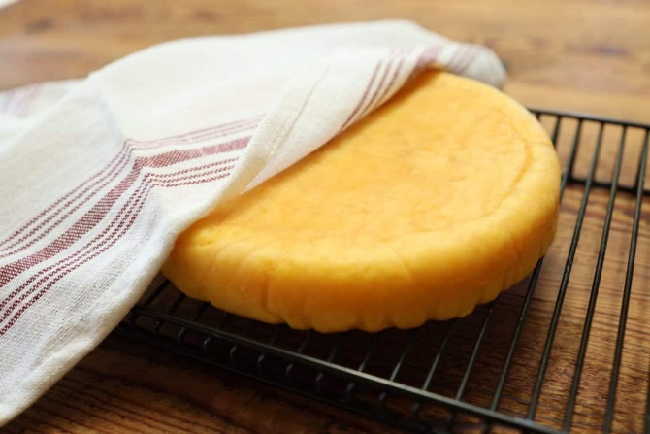

We age ours for about 4 weeks. The longer the cheese ages, the sharper the taste will get. The rind will also continue to dry out and get harder the longer you wait. We’ve found 4 weeks of aging to typically be the right amount.

Sourcing Ingredients
Source the highest quality and most natural cheesemaking ingredients.
MILK
Cheesemaking pairs best with fresh milk that is as close to its natural form as possible. Finding raw milk from a local farm with cows raised on pasture is your best bet. Or, looking for milk that is not ultra-pasteurized and/or non-homogenized is an alternative. The beauty of this cheddar recipe is that the milk never gets above 90° F. This preserves the native bacteria inside raw milk making a truly raw cheese.
YOGURT/KEFIR
Any plain yogurt or plain Greek yogurt will work to culture this farmhouse cheddar recipe. For best results, look for options without added thickeners or artificial ingredients. Culturing with kefir also works. Kefir will contain a higher quantity of the bacteria needed to culture your cheese.
RENNET
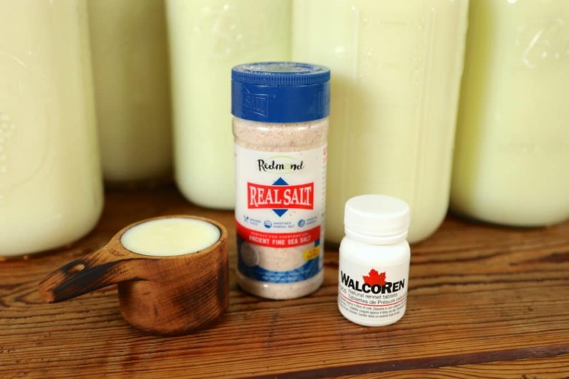
Rennet contains the enzyme from the fourth stomach of a calf that naturally coagulates milk to set it into a firm curd. Coagulated milk is easier to digest making nutrients more bioavailable. Nearly all cheesemaking requires rennet. We use WalcoRen tablets. They offer a pure and natural form of dried chymosin (enzyme from calf stomachs) with minimal additives. Many liquid rennet options are plant based and can contain genetically modified ingredients and other preservatives.
BUTTER
Farmhouse cheddar ages with a thorough coating of butter. Raw milk butter will age best with the cheese. Lard can also be used to coat your cheese. If your sourcing of butter or lard is questionable, you may want to scrape off or cut off the rind once the cheese is aged before you eat it. We use homemade butter with milk from our cow and don’t remove the rind.
SALT
There are special cheesemaking salts that are more course. But any granulated salt will work. We recommend an unprocessed sea salt option and use Redmond Real Sea Salt as our salt of choice.
Do I need to buy cheesemaking equipment?
As I was thrilled to find out, you may not need to buy anything to make this cheddar recipe! If you have a large stock pot, wooden spoon, slotted spoon, food thermometer, colander, strainer, drying rack, cookie sheet, and some other basic kitchen items, you likely have what you need!

Here are some equipment considerations:
CHEESE PRESS
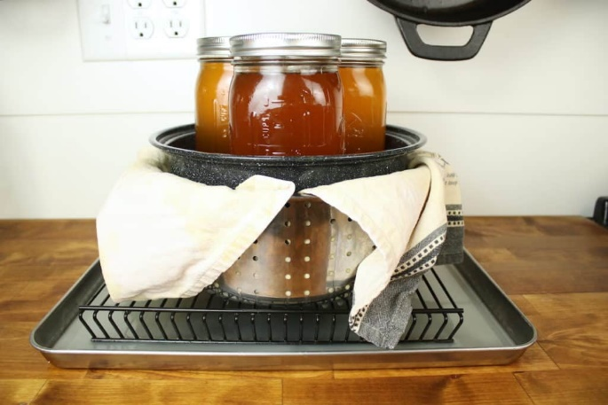
If you have a cheese press – great! If not, they can range from $50 up to hundreds of dollars to purchase. I don’t own a cheese press and have been making this cheese for years without one. We have a stainless-steel colander that came with our stock pot. I found a pot we had lying around that fits snuggly within that colander that acts as a follower. To apply weight, I simply add three (kombucha) filled quart-sized mason jars to the follower pot. As more weight is needed, I stack heavy books on top of that. There are many ways to rig up a homemade cheese press and this system has worked perfectly so far!
CHEESE CAVE
Because of the low aging time of this cheese, your aging conditions are very forgiving. Typically, cheeses are aged in a cheese cave that maintains a temperature of 50° with high humidity. However, a cool basement will work for farmhouse cheddar, or even just a spot on your countertop. We have found it easy to forget about your cheese in the basement and have had fine results on the countertop. Aging in your fridge is also an option.
THERMOMETER
Any kitchen thermometer should work – especially considering that traditionally cheesemakers just used their finger to gauge temperatures! However, we did purchase this thermometer that works very well with cheesemaking.
CURD SPOON
For years I used a standard large slotted spoon to scoop curd out of the pot. It works! But recently I did upgrade to this curd spoon which, I’ll admit, makes the process go much smoother and quicker!
CHEESE CLOTH
Picking up some cheese cloth is helpful for squeezing or straining out some whey from your curd. Butter muslin also works, or even a smooth thin cotton towel.

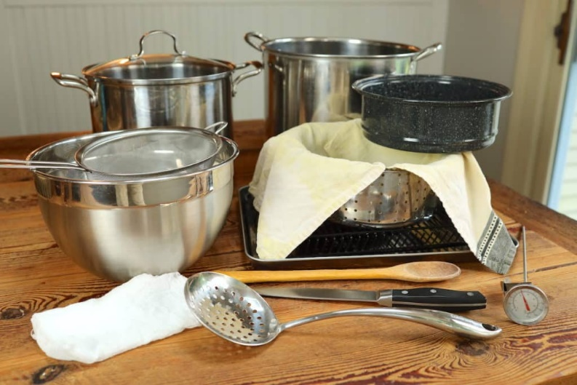
Equipment:
- Stock pot
- Cheese press*
- Long handled wooden spoon
- Long-bladed knife
- Curd spoon or large slotted spoon
- Thermometer
- 1 cup liquid measuring cup
- Strainer
- Large bowl
- Drying rack
- Stock pot larger than the pot your milk will be in (or double boiler)
- Cookie sheet
- Cheesecloth for pressing
- Smooth thin cotton towel for lining press
- Cloth napkin to cover aging cheese
*If you don’t have a cheese press, see the note about making your own with common kitchen items.
Ingredients:
- 2.5 gallons fresh, good milk*
- 1/3 cup plain yogurt or active kefir**
- Rennet (use dose that corresponds with milk quantity)
- 2-3 Tbsp salt
- 1/2-3/4 cup unchlorinated water
- 3-5 Tbsp butter or lard
*The minimum amount of milk you will want to use is 2 gallons. Our stock pot fits 2.5 gallons, hence the 2.5 gallons for the recipe. Anywhere from 2-5+ gallons, depending on your equipment capacity, is great.
**Use around 1/8–1/4 cup active culture (yogurt or kefir) per gallon of milk used.

homemade aged farmhouse cheddar

Directions:
This recipe is broken down into many simple steps. Don’t be intimidated! Take it one step at a time.
step 1
Pour milk into stock pot and place on medium heat stovetop. Heat milk slowly to 90° F stirring often.
If using store bought mill make sure it is not ultra-pasteurized. The difference will be that raw milk is already starting with live and actives cultures within it where the yogurt/kefir culture is fortifying what’s already there. With store bought, pasteurized milk you’re starting with nothing. If you go this route, I’d recommend allowing some extra time for the milk to culture while maintaining a steady 90°F temp. Probably in the 30-60 minute range to really make sure the culture establishes
step 2
As milk is heating, dilute 1/3 cup yogurt or kefir with a couple tablespoons of fresh milk (I just use the milk that settles at the bottom of the milk jugs). Stir.
step 3
Once the milk has reached 90°, remove milk from the stovetop. Pour in diluted yogurt or kefir. Stir immediately for about a minute. Place cover on stock pot and let milk sit undisturbed for 10 minutes to culture.
step 4
Add rennet to unchlorinated water in a liquid measuring cup. I generally use about a ¼ cup of water per gallon of milk. Make sure tablets are fully dissolved.
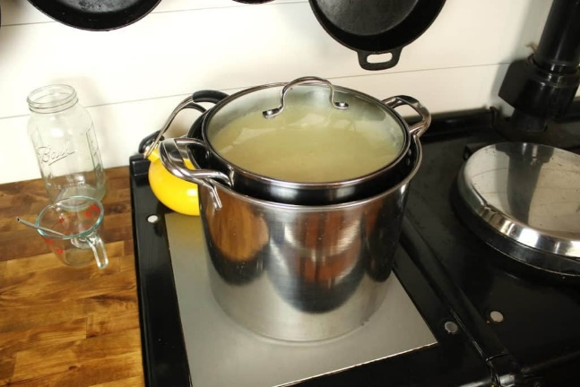
Create a double boiler system to keep your milk at 90°. I do not have a double boiler and use a second larger stock pot filled about ¼-1/3 with 90-100° tap water. Once milk is cultured, place that stock pot inside the larger pot so the pot with the cultured milk is mostly surrounded by water.
step 6
Pour in rennet and water. Stir quickly for about a minute. Place cover back on the stock pot and let milk sit undisturbed for 20-40 minutes, or until a clean break* is achieved.

homemade double boiler for cheesemaking

step 7
Once you have a clean break, slice the formed curd into roughly 1-inch cubes using a long-bladed knife. Slice top to bottom and left to right vertically, and also do your best to slice horizontally in 1-inch increments. Any large curd chunks missed can be made smaller during stirring.
step 8
Stir the cubed curd for 15-20 minutes with a wooden spoon to release the whey. If large curd chunks that missed being cut are observed, break them into smaller pieces with your spoon. The curd cubes will go from having sharp edges to rounded edges. Once the curd is roughly the consistency of a poached egg, the curd is ready.
step 9
Scoop a baseball sized portion of curd into a waiting strainer lined with cheesecloth. Be sure your strainer is sitting on top of a large bowl to catch the whey. Gather up the cheese cloth and gently squeeze the curd to drain some whey. This step is just to remove some excess whey; the cheese press will remove any remaining whey. Place ball of curd into waiting cheese press (or colander if using my cheese press method mentioned above) lined with smooth thin cloth. Place cheese press on top of a cookie sheet to collect whey.
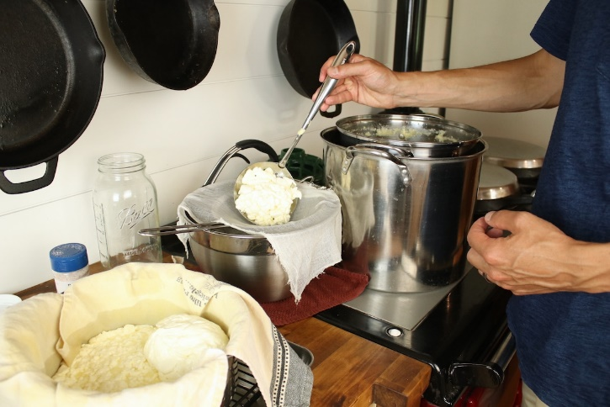
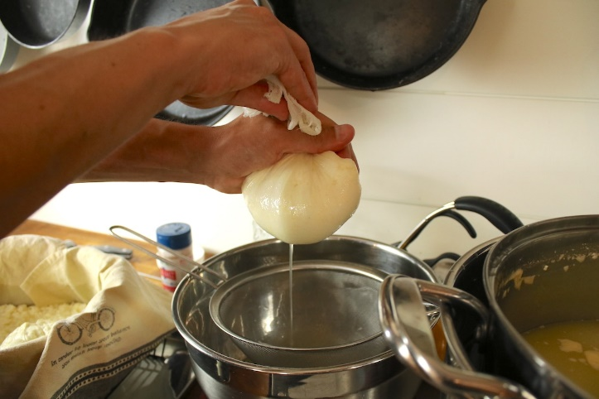

step 10
After 2-3 balls of curd are added to your press, sprinkle about a tablespoon of salt on top of your curd. Work salt into the curd with your hand. Repeat this step along the way until all your curd is in the press and salt is thoroughly distributed throughout.

step 11
Add follower to cheese press. Apply just enough weight to your press to see steady drips of whey flowing below. Let sit in press for 12 hours increasing weight gently to remove whey. Your cookie sheet collecting whey may need to be emptied during this process. (The follower is the top part of the press that puts pressure or weight down on the cheese)
STEP 12
After 12 hours, remove the cheese from the press, flip it, and reinsert it into the press. Apply weight again to gently remove whey and let sit for another 12 hours.
step 13
Remove the cheese from the press. Place on a drying rack and cover fully with a cloth napkin. Allow cheese to dry out for 3-5 days flipping a few times daily.
Note: As cheese dries, it may form mold on the surface. This is normal. Wash down moldy spots with apple cider vinegar.
step 14
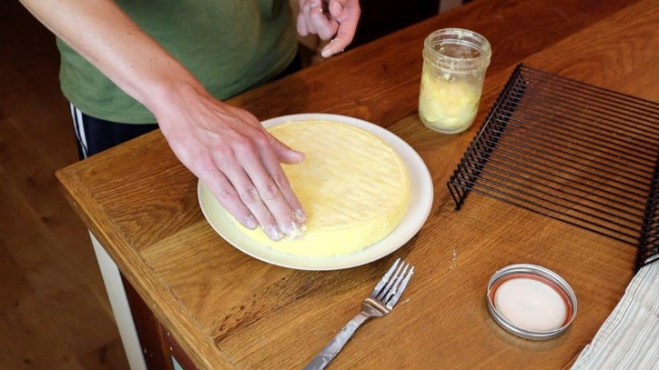
After the outside of the cheese dries or mold has formed (clean as noted above), coat the cheese thoroughly in butter (or lard). Room-temperature butter works best. Place the buttered cheese back on the drying rack and cover with a cloth napkin.
step 15
Put cheese away to age for 3-4 weeks, flipping once a day.**

*If you are new to cheesemaking, like I was, the term “clean break” won’t make sense. Essentially, this is just the home cheesemakers method knowing if the curd has set. To check for a clean break, simply insert your finger into the top of the curd 1-2” at a 45 degree angle. Lift your finger out, pulling on the curd. If the curd breaks clean and there is minimal or no curd remnants on your finger, then you have a clean break. If the curd is not yet separated, or fully separated, wait 5-10 more minutes then try again.
**Should cheese form moldy spot while aging, spot clean the moldy area with apple cider vinegar and reapply butter (or lard) coating.

A Note on How To Use Whey and Why
Whey is the natural byproduct of cheesemaking. Milk contains curd plus whey; making cheese separates the two. Whey is a nutrient-rich food that contains protein along with vitamins and minerals.
Because of this, don’t just discard your whey! Pouring it down the drain is a missed opportunity to use this amazing food.
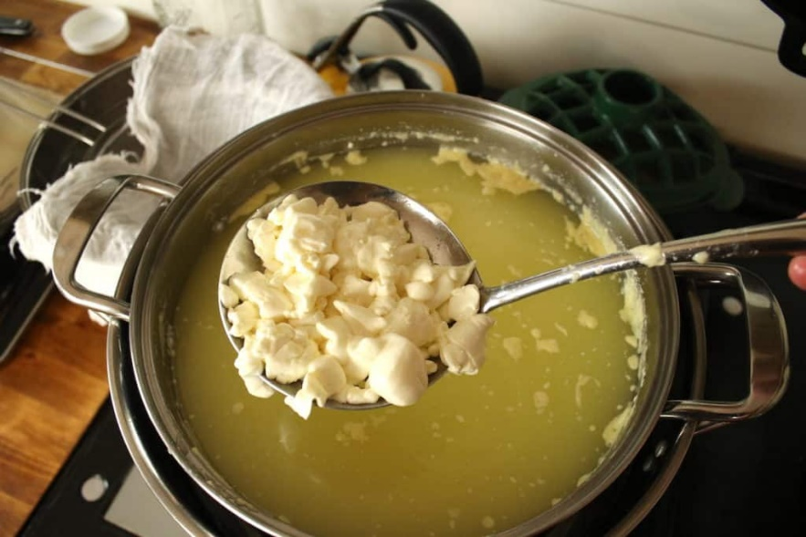
Here are some ways we use leftover whey:
- My favorite is ricotta cheese
- As a stock for soups, stews, or porridge.
- To cook things like rice, beans, and oats in.
- As a water replacement in breadmaking or baking.
- Pour in garden or landscape areas for fertilizer.
- Feed to animals like pigs or chickens. (Dogs or cats will appreciate it too – just in small quantities to not upset their stomach!)

Tip:
Store a couple of the wedges in a container in the fridge that we know you will eat within a couple weeks, and the rest we put in a Ziplock bag and freeze for later use. The taste and texture is still great after it thaws. It’s likely that the cheese will last longer than a couple weeks in the fridge, and maybe even continue to age some, but we’ve found it easier just to freeze and take it out as needed. Hope that helps and happy cheesemaking!
Source:
www.fromscratchfarmstead.com

How To Make Quick and Natural Mozzarella Cheese with Vinegar

Sourcing Ingredients for the Most Natural Mozzarella
MILK
Using the freshest and least processed milk you can find will result in the best mozzarella cheese. You can use store bought milk, but be sure to find milk that’s not ultra-pasteurized. Your best bet with any cheesemaking is to find a local dairy farmer or homesteader in your community to get raw milk from.
VINEGAR (OR LEMON JUICE)
Apple cider vinegar, balsamic vinegar, and standard white vinegar will all work for acidifying milk to make mozzarella. This recipe is based on using apple cider vinegar, which we prefer both for taste and the fact we always have it on hand in the kitchen. To gain the most health benefits, we choose organic, raw, unfiltered apple cider vinegar that comes “with the mother.” Keep in mind you may need to play with the ratios slightly if using other forms of vinegar. Fresh squeezed lemon juice is also a great alternative.
RENNET
Rennet contains the enzyme present in the fourth stomach of a calf (or other ruminants) that naturally coagulates milk to set it into a firm curd. Coagulated milk is easier to digest making nutrients more bioavailable. We use WalcoRen tablets. They offer a pure and natural form of animal rennet that we’ve found to be well suited for home cheesemaking. Many liquid rennet options are plant based and can contain genetically modified ingredients and other preservatives.
SALT
There are special cheesemaking salts but any granulated salt will work. We recommend an unprocessed sea salt option and use Redmond Real Sea Salt as our salt of choice.
Quick and Natural Mozzarella Cheese Recipe
The Perfect Mozzarella After Years of Experimenting | Step by Step Guide to make NATURAL Mozzarella
YIELD:
About 4 medium-sized mozzarella balls.

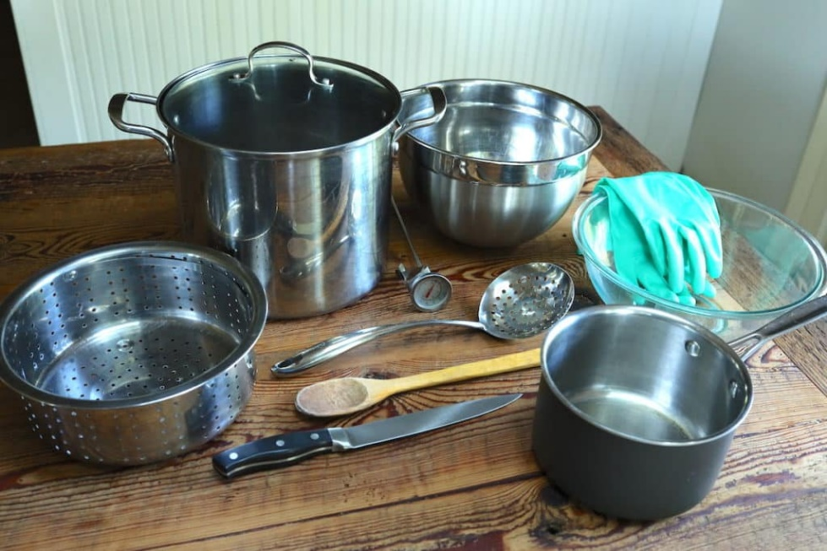
Equipment:
- Stock pot
- Medium Sauce Pan
- Colander
- Large bowl x2
- Wooden spoon
- Long-bladed knife
- Curd spoon or large slotted spoon
- Thermometer
- Small liquid measuring cup
- Large liquid measuring cup
- Gloves
Ingredients:
- 1 gallon fresh, good milk
- ½ cup vinegar*
- Rennet**
- 2-3 tsp salt
- unchlorinated water
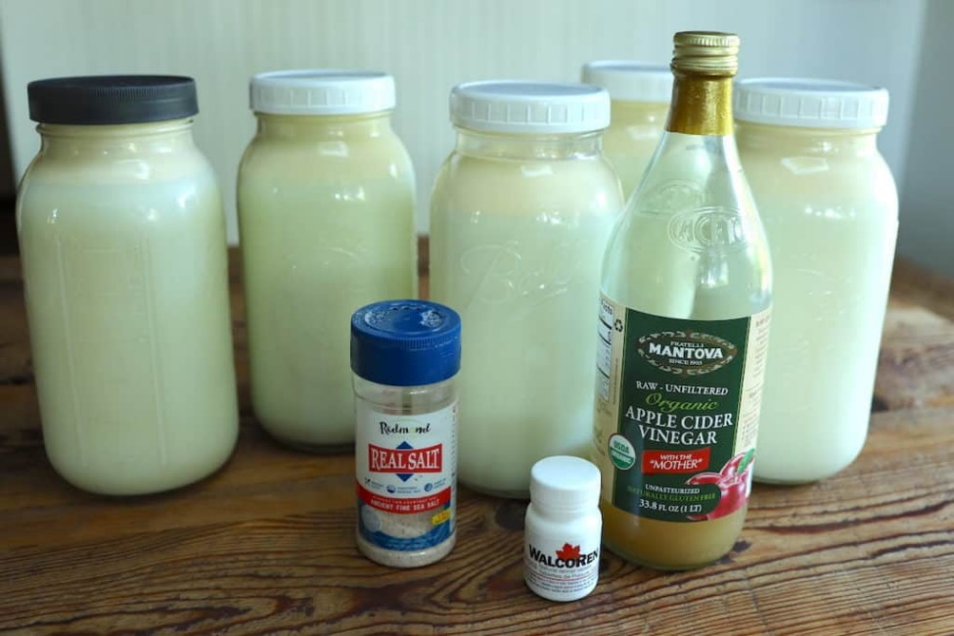
*This recipe is based on using apple cider vinegar. See note above on alternative vinegar options in the section on Sourcing Ingredients. If using fresh squeezed lemon juice, also use ½ cup per gallon of milk.
**Use recommended dose or slightly above recommended dose. For mozzarella, I have had good results using a slightly higher ratio than what is listed on the packaging.

Directions:
step 1
Pour cold milk into stock pot. Make sure your milk is COLD to start! Adding acidity directly to milk that is too warm will run the risk of curdling it.
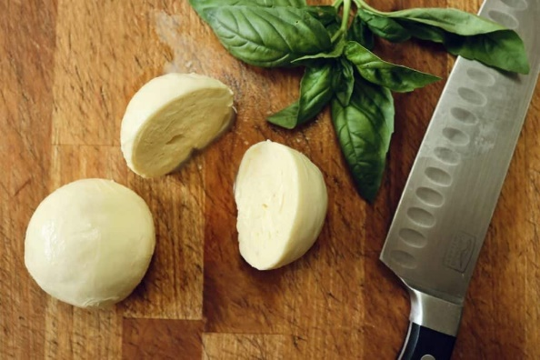
step 2
Dilute vinegar (or lemon juice) in 2 cups of unchlorinated water. Pour into the cold milk and stir in briskly for a minute to acidify milk.
step 3
Warm the acidic milk slowly to 90° F on a low-med stovetop. Stir regularly and be sure to not heat milk too quickly to prevent curdling.
step 4
While milk is warming, dissolve rennet into ¼ cup unchlorinated water. I use about ¼ cup unchlorinated water per gallon of milk. Break up tablets as needed and stir until fully dissolved into water.
step 5
Once acidic milk has reached 90°, remove from heat and pour in dissolved rennet. Stir immediately and thoroughly for 1 minute. Then place cover on stock pot and let sit undisturbed until a clean break is achieved – approximately 15-30 minutes. Apply low heat as needed or wrap pot in towels to maintain 90°.
step 6
While waiting for a clean break, 1) fill large bowl about ½ full with cold water and stir in 2-3 tsp of salt until dissolved – then place in fridge to chill, and 2) fill a medium sauce pan about 2/3 full with warm water.

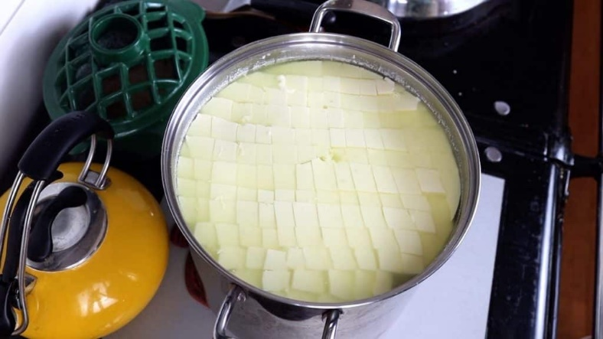
step 7
After you have a clean break, slice the formed curd into ¾ – 1 inch cubes using a long-bladed knife. Slice top to bottom and left to right vertically, and also do your best to slice horizontally in ¾ – 1 inch increments. Any large curd chunks missed with the knife can be made smaller during stirring.
step 8
Stir the cubed curd with a wooden spoon for about 15 minutes. The curd will release its whey during this time and you’ll observe the edges of the curd going from sharp to rounded. Once the curd has the consistency of a poached egg, you are ready to move on.
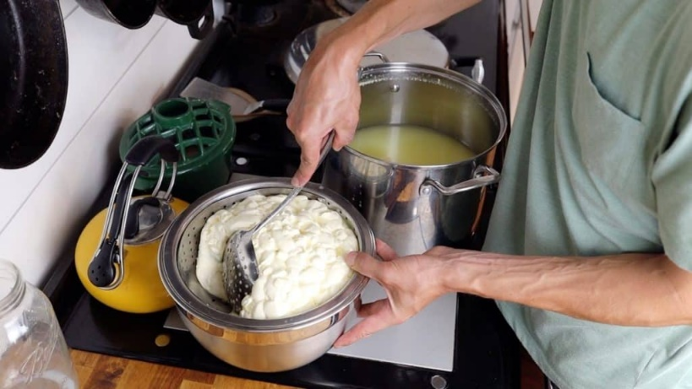
step 9
Scoop the curd into waiting colander atop a large bowl to catch the whey. If the holes of your colander are too large, you might consider lining it with a cheesecloth to hold the curd.
Optional – Pull curd toward the center of the colander with a curd spoon to remove excess whey. Perform this technique around the outside of the curd keeping the curd intact.
Let curd rest in a colander for 15-30 minutes until curd is knit together.
step 10
While waiting, heat a hot water bath in a saucepan to 160-180°.
step 11
Once you have one solid curd, cut it into thick slices that will be used to form your balls of mozzarella cheese. Place a couple of slices of curd into a 160-180° hot water bath. Wait 3-5 minutes.

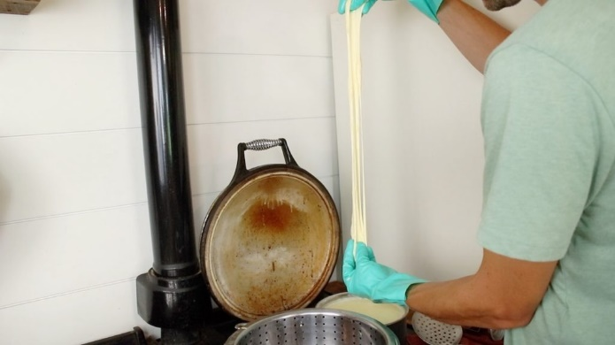
step 12
After waiting, attempt, a “stretch test” by removing a slice of curd from the hot water bath and pulling it apart slowly. The cheese should stretch freely. If it does not, place it back in the hot water bath for another minute or so and try again.

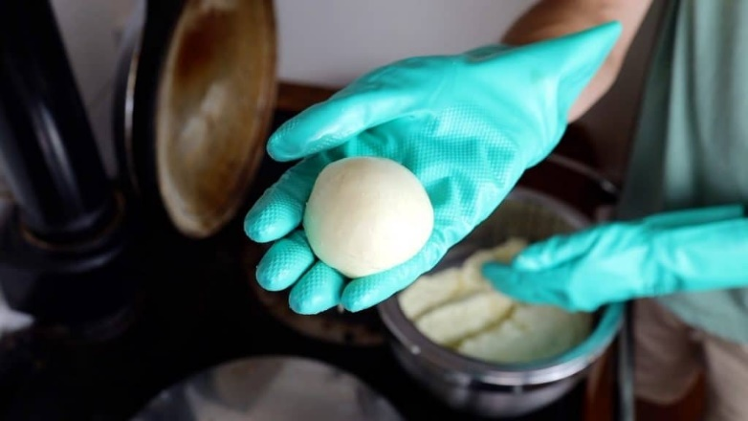
step 13
Remove one slice of cheese at a time from the hot water bath shaping it into a mozzarella ball. Similar to kneading bread, work the ball with your hands tucking it back within itself establishing layers throughout the cheese. Work each ball for a short period of time, form ball into final shape, and place in waiting cold water bath with salty brine.

step 14
Repeat steps 11-13 until all your curd is turned into fresh mozzarella balls.
step 15
Place cold water bath back in the fridge for a couple of hours to continue to chill down the mozzarella. Then remove the mozzarella from the cold water bath and store in a container.
cold water bath chilling down mozzarella cheese balls
Frequently Asked Questions When Making Mozzarella Cheese
WHY ISN’T MY CURD STRETCHING EASILY?
You might find that no matter how many stretch tests you perform, your curd seems to break apart rather than stretch. This unfortunately means your acidity level was off for this batch of mozzarella. You can continue with the rest of the steps and still come out with delicious balls of mozzarella cheese in the end. But they might not be smooth and pretty due to their lack of plasticity. You can dial in the amount of acidity you add over time as ratios can vary based on the type of vinegar and milk you are using.
WHAT IS THE BEST WAY TO STORE MY MOZZARELLA CHEESE?
Your cheese will store fresh for 1-2 weeks in the fridge. Some whey or liquid may continue to drain out of the mozzarella – pour this out of the container regularly for the longest storage. We’ve also found that mozzarella freezes very well to preserve longer. Simply flash-freeze the fresh mozzarella balls on a cookie sheet, then transfer them to a Ziplock bag in the freezer. Remove cheese as needed a day or two before using to thaw.
DO I NEED TO WEAR GLOVES TO MAKE MOZZARELLA?
Technically, no. If you keep your hot water bath around 150 deg. you will likely be able to shape your cheese without the use of gloves. However, I have had best results when working with a hot water bath between 160-180°. At these temps, your hands will be quite uncomfortable without the use of gloves.
If you use vinegar or lemon juice to curdle the milk, why do you also need rennet?
The curdling you would get from adding vinegar or lemon juice to warm milk wouldn’t have the same effect as rennet would. Rennet, when used in the right dose, gives you a full coagulation and separated curd that you can work with. My understanding is that the curdled milk would separate some but not entirely. Plus, the milk may not acidify correctly leaving you with a mozzarella that doesn’t stretch. Hope that helps! Happy cheesemaking!
Can I adjust the ratios of the ingredients?
Thanks! You can scale all the ingredients according to how much you’re making. It might be easiest to work in half gallon increments, but you can also adjust to something more specific. The quantities are somewhat forgiving, so just do your best to adjust based on how much milk you’re using. With less milk, I’d also recommend you keep a closer eye on temperatures as things will heat up more quickly.
What kind of gloves do you use and where did you get them?
https://cheesemaking.com/products/food-grade-gloves. I love them! If you clean them well and take care of them they’ll last you for years! Plus they come on and off so much easier than the tight latex gloves.
Source:
www.fromscratchfarmstead.com

