  tRAINING MANUAL  11/2023 | OUR OATH: I do solemnly swear (or affirm) that I will support and defend the Constitution of the United States of America against all enemies, foreign and domestic, that I will bear true faith and allegiance to the same, and that I take this obligation freely, without any mental reservation or purpose of evasion, pledging my life, my fortune, and my sacred honor. So help me, God.

Contents
EMERGENCY COMMUNICATIONS 1
Recommended Communications Equipment 2
DMR Radio and Hotspot DMR Radio 7
DMR Primer 9
Baofeng DM-1701 Review 14
Full Duplex MMDVM Hot Spot 16
Emergency Response Sheet 17

EMERGENCY COMMUNICATIONS

Recommended Communications Equipment

Before you purchase anything contact the Comms Coordinator for advice unless you are an experienced radio operator.
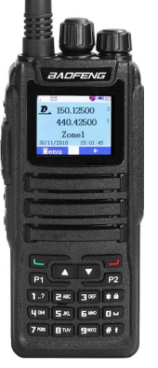
CommsCoord@IndianaOathKeepers.org

CPT Team - Individual Comm – CPT Team AO Comms

- Baofeng DM-1701 DMR Handheld, Highly Recommended
– Works best when used with a Hotspot. Will work through
repeaters and in simplex both digital and analog modes. This
radio will work analog without a DMR ID but the DMR
channels require a DMR-ID which is easy to apply for and free
if you have a Ham Technician License.

DM-1701DMR Radio $99.00, Hotspot about $135.00

https://www.radioddity.com/collections/consumer-radios/products/baofeng-dm-1701
There is a special review of the DM-1701 written by the comms coordinator.
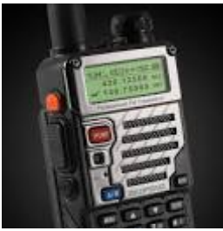
- Baofeng RD-5R DMR Handheld, – works best when used with a Hotspot.
Will work through repeaters and in simplex both digital and analog modes.
This radio will work analog without a DMR ID but the DMR channels
require a DMR-ID which is easy to apply for and free if you have a Ham
Technician License. The RD-5R has trouble with accessories like
Speaker Mics and Tactical Headsets.
RD-5R Radio $69.00

https://www.radioddity.com/collections/consumer-radios/products/radioddity-x-baofeng-rd-5r-dmr-ham-amateur-two-way-radio
Read the DMR Primer to learn more about DMR.
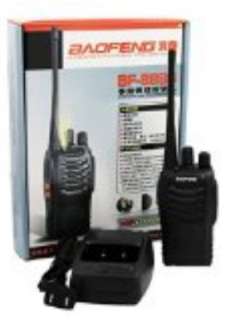
The Anytone 878 plus is an excellent radio but cost more.

Baofeng BF-888S UHF Handheld – 16 Channel FRS
– 1 to 4 Watts, 1-4 miles. $15.00 on Amazon.
Pictured – When ordering this radio read
the description and look for scrambler option
in the description. Some of this model do not
have this option. Only order the ones with
the scrambler option. This is essential for
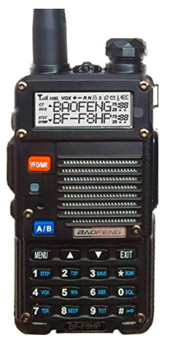
local CPT operations.
- Antenna, Nagoya NA-717, $16.00

Dual Band Handhelds – VHF/UHF
- Baofeng BF-F8HP, 8 Watt, UHF/VHF, $63.00,
pictured, Recommended
o Antenna, Nagoya, NA-771, $17.00

o A mobile antenna on your vehicle with an antenna
adapter will help these handhelds work
exceptionally on your vehicle when mobile.
Local Mobile Comm
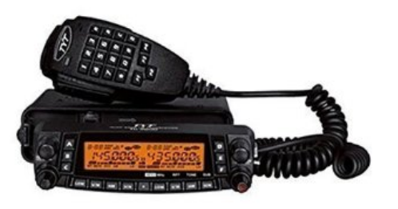
- CB Radios – 5-10 mile
- Recommend the TYT TH-9800,Quad Band, Ham – Vehicle
Mounted Quad Band with cross band repeat, will extend
Teams comm 20-50 miles on Repeaters. This radio will
do CB (AM) and FRS and GMRS as well as four Ham bands.
$223.00. can be ordered on Amazon. Pictured. See power
supply below.
- Antenna for Th-9800, Comet or Diamond Quad Band, $126.00. Needs a heavy duty antenna mount. This antenna can be used on your vehicle or on your home if set up properly.

The Antenna is the most important part of a radio.
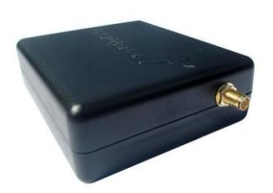
State, Regional, National Comm
Receiver (No Ham License required)
- SDR Play, RSP1 – For use with a PC or Laptop,
$149.00. The SDR play is a powerful Receiver that
is capable of receiving almost any communications,
whether ham or otherwise. It receives (depending on
antenna) as well as most HF ham radio transceivers.
Information - http://www.sdrplay.com/
To Purchase - https://www.hamradio.com/detail.cfm?pid=H0-015965

HF Radio
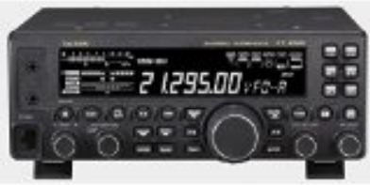
- Yaesu Ft-450D, 100 Watts, all
mode, $699.00, pictured, Recommended
- ICOM 7300, 100 Watts all mode,
$1200.00. Better radio, far more
complicated to setup and operate.
Antenna – 80m, 40m, 20m minimum

- A simple homemade 80m dipole works very well, with an external tuner.
- Off center Fed Dipole (OCF), 80m All Band, No tuner, 137 feet end to end. You will need to purchase a 4:1 Current Balun and the wire needed to build this antenna. Comm Coordinator has one of these.
- An Inverted L for small locations. The inverted L only requires 30 foot of horizontal space and about 33 foot of elevation. Most yards will accommodate this 80m antenna. It also requires tuner.
- A Folded Dipole works well in small locations too.
- Power Supply, Iota DLS-45, $148.95. Can be used with or without a battery. If you use this with a battery get one of the IQ modules to control the charge. You can purchase a DLX series as well, I prefer the DLS series (my preference). These supplies will act as full full-featured battery charge controller as well as a power supply. You may not think you need a battery but eventually, you will want one or two batteries. Batteries (deep cycle, like for a trolling motor) act as a filter for your ham station (main advantage) as well as Emergency Power. https://www.solar-electric.com/iota-dls-45-12-volt-45-amp-regulated-battery-charger.html
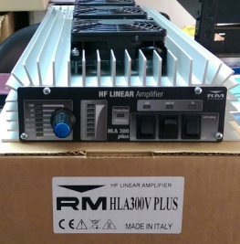
- HF Amp – An HF Amplifier can make all the difference in getting through when bands are bad. We are currently in a portion of the sunspot cycle where the bands are often bad and will be for the next couple of years. Therefore, an HF Amp can mean the difference in being heard or not being heard. RM Italy makes some great inexpensive amps. I own and use an RM Italy HLA
300 Plus. http://www.rmitaly.us/ . RM Italy makes several different
amps at reasonable prices be sure to get one that covers the whole
HF Band, or at least most of it. These amps are made in Italy and
Tech Support is very difficult in the USA. However, they are priced
within reason. You may want to get an amp that has fans on it. With
an Amp like this, you will have to purchase an external Tuner as well.

Digital Modes When thinking about Emergency SHTF communications passing messages and information will be very important. Digital modes are the best way to pass traffic or messages. Digital Modes work with HF and VHF/UHF radios when connected to a computer. Once your station is setup the cost of adding Digital Modes is small. Some radios have the signal link type interface built in.

- Receive, A computer and FlDigi, free download
- Transmit , Signal Link USB, $99.00

DMR Radio and Hotspot DMR Radio

(No need to purchase other antennas if used with a Hotspot)

DMR radios work with local repeaters just as analogue radios with the added capability of Internet bridges for expanded worldwide communications. While the repeaters work well a hot spot is by far preferred for numerous reasons. A hotspot works as your own personal repeater so long as you have a wifi connection for it to connect with. The wifi can be your home wifi or the wifi hot spot in most smart
phones. When used with a phone hotspot it can be used mobile. A hot spot uses very little bandwidth less than 500 megabits per month if used daily.

- Baofeng DM-1701 DMR Handheld, Highly Recommended – Works best when used with a Hotspot. Will work through repeaters and in simplex both digital and analog modes. This radio will work analog without a DMR ID but the DMR channels require a DMR-ID which is easy to apply for and free if you
have a Ham Technician License. This radio works well with Speaker/Mic accessories, as well as tactical headsets.

https://www.radioddity.com/collections/consumer-radios/products/baofeng-dm-1701

- Baofeng RD-5R

https://www.radioddity.com/collections/consumer-radios/products/radioddity-x-baofeng-rd-5r-dmr-ham-amateur-two-way-radio

The Baefeng RD-5R is a good low cost DMR radio, it works well. They offer a larger battery for the radio on the website. This is a good battery. They also offer a Mic/Speaker that plugs into the radio port, this speaker/mic does not work well with this radio it causes interference called motorboating; save your
money.

- Anytone 878 Plus

- https://www.ebay.com/itm/AnyTone-AT-D878UV-Plus-GPS-Bluetooth-3100-mAh-battery-and-more-US-seller/293078468382?epid=3027055803&hash=item443cd6871e:g:oH4AAOSwuMxdDN~h

This is a more expensive DMR Radio and it carries many more excellent features and the Lapel Mic and Speaker/Mic work perfectly with this radio. This radio is worth the money. I use the tactical lapel mic (link below) with this Anytone 878. It works great and has a very good volume.
https://www.amazon.com/gp/product/B01LZH77J6/ref=ppx_yo_dt_b_asin_title_o00_s00?ie=UTF8&th=1
- MMDVM Hot Spot,

Simplex Model Completely Assembled
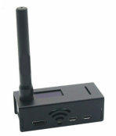
https://www.ebay.com/itm/MMDVM-Hotspot-Support-P25-DMR-YSF-Raspberry-Pi-OLED-Antenna-Case-6G-Card/312861126705?_trkparms=ispr%3D1&hash=item48d7f9f031:g:844AAOSwnGleBGn7&enc=AQAFAAACYBaobrjLl8XobRIiIML1V4Imu%2Fn%2BzU5L90Z278x5ickkRjLZq23gAR%2BKma9gM2Z1hnXo4fULwPOAbkvP%2FxxcFY7OHTCcCO4XPnEHKiJ3qoCwYJPpNgmZbD4CdjJ1h7fb53BHwzMdoPYgOeHY6faa%2FsmKo7B3GChApE1Yl7ZWsO36DZWrxvRDUfXW0Pg1kF74NglfviIMQzJxH5fjMQ6Ja2nEE2X8unbU3PsVkJ7Onpk29%2FIjX95ppAxRLJpCukzfUKaNHnK83XYUsxCocGpWyEVORs5OwYtjZPk%2Fjhm5Nb%2FOdfA2DVH5d4v3fH70YjtG5HXCqRfzfeLXwYM2rlGmndqFbMhFVPwbf%2BCEjgdYcnKsqd3Cm93TZqhFU0bwZwfPbCeBgHOkBLS9uMRfIJ%2FOm0FgRP68NN5mag2ep0h2P9sW4UA38jT6sBx2R5MUIK06ZEwRQuH0%2FiWH49x656a3l7SsSH3zHfVAlykFRun1kRRu4SOUHw0BvZ662GtSzPedAiymC9SYxlUcwEvd%2FjVH6AHAH7qq5SjmYtzzB2zJdqxJQjvdYtoFqOmd%2BTJMahGN8wbsHZrjG9iUf%2Fp6zbMV%2Ba1g2m%2B7slMUdJ0jqnJfWuX120F%2ByVg3mgVvq6miGPwyGSAl92vHlI8hYmZXDK36rKkF%2BVVCyQPVlHWFlPWMQS3lHr5zGh%2B5q2gY3cM%2B8cP%2BZWH8JWMNQ8ucwqjIQYwUwoJ4fzX2J1L0qZ81%2FCNdiMv3kGX1%2By8a%2B%2BAsU834i6xnxuykKcyF3vyy6DxfjSrEU6tt2pCR5lhvkTLWKX3SCsaf&checksum=312861126705a01927497830479ea45719a9c8bfc57b

You will have to provide a Micro USB cable and USB
power supply for the Jumbo Spot. Setting up the Jumbo
Spot can be frustrating. I have many of these and know
how to set them up. I will help you get set up and will teach
you the in’s and outs of the DMR system.

- Duplex Model,
https://www.ebay.com/itm/MMDVM-Duplex-HotSpot-Dual-Band-2m-440-Fully-Assembled-w-3-5in-Nextion-isplay-S/124248544913?hash=item1cedca5691:g:ZSoAAOSwDaVfAhEf
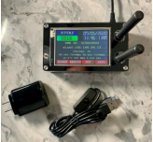
The Full Duplex Hot Spot works just like a repeater
and works better than the simplex model. However it
costs more.

DMR Primer
DMR Radio is different from FM analogue radio operation in that DMR stands for Digital Mobile Radio. In DMR your voice is converted to a digitized signal that can be sent over the air with amazing clarity and is well fitted for transmission over the internet as well.
A DMR repeater works just like any other repeater when the internet connection is taken out of the picture. It receives a signal from a radio and retransmits it so other more distant stations can receive the signal. As with any two-meter (VHF) or seventy centimeter (UHF) system a repeater can receive and send signals farther because its antennas are usually mounted high up in the air, perhaps 300 to 400 feet in the air. A higher antenna has a far longer line of sight than a lower antenna.
The output power of the radio may contribute some but the height of the antenna is the biggest contributing factor. DMR repeaters also have the ability to connect to a central system over the internet allowing many repeaters to contribute to the reach of the system. Hence, DMR over the internet gives operators worldwide operations.
So, as Oath Keepers using DMR, we gain communications capabilities when the grid is up and loose no capability when the grid is down in comparison the analogue systems. Except perhaps the fact that there are more analogue repeaters than there are DMR repeaters. But these radios will fully function as analogue radios too. So we loose nothing by using these DMR radio’s.
Getting Started with DMR
What you need to do is,
- Order a DMR Radio. Our Recommended Equipment List provides brief description of three DMR Radio’s. The Anytone 878 Plus is an excellent DMR Radio with many added capabilities and features, I own two of these but they do cost more.
- Apply for your DMR ID. It is free and may take a day or two to get your number. You must have this number before programming your radio.
https://www.radioid.net/register#
- Get your radio programmed.
- Operate your radio.
Basic Operation
Basic Description - DMR works through Talk Groups. You tune to the Repeater (Zone) and then the Talk Group (channel) you wish to talk on then momentarily press your PTT to tune the repeater to that Talk Group, and if the channel is clear you begin operating. You must bump the PTT to tune the repeater to that Talk Group before you will be able to hear or talk on that group.
Some repeaters have static talk groups that are on the air all the time, if no one is using the repeater, so you can hear those static talk groups when you tune to the repeater sometimes. If you desire a different talk group and no one is using the repeater you are accessing then just bump the PTT and operate.
DMR Radios will function in simplex as well, you do not have to bump the PTT for simplex operation.
Busy Repeater - To determine if a repeater is being used you tune to the repeater and talk group and bump your PTT if someone is using the repeater you will get a tone and either a busy or failed message on your radio. No problem, just wait until they are done or join in the group conversation when the opportunity arises. On some radios there is a Monitor Function that allows you to hear any activity on a repeater regardless of the TG they are using. Often a repeater is being used and when you tune to your desired TG you do not hear the other operators because they are on a different TG, the Monitor function allows you to hear them if they are active.
Radio Buttons – Please note that on your program guide there is a listing for the button functions on this radio. The Moni Button is the one under the PTT switch on some Radios.
The Orange Button is above your PTT switch. Each button has a Long and Short Press Operation. You might want to note the Low/High power function as you will add life to your battery by operating in Low Power, however it may not be practical to use lowpower when traveling and using repeaters.
Tuning to a Channel - To tune a Channel
- Select your desired Zone. Remember a Zone is usually representative of a select Repeater or a Hot Spot.
2. Select your desired Talk Group or channel.
3. On DMR bump the PTT switch to activate the Talk Group on the repeater or Hot Spot. Bumping the PTT is not necessary for Analogue channels or repeaters.
4. Operate as normal.
Notice the additional steps in DMR operation. You must select the Zone (repeater)then the Talk Group (channel) you wish to talk on. Each must be selected separately. If you wish to change Talk Groups on the same Zone you do not have to go into Zone Select again you just select the desired Talk Group and bump the PTT to activate it.
However, if other hams are on the same talk group and do not wish to change talk groups you must wait until they clear to change the talk group.

A Disadvantage With The RD-5R
The RD-5R does not work well with tactical mics. Something in the design of the radio and the nature of DMR radio the remote wired mics will inject a noise referred to as Motor-Boating into your transmission. This can be so loud that one cannot hear the audio. The only way I have found to use a tactical mic with the RD-5R is the remote your antenna away from the radio. This is a somewhat frustrating problem.
Other DMR Radio’s like the Anytone 878 and the Beofeng DM-1701 do not have this problem.
Hot Spots via Wifi
A hot spot acts like your own personal repeater and connects to your local internet service via a network connection or wifi depending on the hotspot DMR device you choose to use. I use a Jumbo Spot (simplex Hotspot), which is really small, and a Full Duplex Hot Spot. These connect to my smart wirelessly and only need power applied to work. I use mine in my car while I’m driving even when I am in an area where there is a repeater. I find that often a local repeater will have other hams using the repeater and they are not on the Talk Group I desire. A hot spot removes this problem. Sometimes it iseasier to just use the Jumbo Spot while I’m driving because I do not have to changerepeaters as I travel.
I use this, https://www.ebay.com/itm/Assembled-MMDVM-hotspot-Support-P25-DMR-YSF-raspberry-pi-OLED-Antenna-Case/122878428117?epid=12015335839&hash=item1c9c2003d5
It is a little bigger than a 9 volt battery. Really small and once set up works great. It was a challenge to configure at first, so you may want help getting it set up.
Why Use A Hot Spot? – You don’t have to use a Hot Spot if you are near a DMR repeater. But you need to understand,
• Some Repeaters restrict which Talk Groups you can access. This is determined by the repeater owner. Brandmeister Repeaters (a protocol) give free access to all Talk Groups by merely selecting the desired Talk Group and bumping your PTT. There are many Brandmeister Repeaters in our state.
• Some Repeaters may get busy at times making it hard to get on the Talk Group you desire at the time you wish to operate. Your DMR Hot Spot is dedicated just to you.
• You may not have a DMR repeater near you. A DMR Hot Spot will give you access to DMR wherever you have internet access.
I encourage all operators to get a hotspot and practice using it. Even if you have a local repeater. You will find the Hot Spot will give you better service even if you are travelingif you can connect it to the wifi in your smart phone.
Keep in mind that a DMR Hot Spot is not just any old cellular hot spot. It is a Hot Spot designed to access the DMR system. Examples include the Jumbo Spot, Shark Open Spot, and the Nano Spot. I use a Jumbo Spot.

Full Duplex and Simplex Hot Spots – A Simplex Hot Spot will operate only on time slot 2 and cannot transmit and receive at the same time; it is simplex. So, if you are on a talk group and you wish to change talk groups you must wait until no one is talking to key up your hot spot to the new talk group. Your hot spot cannot transmit and receive at the same time. A Full Duplex hot spot, which costs a little more, can transmit and receive at the same time so there is not problem sending signals to your hot spot even when someone is talking. I highly recommend spending a little more to get the Full Duplex Device.
However, part of the convenience of the single duplex device is its size. It can be placed in one’s pocket with a small battery pack and be carried wherever you go. The Full Duplex unit is a little big for that. I use simplex hotspots in my car and a Duplex hotshot at home. If you use more than one hotspot be sure they operate on different frequencies to avoid conflicts.
A hot spot can work a distance, I can access mine out to about a quarter of a mile. This can vary depending on your surroundings. It is possible to amplify a hotspots output power using a specially designed amplifier
A Word About Talk Groups – There are all kinds of Talk Groups associated with DMR; thousands of them. You can go to the Bradmeister web page and look up a list of the many Talk Groups and their intended purposes.
As a DMR operator just understand,
• World Wide, Nation Wide, and State Wide groups are intended as initial points of contact. A contact (QSO) should be relatively short on these Talk Groups. Those wishing to hold longer QSO’s should arrange to meet the desired parties on another Talk Group designed for extended conversations. These wide area Talk Groups contact many repeaters and tie all of those repeaters up for the duration ofthe QSO.
• TAC Group – TAC group such as INTAC standing for Indiana Tac and TAC 313 through TAC 319 and other such groups are meant for longer duration QSO’s and operators should feel welcome and comfortable holding extended conversations on these Talk Groups. Avoid Tac 310-312.
• Club or Association Talk Groups – These groups are meant for their intended purposes which are described in the description of the group on the Talk Group website. Many of these various Talk Groups openly invite allhams to enjoy long QSO’s on their Talk Group.
• Local 2 – This shows as “Local” in our program. This talk Group uses only the local repeater that the Operator has tapped into. Hams who have access to the same repeater are encouraged to use this Talk Group for their QSO as it only ties up one time slot on their repeater.
• Private DMR ID’s – Any ham can use their DMR ID setup as a group talk group to establish a private talk group. In our code plug my DMR ID is setup for this purpose. Any of our hams that connect to these groups will be using a somewhat private talk group.

DMR ID.
Time Slot 1 & Time Slot 2 – DMR is unique in its use of TDMA which divides the repeater frequency into two time slots. This allows for two different QSO’s on the same repeater at the same time. So, a ham or group of hams could be using Time Slot 1 to talk on Indiana Statewide while another group talks on Time Slot 2 using the Local Talk Group. This is an amazing feature of DMR.

As an operator you won’t always know what Time Slot you are on but you will enjoy the QSO’s and the technology.
I hope this DMR Primer will help you to understand enough about DMR to get on the air with your DMR radio.

Baofeng DM-1701 Review
Upon a request from an IOK member I purchased a,
- Radioddity GD-77
- Baofeng DM-1701
For testing and review.
The Radioddity GD-77 failed quickly for very low volume. I had trouble hearing anything from the speaker and the headset had very low volume. I do have bad hearing. I returned the GD-77 and do not recommend the radio. Maybe I had a defective unit.
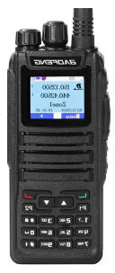
The Baofeng DM-1701 is an excellent DMR radio.
It works as expected and has great volume. It was a little difficult getting the radio connected to the PC because the drivers needed do not load automatically and there are no real clear directions about which driver to actually load from the cd that came with the radio. However once the drivers are loaded the connection is great.
The DM-1701 had to have a firmware update out of the box which may add difficulty to getting the Radio up and running.
Once everything needed is installed the radio Programming Software is typical for DMR radios. Programming a DMR radio is never easy, until one figures out all the different elements needed. I have written a Code Plug for using this radio with a Hot Spot and will expand the Code Plug to Indiana Repeaters as time allows.
The DM-1701 will handle Analog and DMR and is an excellent choice for its price.
I tested the radio with two Speaker Mics and two Headsets as pictured and all seemed to work very well with the radio. The Baofeng Speaker Mic worked slightly better than the TYT but they both worked well.
This radio is a great upgrade from the Baofeng RD-5R and will become our recommended Radio for IOK members. This radio has many added capabilities that the RD-5R does not have. The RD-5D is a much older DMR radio.
The DM-1701 will accept up 120,000 contacts from the DMR ID database. There are currently almost 180.000 DMR ID’s issued to date so the radio will not accept them all. I loaded all USA, GB (Great Brittan), Australian ID’s which required just under 80,000 DMR ID’s. The RD-5R would not hold many contacts at all. The great thing about these DMR ID’s is that the radio display shows the Call Sign, Name. and other information of the station to whom you are talking.

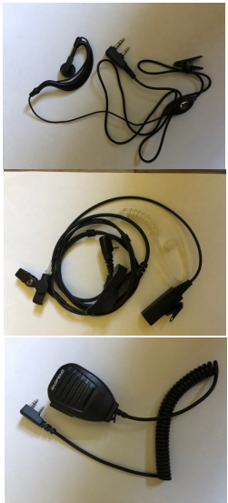
The Battery Life is very good. However, it takes a long time to charge. At this time it is very hard to find spare batteries for theradio. This will change in the future as time passes.
The Radio is approximately the same size as the RD-5R with the extended battery attached. It is larger than a RD-5R with its standard battery.
The Baofeng Dm-1701 comes highly recommended for IOK members for its cost. The Anytone 878 Plus is still a better radio but the price tag is much higher. The big advantage to the Anytone 878 Plus is its Bluetooth which removes all wires when using a headset, there is nothing to get tangled in your gear. As well as better Receive sensitivity and other great features.
I highly recommend using a DM-1701 in DMR mode with a Hotspot for your best operational results.
I also recommend purchasing a DM-1701 from Radioddity.com and contact them to make your purchase they are quick to provide accessories as a bonus to your purchase.
I hope this helps.
IOK Communications Coordinator

Full Duplex MMDVM Hot Spot
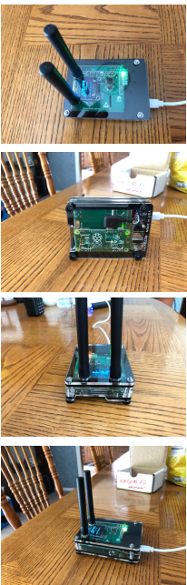
This is a Full Duplex, Not Simplex, Hot Spot that I built and
programmed in about 3 hours.
It consists of,
• Modified case from C4Labs
• Full Duplex MMDVM Kit with OLED
• Pi Zero W
• Micro USB breakout and 90 degree cable (inside the
case)
I will work with DMR, P-25, D-Star, and System Fusion.
It is fully assembled and operational.
All you need beside this device to have essentially your own Digital Repeater is,
• A Micro USB cable and power supply. Very low current. Most wall warts with micro USB will work fine or a rechargeable battery pack with a micro USB cable will power this for many hours.
• Wifi internet access home or through a smart phone.
• DMR ID to work with DMR on this device. DMR ID’s are free for any ham with a Tech license. Simple application process.
• A DMR radio to work with DMR or a radio for the mode you wish to operate.
It cost me $131.03 to build this device and I will sell it and help program it for any Active IOK. A small donation for my time would be appreciated but is not necessarily required.
DMR will give IOK a communications platform that uses radios,
some of which are very inexpensive like the RD-5R, or for a reasonable price provide many impressive features like the Anytone 787 Plus (my favorite handheld with Bluetooth).
DMR will give us private comms, and when necessary secure comms, in multiple different ways as well as statewide, nationwide, and worldwide comms on a Technician License.

Emergency Response Sheet

